

**JOMO KENYATTA UNIVERSITY**

**OF**

**AGRICULTURE AND TECHNOLOGY**

# TITLE: UHAI BORA SYSTEM FOR CONNECTING PATIENTS AND MOBILE DOCTORS WITH GPS CAPABILITY

**PROJECT DOCUMENTATION**

Submitted By

Jonathan Mutune David

CS282-8123/2014

In Fulfillment of the requirements for the award of the degree of

**BSC. COMPUTER TECHNOLOGY**

This is to certify that the project entitled

**UHAI BORA SYSTEM FOR CONNECTING PATIENTS AND MOBILE DOCTORS WITH GPS CAPABILITY**

Is the bona-fide record of project work done by:

Jonathan Mutune David

CS282-8123/2014

Of Bachelor of Science in Computer Technology during the year 2018/2019

Project Guide

Supervisor 1

Dr M. Kimwele

Supervisor 2

Dr W. Chemwa

# DECLARATION

I affirm that the project work titled “**UHAI BORA SYSTEM FOR CONNECTING PATIENTS AND MOBILE DOCTORS WITH GPS CAPABILITY**” being submitted in partial fulfillment for the award of BSc. Computer Technology is original work and has being carried out by James Ikubi, Lennox Onyango and I (Jonathan Mutune). It has not formed the part of any other project work submitted for the award of any degree either in this or any other university.

Each of us participated in reviewing different fields. The roles are as follows:

***Jonathan Mutune***

I researched and reviewed on usability in mobile and web applications and the suitable user interfaces; hence proposing a suitable user interface for our project.

***Lenox Onyango***

He researched and reviewed on Geolocation and Global Positioning System (GPS) and technologies related to it. He reviewed and proposed a technology to be applied in the whole system. This involves use of maps and markers, by using geolocation coordinates; latitude and longitude.

***James Ikubi***

He I researched and reviewed on databases and security. As a result I was able to suggest the best applicable type of database to use in our system, and the security measures to be undertaken. The database I researched on is the firebase real-time database. It is a NoSQL database. In the security research, this involved things like authentication using emails and passwords.

Jonathan Mutune

CS282-8123/2014

Sign: --------------------------Date: ------------------------------

# ACKNOWLEDGEMENT

I am extremely grateful to those people who have helped me successfully complete the first part of our project. Without the considerable help I have received from many people, I would not have been able to embark on such a project. I would like to thank in particular the following people; my project Supervisors Dr. M. Kimwele and Dr. W. Chemwa, for his guidance and advice which was essential; my project Coordinator Dr. H. Ratemo for her on time delivery of wanted materials for project, her guidance and advice which has been essential; Our project client ; and the Salutare staff for giving us chance to work with them; our panel supervisors for giving us the required guidance on our Proposal writing, Literature review and research Methodologies , analysis and design, and then for guiding and correcting us on the final project implementation. I also thank my parents for their continued support through the demanding project phase, for the provision of funds and finally, and finally my two partners **James Ikubi** and **Lenox Onyango** for their support in implementing and documenting these project. Through them am able to appreciate the great achievement of a teamwork.

# ABSTRACT

Uhai Bora, web and android system for connecting patients and mobile doctors with GPS capability is a system that helps to improve healthcare by connecting patients with doctors who can travel to the patient’s location. Both the patients and the doctors have an application (android applications). The patients uses their application to request for a mobile doctor. A mobile doctor then travels to the location of the patient to treat them. The application utilizes GPS to help the users to see the current location of the other party. Uhai Bora also has an administrator system which has being implemented by use of a web application.

The documentation covers the analysis and design, implementation, coding and testing of the system. The system design also consists of three designs which are logical design, physical design and architectural design. The system therefore has been implemented in the modules namely: two android applications which are made to be used by patients and doctors and then a web application which is made to be used by the administrator of the system. The three modules (applications) share one central database.

The system client requested that the applications be named “Salutare”. Therefore our project is “Uhai Bora”, but our applications are named Salutare Doctor, Salutare Patient and Salutare Admin.

The modules fetch or update their data to a real-time database which in our case we used firebase. The reason for using this real-time database because you can focus your time and attention on developing the best app(s) possible for your project. Since the operations and internal functions are so solid, and taken care of by the Firebase interface, you can spend more time developing the high quality app that users are going to want to use. Some of the firebase features are the cloud messaging which help to deliver and receive messages in a more reliable way across platforms.

The Modules have been successfully been tested. We also conducted different types of this was to demonstrate the working functionality of the system, to assess the usability of the system, to assess the system’s accuracy and to check systems security of information. We also produced test cases accordingly. The tests included: performance, usability, portability, functionality, security, unit and integrations testing.

Table of contents

TITLE: UHAI BORA SYSTEM FOR CONNECTING PATIENTS AND MOBILE DOCTORS WITH GPS CAPABILITY

DECLARATION ii

ACKNOWLEDGEMENT iii

ABSTRACT iv

TABLE OF FIGURES xi

LIST OF TABLES xiii

LIST OF ABBREVIATIONS xiv

CHAPTER ONE: PROPOSAL 1

1.1 Abstract 1

1.2 Problem Background 1

1.3 Problem Statement 1

1.4 Proposed System Design 2

1.4.1 General System workflow 2

1.4.2 The Use Case diagram showing workflow 2

1.5 Objectives 3

1.5.1 General objective 3

1.5.2 Specific Objective 4

1.6 System Methodology 4

1.6.1 Justification for the methodology 4

1.7 The Client 5

1.8 Proposed Solution 5

1.8.1 Solution Justification 5

1.9 Summary 6

CHAPTER TWO: LITERATURE REVIEW 7

2.1 Abstract 7

2.2 Background 7

2.3 Related Fields 9

2.3.1 Clinical Communication Applications 9

2.4 User Interface and Usability 10

2.4.1 User Interface 10

2.4.2 Usability 10

2.4.2.1 Limitations for Mobile Applications Usability 11

2.4.2.2 Previous Reviews Related to Usability 11

2.4.2.3 Control and Confirmation 12

2.4.2.4 Revealing More Information 12

2.4.2.5 Lateral Access 12

2.4.2.6 Display of Information 13

2.4.2.7 Buttons 14

2.5 Summary 15

2.6 Geolocation and Usability 15

2.6.1 Abstract 15

2.6.2 Introduction 15

2.6.3 Definition and Invention of GPS 15

2.6.4 Mobile Phone Tracking 17

2.6.5 Satelite Positioning 17

2.6.6 How a GPS Works 18

2.6.7 How Global Positioning System has Revolutionized our lives 18

2.6.7.1 Road Navigation 18

2.6.7.2 Real-time Positioning Data 19

2.6.7.3 Military Applications 19

2.6.7.4 Marine Navigation 19

2.6.7.5 Logistics 19

2.6.8 Geolocation Feature Used in Mobile Apps. 20

2.7 summary 20

2.8 Database and Security 21

2.8.1 Abstract 21

2.8.2 Database 21

2.8.2.1 Types of Database 21

2.8.2.1.1 No-SQL Database 22

2.8.2.2 SQL vs. NoSQL 24

2.8.2.3 Firebase 25

2.8.2.3.1 features of firebase (GeekyAnts, 2017) 25

2.8.2.3.2 Firebase Pros & Cons 26

2.6.2.4 Why Use Firebase for our Project? 26

2.8.3 Security 26

2.8.3.1 How to Secure an Android App 27

2.8.3.1.1 Use Internal Storage for Sensitive Data 27

2.8.3.1.2 Encrypt Data on External Storage 27

2.8.3.1.3 Use intents for IPC 27

2.8.3.1.4 Use Https 29

2.8.3.1.4 Use GCM instead of SMS 29

2.8.3.1.5 Avoid asking for personal data 29

2.8.3.1.6 Validate User Input 30

2.8.3.1.7 Use ProGuard before publishing 30

2.9 summary 31

CHAPTER THREE: RESEARCH METHODOLOGY 32

3.1 Introduction 32

3.2 Interviews 32

3.2.2 How to conduct interviews for research 32

3.3 Questionnaires 33

3.3.1 How to write questionnaires 33

3.2.5 Sample Questionnaire Used 35

3.4 Data collection 35

3.5 Data Analysis 35

3.5 Summary 36

CHAPTER FOUR: Analysis and Design 37

4.1 Analysis 37

4.1.1 Introduction 37

4.1.2 System Methodologies 37

4.1.3 Data Sources 38

4.1.3.1 Questionnaires 38

4.1.3.1.1 Participants 38

4.1.3.1.2 Data Analysis 39

4.1.3.1.3 Results 39

4.1.3.1.4 Evaluation Outcomes 40

4.1.3.1.5 Appointment Making and Medical Treatment 41

4.1.3.1.6 Smartphone and App Usage 42

4.1.3.2 Interview 43

4.1.3.2.1 Analysis and Findings. 44

4.1.3.2.2 Opportunities to Address the Issues 44

4.1.4 Feasibility Study 44

4.1.4.1 Economic feasibility 45

4.1.4.2 Technical feasibility 45

4.1.4.3 Schedule feasibility 45

4.1.4.4 Operation feasibility 46

4.1.5 System Requirements 46

4.1.5.1 Functional Requirement 48

4.1.5.1.1 Doctors’ Module 48

4.1.5.1.2 Patients’ Module 49

4.1.5.1.3 Admin web Module 50

4.1.5.2 Non Functional Requirement 50

4.1.6 Conclusions 52

4.2 Design 52

4.2.1 Introduction 52

4.2.2 Logical Design 52

4.2.2.1 Use case Diagram 53

4.2.2.2 Activity Diagram 53

4.2.2.3 Sequence Diagram 56

4.2.2.4 Class Diagram 57

4.2.2.5 Entity-Relationship Diagram 58

4.2.3 Physical Design 59

4.2.3.1 User Interface designs 60

4.2.3.1.1 Doctor’s Module 60

4.2.3.1.1 Admin web Module 62

4.2.3.1.1 Patient Module 63

4.2.3 Architectural Design 65

4.4 Summary 66

CHARPTER FIVE: CODING AND IMPLEMENTATION 67

5.1 Introduction 67

5.2 System Implementation 67

5.2.1 Admin web module 67

5.2.1.1 Icons and Information windows 67

5.2.1.2 Tables 68

5.2.1.3.1 Sorting and Searching 69

5.2.1.4 Forms 73

5.2.1.5 Maps 76

5.2.1.6 Menus 78

5.2.1.7 Graphics 79

5.2.2 Android doctors’ module 84

5.2.2.1 Menus 84

5.2.2.1.1 Option Menu 84

5.2.2.2 Switch 85

5.2.2.3 Button 86

5.2.2.4 Text view 86

5.2.2.5 Maps 86

5.2.2.6 Toast Message 87

5.2.2.7 Android Tabbed Layout 88

5.2.3 Patient android module 89

5.2.3.1 Navigation Drawer 89

5.2.3.2 Android containers: List view 89

5.2.3.5.1 Radio Buttons 91

5.2.3.7 Image view 92

5.2.3.7.1 Circle Image View 93

5.2.3.8 Progress dialog 93

5.2.3.9 Alert dialog 94

5.2.3.10 TextInputEditText 94

5.2.3.11 Forms 95

CHAPTER SIX: TESTING 96

6.0 Introduction 96

6.1 Objectives of testing 96

6.3 Testing scope 96

6.3.1 Functional Testing 96

6.3.1.1 Performance testing 98

6.3.1.2 User interface testing 98

6.3.1.3 Security testing 99

6.3.1.4 Portability testing 99

6.3.1.5 Test cases 100

6.3.3 Integration Testing 102

6.3.4 System Testing 104

CHAPTER SEVEN: CHALLENGE, RECOMMENDATION AND CONCLUSION 105

7.1 introduction 105

7.2 Challenges 105

7.3 Recommendation 105

7.4 conclusion 105

BUDGET 107

References 108

# TABLE OF FIGURES

Figure 1 General workflow of the system 2

Figure 2 Proposed workflow of the system 3

Figure 3 Example of No-SQL database 23

Figure 4 Sample Questionnaire 35

Figure 5 Use case diagram 53

Figure 6 activity diagram 55

Figure 7 Sequence Diagram 56

Figure 8 Name, attributes and operations of a class diagram 57

Figure 9 Class diagram 58

Figure 10 Entity relationship diagram 59

Figure 11 The Notification interface 60

Figure 12 Doctor Home Page interface 60

Figure 13 Doctor Session initiation interface 61

Figure 14 Doctor Session Termination interface 61

Figure 15 The Dashboard interface of the Admin Web Application 62

Figure 16 Admin Analysis interface 62

Figure 17 Transaction history interface 63

Figure 18 Patient module dashboard interface 63

Figure 19 Patient booking process interface 64

Figure 20 checking Doctors in the map Interface 64

Figure 21 Uhai Bora Salutary Architectural design 65

Figure 22 Doctor’s table on admin web module 68

Figure 23 Dialog box on the admin web module. 69

Figure 24 The searching algorithm on the admin web module 69

Figure 25 the sorting algorithm on the admin web module 69

Figure 26 sorting by the specialty of allergist, cardiologist, Dentist 70

Figure 27 Example of a web form 73

Figure 28 Salutary Map showing available doctors in the Organisation 76

Figure 29 Details of doctors In the Organisation on the map 77

Figure 30 The Salutary menu window 79

Figure 31 line chart of Salutare 79

Figure 32 Admin Module dashboard 82

Figure 33 Doctors table interface 82

Figure 34 Doctors graph interface 83

Figure 35 Doctors Form 84

Figure 36 Analytics page with graphics 84

Figure 37 Option menu on doctors ‘module 85

Figure 38 switch button for showing status of a doctor 85

Figure 39 Start and terminate buttons which are used to monitor the session which a doctor and patient spend 86

Figure 40 Text view of a doctor in salutary system 86

Figure 41 Map functionality on doctors’ module 87

Figure 42 Example of toast message in the salutary 88

Figure 43 android tabbed layout 88

Figure 44 the patient module navigation drawer 89

Figure 45 List view 90

Figure 46 map module showing patient the location of a doctor 90

Figure 47 Patient buttons for booking a doctors, also for monitoring session 91

Figure 48 radio buttons used for selecting the gender of a user 91

Figure 49 Rating Bar 91

Figure 50 Calendar view 92

Figure 51 Image View 92

Figure 52 Circle image view 93

Figure 53 Progress Dialog 94

Figure 54 An alert dialog 94

Figure 55 Users filling form 95

Figure 56 Checking and booking doctor module functionality 97

Figure 57 doctors accepts patient request and views the location on a map 97

Figure 58 Navigation Drawer for the android modules 98

Figure 59 Admin module navigation drawer 99

Figure 60 Patient checking doctors in the system unit test 101

Figure 61 Doctors checking the route to patient’s place of residence 102

Figure 62 Monitoring Daily transaction module testing 102

Figure 63 Data uploaded to the database on patient module unit 103

Figure 64 Data retrieved from the database using doctor’s module unit 103

Figure 65 Analytics functionality showing all transaction happened in a particular scope 104

# LIST OF TABLES

Table 1 Participant demographics of the Part A questionnaire. 40

Table 2 Participant characteristics of the Part B questionnaire. 40

Table 3 The interviews were recorded and transcribed, and a general thematic analysis was undertaken 44

*Table 4 Opportunities to address issues in mHealth implementation.* 44

Table 5 Android module requirements 47

Table 6 Web module requirements 48

Table 7 Doctors module functional requirements 49

Table 8 User/Patient Module functional requirement 50

Table 9 Web module functional requirement 50

Table 10 Gnatt chart 107

Table 11 Budget 107

# LIST OF ABBREVIATIONS

GPS – Global positioning system

ICT – Information and Communications Technology

PC – Personal Computer

P.D.A – Personal Digital Assistant

O.O.S.A.D – Object Oriented Systems Designs

D.B.M.S - Database Management Systems

R.D.B.M.S – Relational Database Management Systems

C.M.S – Content Management System

JSON – JavaScript Object Notation

XML – Extensible Markup Language

GCM – Google cloud Messaging

SDK – Software Development Kit

SMS – Short Message Service

IPC- Inter-Process Communication

API – Application Programming Interface

HTTP – Hypertext Transfer Protocol

HTTPS – Hypertext Transfer Protocol Secure

SQL – Structured Query Language

NoSQL – None Structured Query Language

BAAS – Backend as a Service

MHEALTH- Mobile Healthcare

UI-User Interface

# CHAPTER ONE: PROPOSAL

## 1.1 Abstract

The proposal presents a mobile healthcare system based on Android and Web applications to be developed. The system will be providing assistance to patients, identifying and selecting doctors based on the location and the specialties of the doctors. The system will be allowing patients to make appointments with doctors and also allowing mobile doctors to come and visit patients. The expected end results the applications is expecting to show a big saving of time and mobility of doctors and patients.

## 1.2 Problem Background

Many medical applications for smart phones have been developed and widely used by health professionals and patients. The use of these applications is very helpful because it leads to better communication between doctors and patients and help to enhance the overall treatment quality. The literature review of healthcare applications shows that applications focus on different area of healthcare such as patient care and monitoring apps, weight loss and fitness apps, communication among doctors and nurses on inpatient wards, the uses of the smart phone in medical education and research. Our proposed healthcare system is based on Android and Web apps to provide medical assistance for patients who live in regions where mobility is difficult and limited and can save the doctor and the patient lots of time. The proposed application identifies and selects doctors registered in the system based on their location, specialty and availability. The application allows patients to make appointments with doctors and also allowing mobile doctors to come and visit patients.

## 1.3 Problem Statement

* High population growth has overburdened the current medical facilities and personnel in Kenya who have to queue in lines for a long time before they are served. Some of the critically ill patients even get worse in those lines as they await to be attended to.
* Frequent strikes by the health care practitioners has led to a great suffering among the Kenyan people as they cannot be able to access healthcare during such times.
* The payment of medical bills especially for the inpatients who have complications can be managed at home by regular doctor check-ups. (Kenyanya, 2015)
* Complaints have arisen over misdiagnosis of patients due to mixing of files that can easily be done, and other various reasons in a hospital that has not yet adopted ICT. (Merab, 2018)
* Constant transport cost incurred, time and energy taken, especially for patients in need of continous medical care like the elderly, pregnant and nursing women, among other people who have to frequently go to hospital is quite a lot.

## 1.4 Proposed System Design

### 1.4.1 General System workflow

Our healthcare system will be composed of three parts; the mobile application, the web application and the web service. The mobile application will be synchronizing with the Web application using the Web service where data can be transferred via GPRS, 3G or WIFI. The system will be enabling data communication between patients and doctors and will be saving lots of time and efforts in mobility.

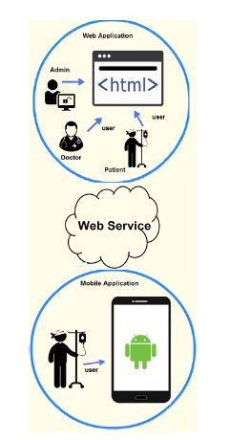

Figure 1 General workflow of the system

### 1.4.2 The Use Case diagram showing workflow

The use case diagram of the patient is expected to include patient account, check vaccinations, and schedule an appointment with reminder, reminder for medications and application update. The use case diagram of the doctor is expected to include vaccination details, schedule a patient appointment, write a prescription, check patient’s medical history and manage patient’s visit. Admin will be responsible of updating all resources including doctors, patients, vaccinations and medications.

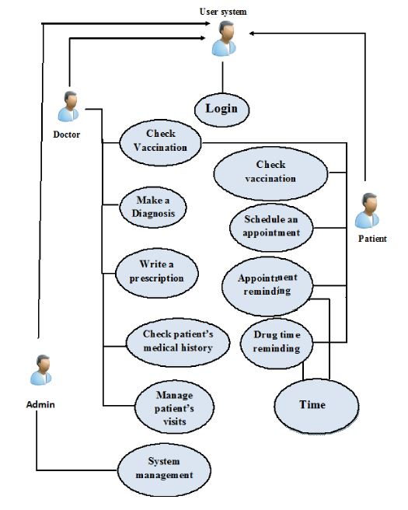

Figure 2 Proposed workflow of the system

## 1.5 Objectives

### 1.5.1 General objective

To develop an efficient system that will enable to connect mobile doctors with patients at any location and time using geolocation tracking capability.

### 1.5.2 Specific Objective

1. Research on geolocation, security, databases, usability and suitable user interfaces.
2. Construct reliable designs for the application that will enable the end user use it without any complexity of operating.
3. Implement an application that uses geolocation to help patients request mobile doctors and the doctors to find their patients using GPS location tracking.

## 1.6 System Methodology

* The system methodology that will be used is OOSAD which is a methodology that uses object oriented perspective whereby an object oriented model of the problem domain where the inital objects represent the entity and methods related to the problems that need to be solved.
* Object oriented design is the process of developing object oriented model of the system necessary to meet specific requirements. The object oriented approach to a system development view a system as a collection of interacting objects that work together to accomplish a task.
* An object oriented model is based on four main principles which are abstraction, encapsulation, inheritance and polymorphism.

### 1.6.1 Justification for the methodology

With the proposed solutions, OOSAD will be used due to the following reasons:

* Objects are easier for people to understand. This is because the objects are derived from the environment being automated, rather than being influenced too early by computer based procedures or data storage requirements.
* Data and processes are not artificially separated: in traditional methods, the data needs to be stored is separated early from algorithms that operate on that data and they are then developed independently. This can result in the data being in inconvenient formats or inconvenient locations, with respect to the processes that need access. With object oriented they are never separated from algorithms. We also end up with less complex code that is less sensitive to changes in customer requirements.
* Code can be reused more easily: with traditional approach, we start with the problem that needs to be solved and allow that problem to drive the entire development. We end up with a monolithic solution to today’s problem. But tomorrow always brings a different problem to solve, no matter how close the new problem is to the last one we dealt with, we are unlikely to be able to break open the monolithic system and make it fit-we hamper ourselves by allowing a single problem to influence every part of the system.

## 1.7 The Client

Salutare is a medical company that has partnered with various health care organizations in order to avail its clients various solutions that enable individuals to access healthcare services easily.

## 1.8 Proposed Solution

The proposed solution will provide the users with a system that will allow them to access medical services by the use of their android mobile phones. The system will be divided into three parts where we’ll have two android applications, one for the doctor and the other for the patients and a web application for the system admin. The system will provide the users with competent doctors who will avail themselves to provide medical services at a reasonable fee. The system will be able to allow users to book appointments via the application if they want to see particular doctors for further consultations and further tests. The system will also have an S.O.S which will help in case of emergencies. The system will be deployed with the GPS capability which will be allowing doctors locate the patients who have requested for treatments hence promoting better lifestyle (uhai bora).

### 1.8.1 Solution Justification

* ***Outcome***: The solution will improve the access to health care services for many people even in events like the strike of medical practitioners.
  + ***Impact:*** provision of healthcare services at all the time regardless of strikes in public hospitals.
* ***Outcome***: It will reduce the work load of the medical facilities and reduce queues thus ensuring that most people are timely served.
  + ***Impact***: Patients are able to access multiple services in a given time.
* ***Outcome***: Cases of misdiagnosis will be rare because records of every transaction will be kept in a database where follow up will be done to ensure that patients receive the best medical care services.
  + ***Impact:*** This will reduce the paper work and also reduce congestion of files in hospitals and clinic.
* ***Outcome:*** The system will also allow the patient to comment and rate the services of the visiting doctor which will keep the doctors on their toes in order not to ruin their reputation.
  + ***Impact:*** it will mobilize the application and make it available for use to as many patients as possible.

## 1.9 Summary

A mobile healthcare system based on Android and Web applications is presented. The system provides medical assistance to patients and save time and mobility. The applications allow patients to make appointments with doctors.

The connectedness and convenience that mHealth and most other facets of eHealth provides have the potential to greatly improve quality of life and ease of care when used appropriately.

From improved medication adherence to aggregated patient data, the benefits are plenty. One of the main challenges that healthcare practioners now face is ensuring that their patients take the correct medication as and when they are supposed to. Noncompliance with a medication regime has a whole host of issues, including hospitalization, relapse, disease flare-ups, poorer quality of life, and possibly even death. However, there are certain mHealth apps easily downloadable to a phone or other personal device that can help people stick to their medication regimen by tracking pills they have and have not taken, prompting them to take a certain drug, and allowing them to log any symptoms.

A lot of mHealth apps can connect a patient with their healthcare provider to improve ease and speed of contact. Being able to chat with a doctor or get advice on a condition, symptoms, or drug at any time has a host of benefits the most important being the possibility of earlier intervention.

If a patient expresses concerns about their health but can't physically get to a doctor, they can use a mHealth app to communicate. The doctor might see fit to intervene, thereby potentially saving the patient's life. Improved monitoring has benefits at the wider population level, too; some mHealth apps are able to collect patient and general healthcare data and store it in a single place. By having such convenient access to health trends — often in real time — healthcare professionals can stay on top of up-and-coming practices, giving them a better idea of how to proceed with patient care.

# CHAPTER TWO: LITERATURE REVIEW

## 2.1 Abstract

Mobile health (m-health) applications have recently attracted attention from both the manufacturing sector and research community. The evolution in the use of the smartphone has been aided by advanced communication and presents challenges in terms of the reliability and accuracy of applications. Awareness of these challenges could help industries and designers to develop better tools to enable patients and users to access effective apps. The aim of the study is to identify the show current development and application areas and present ongoing trends in field of mobile computing. Our research on the mobile development shows that we have 10 application areas which the computing department have so far managed to interact with the healthcare sector. The application areas include: ***patient monitoring****,* ***infrastructure****,* ***software architecture****,* ***modeling, framework,******security****,* ***fications****,* ***multimedia****,* ***mobile cloud computing****,* and literature reviews on the topics. The most relevant challenges include the low battery life of devices, ulti platform development, data transmission and security. We believe that by understanding m-health app critical content requirements and its classification, new solutions may be revealed with the potential to overcome the present challenges.

Our literature review has being divided into four parts: review of other health applications, review of user interface and usability, review of geolocation and review of databases and security.

## 2.2 Background

Recent years have seen an increased adoption of smart-phones by healthcare professionals as well as the general public. The smartphone is a new technology that combines mobile communication and computation in a handheld-sized device, facilitating mobile computing at the point of care. The main objective of this study is to classify the smartphone-based healthcare technologies in the literature according to their functionalities and summarize them in each category.

The healthcare system is highly mobile in nature, involving multiple clinical locations such as clinics, inpatient wards, outpatient services, emergency departments, operating theaters, intensive care units (ICUs), laboratories, etc. As such, working in the healthcare system requires extensive mobility of healthcare professionals as well as communication and collaboration among different individuals, including their colleagues and patients. Healthcare professionals mainly used pagers for mobile communication until the wide availability of cell phones in 1990s. The advent of mobile Personal Digital Assistants (PDAs) during 1990s enabled healthcare professionals to organize their contacts and calendars electronically, adding another device in their pockets. The combined functionality of a pager, a cell phone and a PDA is now replaced by a single device called a “smartphone”, which is becoming very popular among healthcare professionals as well as the general public(Stergiannis, Nov 2018)**.**

A systematic review summarizing 23 surveys on PDA usage by healthcare professionals (conducted in the U.S (16 surveys), Canada (4 surveys), Australia (1 survey), both the U.S. and Puerto Rico (1 survey), and both the U.S. and Canada (1 survey) between 2000 and 2005) demonstrated that overall adoption rate varied between 45% and 85% in 2004–2005 [1]. The patterns of PDA usage reported by this study were:

(1) Younger physicians (94%) were more likely than older physicians (84.5%) to use a PDA, and students and medical residents tended to be younger and were more likely to use a PDA,

(2) No significant gender difference in PDA users was reported among physicians, internists or residents,

(3) The biggest adopters of PDAs were family and general practitioners,

(4) Large-practice and hospital-based physicians were higher adopters of PDAs than office-based physicians; and

(5) PDA use was more likely among urban physicians than rural physicians.

According to research conducted by Manhattan Research in 2009 on the professional use of smartphones by physicians, about 64% of the physicians in the U.S. used smartphones in 2009 compared to only 30% in 2001.

The evolution Personal digital assistants and the smartphones led to the development of a new area called Mobile Health (often shortened to mHealth) which, according to the World Health Organization (WHO), is the medical practice with support of mobile devices, like cell phones, patient monitoring devices, PDAs and other wireless devices, including the use of cell phones functions like audio, messages, Bluetooth and other services. According (Armitage, December 2015)to the use of mobile devices is becoming more frequent in medical area as such devices help doctors in a safe and efficient way, for example, with patient data records and life signs monitoring.

In the last decade, advances in wireless communications and network technologies have had a substantial impact on m-health. M-health apps are receiving increased attention largely due to the global penetration of mobile technologies. A rapid growth in health technology is underway. With the growing use of mobile phones, m-health has evolved rapidly and its revolution demonstrates a tremendous impact particularly in developing countries. This is a positive development for physicians, patients, healthcare institutions and general m-health app users. Thus, healthcare practitioners are now progressively implementing m-health apps in their practices. It benefits patients and health practitioners by decreasing the cost for both parties. Regarding the high cost of health care, m-health apps can offer real cost savings by utilizing the high take-up of mobile applications, as well as provide a quality patient care and physician efficiency. For instance, patients can manage their own health and gain benefit from accessing the expertise of healthcare professionals at their fingertips when and where they need it.

## 2.3 Related Fields

Application for Healthcare and wellness

There are many smartphone-based applications for healthcare professionals. In our study, a total of 11 applications for health and wellness were identified. Health and wellness apps are mobile application programs that offer health-related services on smartphones, tablet PCs and other communication devices. The 11 identified applications include:

* Sports and fitness activity tracking
* Diet and nutrition
* Weight loss coaching
* Pharmacy
* Sleep cycle analysis
* Stress reduction and relaxation
* Meditation
* Medical advice and patient community
* Menstrual period tracking
* Pregnancy
* Hospital selection and appointment management.

The applications are categorized into the following:

* Disease diagnosis Like the Pharmacy App
* Drug reference Like the Stress reduction and relaxation
* Medical calculators like meditation app
* Clinical communication like Menstrual period tracking and the Uhai Bora application(The app to be developed)
* Medical training like the diet and nutrition application.

Our review was based on clinical communication category of applications.

### 2.3.1 Clinical Communication Applications

Smartphones support several means of communication including voice calling, video calling, text messaging, email messaging, multimedia (text, image, and video) messaging, and conferencing through the cellular phone service provider. Besides standard communications, clinical communication applications are designed to simplify communication among clinicians within a hospital.

The use of mobile phone communication in critical care environments facilitates relaying important information quickly, reducing the risk of medical errors. Nurses may need to go through a complex process to find the responsible physician for a patient using traditional numeric paging. In KBL clinic, the use of smartphones simplifies reaching the responsible physician. Nurses can send email messages indicating priority and requesting feedback if necessary, or can call directly in emergency cases. Our system will not observe that, instead we are proposing a system that will provide the users with a solution that will allow them to access medical services by the use of their android mobile phones. The system will be divided into three parts where we’ll have two android applications, one for the doctor and the other for the patients and a web application for the system admin. The system will provide the users with competent doctors who will avail themselves to provide medical services at a reasonable fee. The system will be able to allow users to book appointments via the application if they want to see particular doctors for further consultations and further tests. The system will also have an S.O.S which will help in case of emergencies. The system will be deployed with the GPS capability which will be allowing doctors locate the patients who have requested for treatments hence promoting better lifestyle (uhai bora).

## 2.4 User Interface and Usability

### 2.4.1 User Interface

User interface is the means by which the user and a computer system interact, in particular the use of input devices and software.

User interface consist of properties like usability, user experience, mobile computing,

### 2.4.2 Usability

Nielsen identified five attributes of usability:

* **Efficiency**: Resources expended in relation to the accuracy and completeness with which users achieve goals;
* **Satisfaction**: Freedom from discomfort, and positive attitudes towards the use of the product.
* **Learnability**: The system should be easy to learn so that the user can rapidly start getting work done with the system;
* **Memorability**: The system should be easy to remember so that the casual user is able to return to the system after some period of not having used it without having to learn everything all over again;
* **Errors**: The system should have a low error rate, so that users make few errors during the use of the system and that if they do make errors they can easily recover from them. Further, catastrophic errors must not occur.

Our system will observe all Nielsen attributes of usability.

#### 2.4.2.1 Limitations for Mobile Applications Usability

Zhang and Adipat highlighted a number of issues that have been introduced by the advent of mobile devices:

* **Mobile Context**: When using mobile applications the user is not tied to a single location. They may also be interacting with nearby people, objects and environmental elements which may distract their attention.
* **Connectivity**: Connectivity is often slow and unreliable on mobile devices. This will impact the performance of mobile applications that utilize these features.
* **Small Screen Size**: In order to provide portability mobile devices contain very limited screen size and so the amount of information that can be displayed is limited.
* **Different Display Resolution**: The resolution of mobile devices is reduced from that of desktop computers resulting in lower quality images.
* **Limited Processing Capability and Power**: In order to provide portability, mobile devices often contain less processing capability and power. This will limit the type of applications that are suitable for mobile devices.
* **Data Entry Methods**: The input methods available for mobile devices are different from those for desktop computers and require a certain level of proficiency. This problem increases the likelihood of erroneous input and decreases the rate of data entry.

#### 2.4.2.2 Previous Reviews Related to Usability

There have been several previous reviews of mobile user interface; however, they did not focus on user interface design patterns. Instead, the focus was primarily on certain application domain of mobile devices. For instance, (Moriso, August 2013) and Alison focused on in-car mobile use. Their article provided an overview of the possibilities offered by connected functions on cars, technological issues, and problems of recent technologies. They also provided a list of currently available hardware and software solutions, as well as the main features**.** (Rodrigues, Novermber 2013) And Pereira made a survey on mobile learning applications and technologies. The article provided an analysis of mobile learning projects, as well as the findings of the analysis. (Becker, June 2015) Surveyed the best practices of mobile website design for library. Monroe et al. made a survey on the use of mobile phones for physical activities (e.g., exercising, walking, and running) and approaches for encouraging and assessing physical activities using mobile phones. Donner reviewed mobile use in the developing world. His article presented major concentrations of the research, the impacts of mobile use, and interrelationships between mobile technology and users. Moreover, the article also provided economic perspective on mobile use in the developing world.

Some review articles concentrated on technical approach of mobile devices and user interface. For instance, (al., June 2013)surveyed smartphone-based systems for opportunistic (nonintrusive) user context recognition. Their article provided introduction to typical architecture of mobile-centric user context recognition, the main techniques of context recognition, lesson learned from previous approaches, and challenges for future research. (Akiki, 2014) Provided a review on adaptive model-driven user interface development systems. The article addressed the strengths and shortcomings of architectures, techniques, and tools of the state of the art. Summary of the evaluation, existing research gaps, and promising improvements were also stated. (Cockburn, December 2008)Provided a review of interface schemes that allowed users to work at focused and contextual views of dataset. The four schemes were overview + details, zooming, focus + context, and cue-based techniques. Critical features of the four approaches and empirical evidence of their success were provided.

Some previous reviews focused on mobile use in some user groups. For instance, (Zhou, May 2013) made a survey on the use and design of mobile devices for older users, focusing particularly on whether and why older users accept mobile devices and how to design the elderly-friendly mobile devices. Their article provided a summary on technology acceptance of the elderly users, input devices, menus and functions, and output devices.

Some more reviews concerned the impact of mobile use. (Moulder, April 2005)Reviewed the evidence concerning whether radiofrequency emitted from mobile phones were a cause of cancer. The article provided summary from relevant medical research. Nevertheless, the evidence for a causal association between cancer and radiofrequency was weak and unconvincing.

#### 2.4.2.3 Control and Confirmation

Physical and cognitive limits of human users often cause unwanted errors that can be trivial to drastic. On computer systems, control and confirmation dialogues are being used to prevent errors, typically user errors. A confirmation dialogue is used when a decision point is reached and user must confirm an action or choose between options. Control dialogue is used to prevent against accidental user-selected destruction, for example, exit guard and cancel and delete protection. Since 2007, there has been no research regarding control and confirmation dialogues on mobile devices.

#### 2.4.2.4 Revealing More Information

Two common types for revealing more information are to display in a full page and revealing in a context. Revealing in a full page is generally part of a process, where large amounts of content will be displayed. Revealing in context is generally used when information should be revealed quickly and within a context. Some of the patterns for revealing more information include pop-up, window shade, hierarchical list, and returned results. Since 2007, there has been no research regarding patterns in revealing more information on mobile devices.

#### 2.4.2.5 Lateral Access

Lateral access components provide faster access to categories of information. Two common patterns for lateral access are tabs and pagination. There are several benefits of using lateral access, including limiting number of levels of information users must drill through, reducing constant returning to a main page, and reducing the use of long list. Since 2007, there has been no research regarding lateral access on mobile devices.

#### 2.4.2.6 Display of Information

On desktops, users are constantly surrounded by ocean of information. Many information display patterns help users in filtering and processing relevant visual information. Examples of information display patterns include different types of lists, including vertical list, thumbnail list, fisheye list, carousel, grid, and film stripe. Effective patterns should reflect user’s mental models and the way users organize and process information.

Limited screen size has caused a design challenge to information display patterns and effectiveness of applying desktop designs to mobile platform unsettled. Since 2007, research has been directed to reassessment of display pattern usability, specifically on efficiency, error rate, and subjective satisfaction. In the fisheye list was compared to the vertical list on satisfaction and learnability, which was measured in terms of task execution time in this study. The study was carried out with 12 participants, aged 10 to 39. The results showed that the vertical list was better than the fisheye menu in task execution time; thus, the vertical list was superior to the fisheye list in terms of learnability. Despite being more efficient, the vertical list was less preferred as the fisheye menu was more visually appealing. Another study compared a list-based to a grid-based interface on click-path error and task execution time. The two layouts were very common on mobile devices. The prototypes in Finley’s study were mobilized versions of the existing website of a university. He ran the experiment with 20 participants, who were experienced mobile phone users, and all of them were students, staffs, or faculty members of the university. The results showed that grid-based interface was significantly more efficient, and it was rated as more appealing and more comfortable by the users.

Besides the layouts, there has been an argument that interaction concepts established on desktops work only with restrictions. Due to limited screen size, list scrolling and item selection can be more demanding on mobile devices than on desktops. (Anderson, July 2011) Compared seven different types of touch screen scrolling lists on three metrics: input speed, input error, and user subjective rating. The some types of list included:

(1) Scrollbar,

(2) Page-wise scrolling with arrow buttons,

(3) Page-wise scrolling with direct manipulation,

The results indicated that there were variations in efficiency of different list scrolling mechanisms. The input speed and error rate of “page-wise scrolling with direct manipulation without physics” were significantly higher than other interaction types. Although the differences between other interaction types were not significant, participants most preferred direct manipulation with simulated physics.

To compensate difficulty of input precision, interaction with mobile devices was sometimes done through a stylus, pressure sensing, or alternative interaction styles. Quinn and Cockburn proposed “Zoofing,” which was a list selection interface for touch or pen devices (Quinn, May 2012). The experiment asserted that the Zoofing technique outperformed conventional scrolling interaction on selection time and input errors. Our will observe keenly Anderson’s seven different types of touch screen scrolling lists.

#### 2.4.2.7 Buttons

Button is one of the most common design elements across all platforms. It is typically used to initiate actions (i.e., standalone button) or to select among alternatives (i.e., radio button). Early research covered several topics, including button size and spacing, tactile and audio feedback, and designing for users with disabilities.

Since 2007, research direction has been strongly influenced by touchscreen characteristics. Touchscreen enabled more versatility in interface designing as a large proportion of the device is no longer occupied by physical buttons; however, this brings about a new design challenge the lack of physical response and tactile feedback. Without physical responses, users have less confidence on the consequences of their actions which eventually compromise system usability. Studies indicated that tactile feedback improved efficiency, error rate satisfaction, and user experience. Nevertheless, not all types of the feedback are equally effective. There are certain factors that contribute to tactile feedback quality. The first factor is the realistic feel of physical touch. (Park, August 2011) Compared different styles of tactile effects, to evaluate perceived realism of physical response and user preference. The varied styles of tactile effects included slow/fast, bumpy/smooth, soft/hard, weak/strong, vague/distinct, light/heavy, and dull/clear responses. The results found that participants preferred the clear or smooth tactile clicks over dull ones for virtual buttons. Besides the realistic feel of physical touch, simultaneity of touch-feedback and the effects of latency is another factor that influences tactile feedback quality. In, latency was varied from 0 to 300 ms. for tactile, audio, and visual feedback modalities. The results showed that long latency worsened perceived quality. The perceived quality was satisfactory when latency was between 0 and 100 ms. for visual feedback and between 0 and 70 ms. for tactile and audio feedback. When the latency condition was 300 ms. quality of the buttons dropped significantly for all modalities of feedback.(Koskinen, January 2008) Study considered user preference towards different tactile feedback modalities. They compared three conditions of virtual button feedback— Tactile and audio, Tactile and vibration, and Nontactile—to find the most preferred style of feedback.

The results suggest the using nontactile feedback was least preferred by the users. It also yielded the lowest user performance which was measured by time to complete tasks and error rate. Tactile and audio feedback was more pleasant and better in user performance than the tactile and vibration one; however, the differences were not significant. Our development will observe the technologies which have been used so far. Our new development will only implement the SOS button for emergency outcomes.

SOS which some people think means “***Save Our Souls***”, “***Send Our Succor”*** or “***Save Our Ship***”. The original use of "SOS," however, dates back to 1908 and the International Morse Code distress signal used with maritime radio systems. It is the International [Morse code](https://en.wikipedia.org/wiki/Morse_code) [distress signa](https://en.wikipedia.org/wiki/Distress_signal)l. It is used as a start-of-message mark for transmissions requesting help when loss of life or catastrophic loss of property is imminent. Other prefixes are assigned for mechanical breakdowns, requests for medical assistance, and a relayed distress signal originally sent by another station.

## 2.5 Summary

The literature provided an overview of prior research and studies on each category of mobile UI design pattern conducted since 2007.

Although mobile devices are becoming an indispensable part of daily lives, there is no true standard for improving the user experience of mobile UI design. Most of the mobile UI designs are based on the desktop paradigm, but the desktop designs do not fully fit the mobile context

Effectiveness refers to the accuracy and completeness with which the users achieve certain goals. Efficiency refers to how fast the users can get job done. Emotional appreciation represents users' comfort in using and overall attitude towards the product.

## 2.6 Geolocation and Usability

### 2.6.1 Abstract

Technology has been advancing so fast in this modern age due to the increase of computational power. This has led to the miniaturization of hardware technology where we now have very small devices capable of performing very many tasks. Smart phones are an upgrade from the normal mobile phones we used to have where they did not have many functionalities. Smart phones have a global positioning system (GPS) facility embedded in them which enables them to be tracked when the global positioning system facility is activated. The global positioning system is globally used for navigation and tracking.

### 2.6.2 Introduction

Location tracking and navigation has become much easier with the incorporation of GPS facilities in many computing devices. Global positioning system was initially designed for the military but nowadays it has a wide range of application areas. Some of the application areas are: navigation, farming, precision mapping, surveying, etc. technological advancements and affordability has made it easier for many people to have access to a GPS device. GPS is not only limited to travel for example, a parent can keep track of their children’s whereabouts. It has revolutionized today’s technology by becoming more interactive and useful in many application areas which has made life much easier and a lot better.

### 2.6.3 Definition and Invention of GPS

GPS, or the Global Positioning System, is a global navigation satellite system that uses at least 24 satellites, a receiver and algorithms to provide location, velocity and time synchronization for air, sea and land travel. The satellite system consists of six earth-centered orbital planes, each with four satellites. GPS works at all times and in almost all weather conditions. This post answers “What is GPS?” and explains how it works.

In general, there are five key uses of GPS:

* Location — determining a position.
* Navigation — getting from one location to another.
* Tracking — Monitoring object or personal movement.
* Mapping — creating maps of the world
* Timing — making it possible to take precise time measurements.

GPS is extremely relevant today and used in numerous industries for preparing accurate surveys and maps, taking precise time measurements, tracking position or location, and navigating.

Some examples of GPS applications include:

***Emergency Response****:* When there is an emergency or natural disaster, first responders can use GPS for mapping, following and predicting weather, and keeping track of emergency personnel for safety. In the EU and Russia, the eCall regulation which comes into effect in 2018 relies on GLONASS technology and telematics to send data to emergency services in the case of a vehicle crash, reducing response time. Read more on the benefits of telematics.

***Entertainment***: GPS is being used for activities and games like Pokémon Go and Geocaching.

***Health and Fitness****:* Smartwatches and wearable technology can be used to track your fitness activity (such as miles run,) and benchmark it against others that match your demographics.

***Construction:*** From locating equipment, to measuring and improving asset allocation, GPS tracking allows companies to increase their return on assets.

***Transportation:*** Logistics companies are implementing telematics systems to improve driver productivity and safety.

The GPS is a system that has slowly become a very trivial part in the society and has been intergrated in many places such in vehicles, airplanes, ships and smartphones among other devices. Although this is the case, upto now there has not been a clear knowledge of thwe person behind its invention. There are various people who are associated with the invention of the GPS and they include Roger L. Easton, Ivan Getting, Bradford Parkinson and Dr Gladys West. Roger L. Easton was a cold war scientist who worked on technology used to monitor satelites and thereafter developed TIMATION, which is a time-based navigational system that utilized space-borne high precision clocks, passive ranging and circular orbits and sychronized them into a master clock. He was recognized for extensive pioneering achievements in various fields including space crafting, navigation and timing technology, that led to the developmet of what was known as NAVSTAR-Global Positioning Systems. His contribution to the development of the GPS was recognized in 2010 by the Hall of Fame of the GPS. However, in 2004 there were other two people in the Hall of Fame who were associated with the development of the GPS. The people were Parkinson and Dr Getting. Getting was recognised on the concept of using an advanced technology with the help of satelites to help calculate more accurate positioning data on moving vehicles. Parkinson was the face of the NAVSTAR-GPS and conducted a series of activities based on the program that attributed to the development of the GPS as he was the chief architect of GPS, from system conceptualization and engineering to development and implementation. With those contributions, he was known as the ‘Father of GPS’. Dr West also worked in the US Naval Weapons Department during the Cold War. She was a mathematician in profession and would process data from satelites to come up with their exact location. She was recognised for her efforts by the Air Force and Missile Pioneers Hall of Fame, one of the highest honors, for the precise calculations that she made on the geodetic Earth Model, a geoid, for what eventually became the GPS’s orbit. All this attributions led to the successful development of the GPS. (Geo Editor, june 17, 2017)

The GPS is an advanced technology that is most suited for android phones and can be assisted by GPRS to figure out the location of a mobile phone more accurately. Also the CPU time and the programming time required for the GPS to function in an android phone is not as overwhelming as such since the most work is redirected to the assistance server. For a GPS to work, it is assisted by various Internet Based Data connections such as GPRS to initiat and maintain contact with the assistance server for A – GPS, Assisted GPS, which is a hybrid technology where the GPS receiver sends additional information through the mobile network.

### 2.6.4 Mobile Phone Tracking

Mobile phone tracking is a process of identifying the current location of a particular device,whether in motion or stationary, A cell phone transmits and receives radio signals constantly even when they are not making calls. Various service providers have got base stations in various part so as to allow their customers to access the services they offer to them. Base stations can cover a particular radius which is known as the cell of the base station. Mobile phone tracking can be achieved in various ways including the use of GPS and the use of radio signals tranmitted between cell towers to the phone.When the person with the simcard moves from one place to another, his/her phone relocates itself to its nearest base station thus enabling a service provider to roughly estimate the position of the person using the particular sim card. Therefore, even without the GPS an individuals location can be known based on the time taken to tranmit a signal to a number of cell towers and the angles at which the cell phone approaches the tower that the phone will be using. Although this is true, one’s specific and accurate location cannot be known. This is where the GPS technology comes in. (Wikepedia, 2019).

### 2.6.5 Satelite Positioning

The GPS and other Location Based Services need specialised infrastructure for the purpose of positioning, determining the location of the object uin a referencesystem, through a process called geocoding which is used to connect the onject to General Cordinate System. These systems are divided into three, satelite positioning local positioning, local positioning and network-based positioning. The system of focus for the paper is the satelite positioning that has systems using earth orbiting satelites and also use terminals that calculate the position of a device based on the information of the three earth-orbiting satelites. This provides an accuracy of about 10-40 meters. The user thus receives total independence of the mobile network with reference to positioning.

### 2.6.6 How a GPS Works

In order to know where a certain device is located, the GPS technology has to determine the location pf atleast three satelites and the relations of the three satelites to one another. GNSS, Global Navigation Satelite System is the network a GPS tracking system uses. The network works with a variety of satelites using microwave signals that are sent to the GPS enabled mobile phones so as to give information about the location. GPS is an acronym for Global Positioning System. It is a system composed of 24 satelites and the US funds them. A GPS tracking system enables one to monitor the movement of the device from one place to the next. The system incoorporates a variety of satelites to triangulate the location of a device without necessarily involving the variouis service providers nor the use of the Internet. Since the earth is spherical variouis satelites are positioned at specific spheres which is the closest to the GPS enabled mobile devices can help in identifying the location of the device, a technique called triangulation of 3D triangulation which includes the lattitude, longitude and alttitude of the earth, regardless of the weather conditions. (Rahman & Haque, 2012)In as much as the GPS provides an exact location of a device, there is a posibility of errors that can occur due to variables like atmospheric conditions, satelite clock drift and measurement noise.

### 2.6.7 How Global Positioning System has Revolutionized our lives

Global Positioning Systems, better known as GPS, has become an integral part of everyday life. From how we move from place to place to how we defend our borders, GPS can be used to enhance our directional accuracy considerably.

These days, locating an establishment you’ve never been to is as easy as asking your phone for directions. GPS makes this seemingly small action possible, the same ways it allows the military to launch accurate missile strikes on targets that are continents away from their base.

GPS is one of those technologies that crept up on everyone and entwined itself with other useful technologies to become invaluable in our ever-growing world. To fully understand just how vital GPS is in the modern world, it is necessary to see just what this technology, in its entire expedience, helps us achieve in different areas. This include the following;

#### 2.6.7.1 Road Navigation

It may seem like years since you last drove somewhere solely relying only on road signs and printed maps, doesn’t it? That’s because GPS has made transportation so easy that we may have forgotten how far we’ve advanced technologically.

These days, all you need to do to get from point A to point B is to key in the location of point B into your vehicle’s GPS. Navigating unfamiliar places no longer requires the need for physical maps as GPS satellites do all the work for you. GPS eliminates the risk of getting lost or missing the right exits when traveling across states, but it also drastically improves how quickly we get from one point to another.

#### 2.6.7.2 Real-time Positioning Data

Real-time GPS data has numerous applications. If you’ve been to a racetrack recently, you may have noticed that it is no longer necessary to be anywhere near the tracks while the races go on. That’s because GPS devices are attached to racehorses these days, and these provide crucial real-time data. Viewers don’t even have to be in attendance anymore to enjoy such events; play-by-play commentary usually accompanies the real-time visual feed of the horses as they race around the track.

#### 2.6.7.3 Military Applications

Long-range missiles need GPS to strike their targets accurately. This technology is what keeps them on-course even when they encounter strong winds and other changes in weather that can divert them from their intended path.

Military personnel deploy the use of GPS-controlled missiles when their targets are in areas with high risk of collateral damage. For them, accuracy is a matter of life and death, and without GPS, it is almost impossible to know whether these missiles will land on the specified targets.

This is only one of several GPS applications that improve military operations.

#### 2.6.7.4 Marine Navigation

Navigating the seas requires pinpoint accuracy; otherwise, a lot of sailors’ lives would be lost at sea. GPS is vital in maritime navigation, not just because it shows us where to go, but also because it enables us to detect storms and severe weather before we encounter it.

Weather satellites, satellite imaging and sea-depth-reading devices all utilize GPS technology, and they are crucial to our survival when we’re out at sea.

#### 2.6.7.5 Logistics

Fleet management and GPS go hand-in-hand these days. Logistics companies use GPS systems to monitor their drivers, keep track of their consignments and to obtain useful real-time data such as total drive time, number of stops made and the average speed of travel.

It can also be used on multiple vehicles at once, making it a rich source of comparative vehicle data as well.

Other areas in which GPS technology has proven useful include on the internet where geotagging has made it possible to attach a location to all posts and media. GPS hasn’t been around for very long, but it is already evident that it is one of the technologies humankind will not be able to do without as we go into the future.

### 2.6.8 Geolocation Feature Used in Mobile Apps.

The trend of Geolocation has been introduced in the mobile world creating very many opportunites and ideas that could not have survived without the feature. There are many mobile applications that have intergrated the GPS which has brought a different platform of providing services to clients and a while different way of interacting with the client. Some applications are based on the feature alone while providing various Local Based Services while other applications have used the feature in conjunction with other features to accomplish service in very many other aspects. There are various mobile apps that have benefit from the Geolocation feature. They include the maps and navigation applications that help the user in navigating the terrain, geosocial apps that focus on the social aspect where users shar information based on their location, weather forecast apps that use geolocation data to determine the weather of a particular location, on-demand services like the app proposed in the paper, that introduce a different platform to service customers as close as to their domestic premise, health and fitness apps that use GPS data for tracking sporting events and activities, lifestyle and hobbies apps that use geolocation data to connect users with the same interests, among other many apps. (widen, April,2018).

## 2.7 summary

In this brief research, various techniques like kalian filtering, fuzzy, neuro fuzzy, and wiener filter and genetic algorithms are implemented for different applications such as navigation, tracking as the subject of research. The amount of attention given to the research field of improving GPS signal accuracy suggests that a GPS system that can provide reliable and accurate position for different applications with a good choice of algorithm would have great potential.

Regarding the increasing development in using GPS and their pivotal roles in various fields including business and the military, improvement in their measurement accuracy and data security in these systems are considered not only as theoretical issues, but also as vital necessities in these systems. In the work, the software approach of different algorithms analyzed for accurate positioning GPS signal was discussed.

Accurate timing using GPS can revolutionize many applications. The past few years have witnessed increasing interest in synchronized accurate timing and how they may be used for various applications. The development of new types of computer based hardware and the completion of the GPS of satellites provide the components needed for true synchronized monitoring systems.

In recent decades, researchers have been actively investigating numerous technologies, ranging from sensitive electronic devices to effective algorithms, in an effort to improve upon existing GPS signal improving methods. Given that it is a relatively young technology with many potential uses and it is continued as one of the technologies researched in academia. In light of recent research efforts, the algorithms appears to show more promise as a more reliable and accurate method of predicting the position during travel time information than other technologies. This work serves as an independent evaluation of the existing used in the GPS field. The numerous references cited in this literature review also indicate that the above discussed algorithms likely possess untapped potential in other applications. This field study appears to be the first of its kind in evaluating an in-place, the full-scale GPS system. It is hoped that this work will serve as a first step in qualifying the efficiency and reliability of the GPS system

## 2.8 Database and Security

### 2.8.1 Abstract

The history of database research over the past 30 years is one of exceptional productivity that has led to the database system becoming arguably the most important development in the field of software engineering. The database is now the underlying framework of the information system, and has fundamentally changed the way many organizations operate. In particular, the developments in this technology over the last few years have produced systems that are more powerful and more intuitive to use. This has resulted in database systems becoming increasingly available to a wider variety of users.

In the review, we try to explain how we came up with a decision to use Firebase as our database for the system. We have reviewed database, and the two different types of database; relational and NoSQL database. We have the further explained the features of Firebase, a NoSQL database, that make it suitable for our project.

Review of security has also being included in the document: the key concepts of computer security and how to achieve security, specifically by securing an android application.

### 2.8.2 Database

**According to** (Rouse, August 2015)**,** a ***database*** is a collection of data, or [information](https://www.britannica.com/science/information-science) that is specially organized for rapid search and retrieval by a [computer](https://www.britannica.com/technology/computer). Databases are structured to [facilitate](https://www.merriam-webster.com/dictionary/facilitate) the storage, retrieval, modification, and deletion of data in conjunction with various data-processing operations. A [database management system](https://www.britannica.com/technology/database-management-system) (DBMS) extracts information from the database in response to queries.

The database is now such an integral part of our day-to-day life that often we are not aware we are using one. To start our discussion of databases, in this section we examine some applications of database systems.

#### 2.8.2.1 Types of Database

There are two main types of databases: [***SQL***](https://www.upwork.com/hire/sql-programmers/)and [***NoSQL***](https://www.upwork.com/hire/nosql-freelancers/)—or, relational databases and non-relational databases. The difference speaks to how they’re built, the type of information they store, and how they store it. (Homan, 2014)

A ***relational database*** is a set of formally described tables from which data can be accessed or reassembled in many different ways without having to reorganize the database tables. The standard user and application programming interface (API) of a relational database is the Structured Query Language ([SQL](https://searchsqlserver.techtarget.com/definition/SQL)). SQL statements are used both for interactive queries for information from a relational database and for gathering data for reports. (Homan, 2014)

***NoSQL*** is an approach to [database](https://searchsqlserver.techtarget.com/definition/database) design that can accommodate a wide variety of data models, including key-value, document, columnar and graph formats. NoSQL, which stand for "not only [SQL](https://searchsqlserver.techtarget.com/definition/SQL)," is an alternative to traditional relational databases in which data is placed in tables and data [schema](https://searchsqlserver.techtarget.com/definition/schema) is carefully designed before the database is built. NoSQL databases are especially useful for working with large sets of distributed data. (Homan, 2014).

##### 2.8.2.1.1 No-SQL Database

NoSQL databases and management systems are the current buzzwords in the storage industry. Big data explosion is the main catalyst behind the growth and popularity of NoSQL databases. Traditional database management systems (DBMSs) are mainly designed for structured data with predefined schema. So, the relational model (RDBMS) finds it very difficult to deal with semi-structured, unstructured or other forms of data, popularly known as big data. (Pal, 2016)

***Database Management systems***

A database management system can be defined as a set of software programs capable of handling database operations. It includes storing, extracting and modifying data along with the administrative activities. All the relational databases have a predefined model/schema which defines the structure of the data and how it is stored.

In NoSQL storage, the schema is dynamically defined.

***NoSQL – A New Way of Thinking about Databases***

Before the explosion of big data, we were quite comfortable with the relational storage model, because the input data was almost in structured form. And, for the small amount of unstructured data, some mechanisms or ***ETL*** tools were used to make it structured and then load into the RDBMS. So, we never faced the challenges of managing huge volumes of unstructured data (big data).

Here's where the role of NoSQL technology comes in. The term NoSQL originally referred to "non-relational." NoSQL is a new way of thinking about databases and their management systems. It provides a mechanism to store and retrieve data, modeled in a non-relational way (without tabular relation). There are different types of NoSQL databases available in the market, each suitable for specific use cases. But the fundamental purpose of all these types are similar – to store semi-structured, unstructured or other forms of data.

***What are NoSQL Database Management Systems?***

In simple terms, NoSQL DBMS is a group of system software/libraries to manage, operate and administer non-relational databases. NoSQL database management systems are specifically designed to manage unstructured data and they are characterized by a schema-less model, high performance, scalability, distributed storage, cloud enablement, etc.

We know that unstructured data, more specifically big data, has four dimensions – volume, velocity, variety and complexity. Now, if we do a combination of these different dimensions, we get different types of data models. So, the NoSQL DBMSs are also designed to have multiple operational models based on the data and target functionality.

There are mainly four types of NoSQL DBMSs. Let us take a look at them one by one.

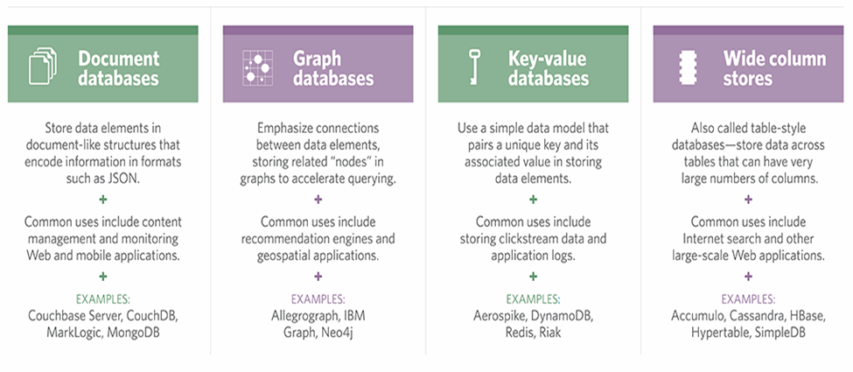

Figure 3 Example of No-SQL database

***NoSQL*** database examples include MongoDB, Firebase, BigTable, Redis, Raven DB Cassandra, HBase, Neo4j and Couchdb.

***KEY-VALUE-BASED MODEL***

* ***Brief description*:** Key-value-based NoSQL storage is the most basic type of NoSQL implementation. The journey of NoSQL DBMS started with key-value pairs only, so they are the basic backbone of the non-relational model. The value of any data is stored with a matching key without any structure or relation. And, the data is also fetched with the help of the key. It has high performance with easy scalability support.
* ***When suitable*:** The key-value model is suitable for storing basic information like user profiles, user sessions, shopping cart data, queuing and live information, etc.
* ***When not suitable*:** These are not recommended in situations where we need to perform data-based query, multiple key-based operations or relationship-based fetching, etc.

***COLUMN-BASED MODEL***

* ***Brief description*:** A column-based DBMS model stores related data in a family of columns. It can be imagined as a row with multiple columns containing related data and identified by a row key. The important point to note is that different rows can have different columns and new columns can also be added to any row at any point of time. So, it is not necessary to maintain the same columns for all the rows.
* ***When suitable*:** It is suitable for storing large volumes of unstructured and non-volatile data. These are mostly used for log aggregation, blogging platforms, etc.
* ***When not suitable:*** It is not recommended for any early stage development or cases where query pattern changes frequently.

***DOCUMENT-BASED MODEL***

* ***Brief description:*** A document-based model is nothing but a key-value store, where the document is stored in the value part and retrieved by the associated key. These documents can be XML, JSON or in any other form, having a hierarchical and self-defining structure.
* ***When suitable:*** It is suitable for storing nested information, CMSs, web-based and real-time analytics, e-commerce applications, etc.
* ***When not suitable:*** It is not suitable for complex operations spreading across multiple documents or complex queries.

***GRAPH-BASED MODEL***

* ***Brief description*:** A graph database is a different flavor compared to the other three types of NoSQL storage. It stores entities with their relationships. Entities are known as nodes (having their own properties) and relations are known as edges. This is like a tree structure where all the nodes are connected based on their relationships.
* ***When suitable*:** Graph databases are suitable in scenarios where we have data with strong relationships. Some of the implementations are social networks, recommendation engines, geospatial data, etc.
* ***When not suitable*:** It is not suitable in situations where the data model does not have strong relationships among the entities. Because the success of the graph is mainly dependent on the relationship-based model.

Now we have a clear understanding of different NoSQL DBMSs and their usage. So let’s have a look at how it differs from SQL and traditional RDBMS.

#### 2.8.2.2 SQL vs. NoSQL

We have been using SQL and traditional RDBMS for decades and it has supported almost all the use cases. Now, in the age of big data, NoSQL technology is being introduced to support the new use cases related to unstructured data. But, it does not mean that the old use cases for which RDBMS is suitable no longer exist. So, NoSQL DBMS is not a replacement for RDBMS, rather is it to support the gaps found in RDBMS while dealing with big data. There are multiple differences in both the models, some of them are mentioned below:

* SQL DBMS followed a strong schema-based relational model. But NoSQL DBMS is relation-less and schema-less.
* RDBMS only supports vertical scaling, whereas NoSQL DBMS supports horizontal scaling.
* RDBMS is ACID (atomicity, consistency, isolation and durability) compliant, but NoSQL DBMS is not.

So, there is no competition between SQL and NoSQL or their database management systems. They are both suitable for specific use cases and will grow in the future.

#### 2.8.2.3 Firebase

The Firebase Real-time Database is a cloud-hosted NoSQL database that lets you store and sync data between your users in real-time. Firebase is a ***Backend As A Service*** *or* ***BAAS***, this means Firebase has its own *Real-time Database, Cloud Storage, Authentication, Hosting and many other services*. (Esplin, 2016)

##### 2.8.2.3.1 features of firebase (GeekyAnts, 2017)

1. ***It’s a Real-time Database***

Real-time data is the way of the future. Nothing compares to it. Most databases require you to make HTTP calls to get and sync your data. Most databases give you data only when you ask for it. When you connect your app to Firebase, you’re not connecting through normal HTTP. You’re connecting through a Web Socket. Web Socket are [much, much faster than HTTP](http://www.websocket.org/quantum.html). You don’t have to make individual Web Socket calls, because one socket connection is plenty. All of your data syncs automatically through that single Web Socket as fast as your client’s network can carry it. Firebase sends you knew data as soon as it’s updated. When your client saves a change to the data, all connected clients receive the updated data almost instantly.

1. ***File Storage***

Firebase Storage provides secure file uploads and downloads for Firebase apps, regardless of network quality. The developer can use it to store images, audio, video, or other user-generated content. Firebase Storage is backed by [Google Cloud Storage](https://en.wikipedia.org/wiki/Google_Cloud_Storage).

1. ***Authentication***

Firebase auth has a built in email/password authentication system. It also supports OAuth2 for Google, Facebook, Twitter and GitHub. Firebase Auth integrates directly into Firebase Database, so you can use it to control access to your data.

1. ***Hosting***

Firebase includes an easy-to-use hosting service for all of your static files. It serves them from a global CDN with HTTP/2.

##### 2.8.2.3.2 Firebase Pros & Cons

***Pros***

* Email & password, Google, Facebook, and GitHub authentication
* Real-time data
* Built in security at the data node level
* File storage backed by Google Cloud Storage
* Static file hosting
* Treat data as streams to build highly scalable applications

***Cons***

* Limited query abilities due to Firebase’s data stream model
* Traditional relational data models are not applicable to NoSQL; therefore, your SQL chops will not transfer

#### 2.6.2.4 Why Use Firebase for our Project?

Firebase is a NoSQL database provided by google. It is free for developers and provides file storage which is essential in our project, where will be storing features such as doctor’s passport. Firebase is also a real time database, this comes in handy in features like providing real time location of a doctor in transit. I.e. A patient can monitor a doctor’s current location after they request them.

### 2.8.3 Security

Computer security - The generic name for the collection of tools designed to protect data and to thwart hackers

Network security - Measures needed to protect data during their transmission and to guarantee that data transmissions are authentic.

***Key concepts of computer security***

* ***Confidentiality***

Preserving authorized restrictions on information access and disclosure, including the means for protecting personal privacy and proprietary information.

* ***Integrity***

Information is changed only in a specified and authorized manner. Guarding against improper information modification or destruction, including ensuring information nonrepudiation and authenticity.

* ***Availability***

Ensuring timely and reliable access to and use of information.

Uhai Bora consists of a web application that is only accessible to the admin of the system, and android applications to be used by the doctors and patients. Therefore, security will mainly be emphasized on the android applications.

#### 2.8.3.1 How to Secure an Android App

The Android operating system has lots of built-in security features, such as application sandboxing, protection against buffer and integer overflow attacks, and segregated memory areas for program instructions and data. As a result, simple Android apps that don't perform any file system or networking operations can often be considered secure by default.

I'm going to list some of the best practices you can follow to build a secure Android app that doesn't leak data or permissions, and is, in general, less vulnerable to malicious apps that might be installed on the user's device.

##### 2.8.3.1.1 Use Internal Storage for Sensitive Data

Every Android app has an internal storage directory associated with it whose path is based on the package name of the app. Files inside this directory are very secure because they use the MODE_PRIVATE file creation mode by default. This means the files cannot be accessed by any other app on the device. Therefore, it is a best place to store all the sensitive data of your app in the internal storage directory.

To determine the absolute path of your app's internal storage directory, it is recommended that you use the getFilesDir () method. Once you know its path, referencing files inside it is as simple as referencing files inside any other directory. For example, here's how you could reference a file called **myfile.dat** in the internal storage directory of your app:

File myFile = new File (getFilesDir (), "myfile.dat");

##### 2.8.3.1.2 Encrypt Data on External Storage

The internal storage capacity of an Android device is often limited. Therefore, at times, you might have no choice but to store sensitive data on external storage media, such as a removable SD card.

Because data on external storage media can be directly accessed by both users and other apps on the device, it is important that you store it in an encrypted format. One of the most popular encryption algorithms used by developers today is AES, short for [***Advanced Encryption Standard***](https://en.wikipedia.org/wiki/Advanced_Encryption_Standard), with a key size of 256 bits.

Writing code to encrypt and decrypt your app's data using the javax.crypto package, which is included in the Android SDK, can be confusing. Third party libraries, such as [Facebook's Conceal](http://facebook.github.io/conceal/) library, are usually much easier to work with and very efficient.

##### 2.8.3.1.3 Use intents for IPC

Sockets, named pipes, or shared files are used to asynchronously communicate with other apps installed on an Android device. These approaches are not only hard and inelegant, but also prone to threats. An easier and more secure approach to interprocess communication on the Android operating system is to use intents.

To send data to a specific component of an app, you must create a new instance of the Intent class and use its setComponent () method to specify both the package name of the app and the name of the component. You can then add data to it using the putExtra () method.

For example, here's how you could send the string ***Hello World*** to an Activity called ***MyActivity****,* which belongs to an app whose package name is ***my.other.app***:

// Create an intent

Intent intent = new Intent();

// Specify the component name

intent.setComponent(

new ComponentName ("my.other.app","my.other.app.MyActivity")

);

// Add data

intent.putExtra("DATA", "Hello World!");

// Send the intent to the activity

startActivity(intent);

To send data to multiple apps at once, you can send the intent as a broadcast using the sendBroadcast() method. However, by default, a broadcast can be read by any app that has an appropriately configured BroadcastReceiver.

Therefore, if you want to send sensitive information as a broadcast, you must use a custom permission whose protectionLevel is set to signature. By doing so, the Android operating system makes sure that only apps that were signed using your signing key can receive the broadcast.

Here's a code snippet that shows you how to send the string ***Hello World*** as a secure broadcast:

// Create an intent

Intent intent = new Intent();

// Add data

intent.putExtra("DATA", "Hello World");

// Specify an action name for

// the receiver's intent-filter

intent.setAction("my.app.receive");

// Send as a broadcast using a custom permission

sendBroadcast(intent, "my.custom.permission");

Note that the above code works as expected only if the custom permission is declared and used in the manifest files of both the sender and receiver apps.

<permission android:name="my.custom.permission"

android:protectionLevel="signature"/>

<uses-permission android:name="my.custom.permission"/>

##### 2.8.3.1.4 Use Https

All communications between your app and your servers must be over an HTTPS connection, preferably using the HttpsURLConnection class. If you think using HTTP for data that is not confidential is fine, think again.

Many Android users connect to several open Wi-Fi hotspots in public areas every day. Some of those hotspots could be malicious. A malicious hotspot can easily alter the contents of HTTP traffic to make your app behave in an unexpected manner, or worse still, inject ads or exploits into it.

By using HTTPS, as long as the server is configured with a certificate issued by a trusted certificate authority, such as [DigiCert](https://www.digicert.com/) or [GlobalSign](https://www.globalsign.com), you can be sure that your network traffic is secure against both eavesdropping and man-in-the-middle attacks.

If your app has a lot of networking code and you are afraid that you might unwittingly be sending some data as clear.Text, you should consider using [nogotofail](https://github.com/google/nogotofail), an open source tool built by Google to find such mistakes.

##### 2.8.3.1.4 Use GCM instead of SMS

Back when GCM, short for [Google Cloud Messaging](https://developers.google.com/cloud-messaging/), didn't exist, many developers were using SMS to push data from their servers to their apps. Today, this practice is largely gone.

The SMS protocol is neither encrypted nor safe against spoofing attacks. What's more, an SMS can be read by any app on the user's device that has the READ_SMS permission.

GCM is a lot more secure and is the preferred way to push messages to an app because all GCM communications are encrypted. They are authenticated using regularly refreshed registration tokens on the client side and a unique API key on the server side. To learn more about GCM, you can refer to [this tutorial about push notifications](https://code.tutsplus.com/tutorials/how-to-get-started-with-push-notifications-on-android--cms-25870).

##### 2.8.3.1.5 Avoid asking for personal data

User privacy is given a lot of importance these days. In fact, there are laws, such as the European Union's [Data Protection Directive](http://eur-lex.europa.eu/legal-content/EN/TXT/HTML/?uri=CELEX:31995L0046) and Canada's [Personal Information Protection and Electronic Documents Act](http://laws-lois.justice.gc.ca/eng/acts/P-8.6/), which mandate the protection of the privacy of a user. Therefore, unless you have a good reason and a very secure infrastructure to collect, store, and transmit personal user information, you must avoid directly asking for it in your apps.

A better approach to user authentication and user profile information look up on Android is through the [Google Identity Platform](https://developers.google.com/identity/). Google Identity Platform allows users to quickly sign in to your app using their Google account. After a successful sign in through the platform, whenever necessary, your app can easily look up various details about the user, such as the user's name, email address, profile photo, contacts, and more. Alternatively, you could use free services like [Firebase](https://www.firebase.com) that can manage user authentication for you.

***NOTE:*** Another major reason why ***firebase*** is the most suitable choice of database for our system, is the security feature.

If you must handle user credentials yourself, it is recommended that you store and transmit them in the form of secure hashes. The most straightforward way to generate different types of hashes using the Android SDK is by using the MessageDigest class.

Here's a little code snippet that shows you how to create a hash of the string ***Hello World*** using the SHA-256 hashing function:

// Initialize MessageDigest to use SHA-256

MessageDigest md = MessageDigest.getInstance("SHA-256");

// Convert the string to a hash

byte[] sha256Hash = md.digest("Hello World".getBytes());

##### 2.8.3.1.6 Validate User Input

On Android, invalid user input doesn't usually lead to security issues like buffer overruns. However, if you allow users to interact with a SQLite database or a content provider that internally uses a SQLite database, you must either rigorously sanitize user input or make use of parameterized queries. Failing to do so makes your data vulnerable to SQL injection attacks.

On a similar note, user input validation and sanitization is also very important if you are using user input to dynamically generate code to run on an embedded scripting engine, such as [Mozilla Rhino](https://github.com/mozilla/rhino).

##### 2.8.3.1.7 Use ProGuard before publishing

Security measures built into an Android app can be severely compromised if attackers are able to get their hands on the source code. Before you publish your app, it is recommended to make use of a tool called [ProGuard](http://developer.android.com/tools/help/proguard.html), which is included in the Android SDK, to obfuscate and minify source code.

Android Studio automatically includes ProGuard in the build process if the buildType is set to release. The default ProGuard configuration available in the Android SDK's ***proguard-android.txt*** file is sufficient for most apps. If you want to add custom rules to the configuration, you can do so inside a file named ***proguard-rules.pro***, which is a part of every Android Studio project.

## 2.9 summary

In our research we identified many different categories of smartphone-based healthcare applications. These applications are grouped according to targeted users (i.e., clinicians, medical and nursing students, and patients). These applications are not intended to re-place desktop applications, but to add to existing technologies for better healthcare. The functionalities of the applications are growing day by day and new functionalities are available with every major release. The work of healthcare professionals is very mobile in nature. Smartphones enable for advanced mobile communication between health professionals, makes medical formula calculations available anywhere anytime, and provides access to evidence-based medical resources including disease diagnosis guides, drug references, literature search, and continuing medical education materials at the point of care. The full potential of smartphones has yet to be exploited. We believe that this study provides a better understanding and greater insight into the effectiveness of the smartphone-based healthcare applications in improving patient care and reducing healthcare expenses.

# CHAPTER THREE: RESEARCH METHODOLOGY

# 3.1 Introduction

The process used to collect information and data for the purpose of making business decisions. The methodology may include publication research, interviews, surveys and other research techniques, and could include both present and historical information.

In order to come up with a system to link patients and remote doctors, different kind of data needs to be gathered and analyzed.

The research will take both a ***qualitative*** and ***quantitativ*e** approach.

***Quantitative****:* Is used to quantify the problem by way of generating numerical data; such as the number of people with access to a smart phone and number of people willing to use such an app.

This type of data is collected using questionnaires, polls and surveys.

***Qualitative****:* Is used to gain an understanding of underlying reasons, opinions, and motivations.

This type of data is collected through methods such as observations and interviews.

We shall use ***interviews,*** to get opinions on the applicationand ***questionnaires*** to get numerical data.

## 3.2 Interviews

A research interview involves an interviewer, who coordinates the process of the conversation and asks questions, and an interviewee, who responds to those questions. ... Interviews are an appropriate method when there is a need to collect in-depth information on people's opinions, thoughts, experiences, and feelings.

Interviews are most effective for qualitative research: They help you explain, better understand, and explore research subjects' opinions, behavior, experiences, phenomenon, etc. Interview questions are usually open-ended questions so that in-depth information will be collected.

### 3.2.2 How to conduct interviews for research

1. Recruit Participants. Determine what it is you hope to learn from interviewing and identify the people that will provide you the richest data and information possible.
2. Establish a Recording Method. Interviews can be recorded in a number of ways.
3. Develop Questions.
4. Interview Participants.
5. Conduct Further Research.
6. To get opinions on how to develop the application; will require an interview with the client of the system (Salutare Lifeline), as well as different potential users.
7. The questions will mainly be used to gather data on features people would like included in the application.

## 3.3 Questionnaires

A questionnaire is a research instrument consisting of a series of questions (or other types of prompts) for the purpose of gathering information from respondents. Although questionnaires are often designed for statistical analysis of the responses, this is not always the case.

### 3.3.1 How to write questionnaires

* Designing a questionnaire involves 10 main steps:
  + ***Write a study protocol***
    - This involves getting acquainted with the subject, making a literature review, decide on objectives, formulate a hypothesis, and define the main information needed to test the hypothesis.
* ***Draw a plan of analysis***
  + This steps determines how the information defined in step 1 should be analysed. The plan of analysis should contain the measures of association and the statistical tests that you intend to use. In addition, you should draw dummy tables with the information of interest. The plan of analysis will help you to determine which type of results you want to obtain.
* ***Draw a list of the information needed***
  + From the plan of analysis you can draw a list of the information you need to collect from participants. In this step you should determine the type and format of variables needed.
* ***Design different parts of the questionnaire***
  + You can start now designing different parts of the questionnaire using this list of needed information.
* ***Write the questions***
  + Knowing the education and occupation level of the study population, ethnic or migration background, language knowledge and special sensitivities at this step is crucial at this stage. Please keep in mind that the questionnaire needs to be adapted to your study population.
* ***Decide on the order of the questions asked***
  + You should start from easy, general and factual to difficult, particular or abstract questions. Please consider carefully where to place the most sensitive questions. They should be rather placed in the middle or towards the end of the questionnaire. Make sure, however, not to put the most important item last, since some people might not complete the interview.
* ***Complete the questionnaire***
  + Add instructions for the interviewers and definitions of key words for participants. Insure a smooth flow from one topic to the next one (ex. "and now I will ask you some questions about your own health..."). Insert jumps between questions if some questions are only targeted at a subgroup of the respondents.
* ***Verify the content and style of the questions***
  + Verify that each question answers to one of the objectives and all your objectives are covered by the questions asked. Delete questions that are not directly related to your objectives. Make sure that each question is clear, unambiguous, simple and short. Check the logical order and flow of the questions. Make sure the questionnaire is easy to read and has a clear layout.
* ***Conduct a pilot study***
  + You should always conduct a pilot study among the intended population before starting the study.
* ***Refine your questionnaire***
  + Depending on the results of the pilot study, you will need to amend the questionnaire before the main survey starts.
* Questionnaires was distributed to number of people in order to gather numerical data. Some of the people given include healthcare officers, Doctors, patients and students.

### 3.2.5 Sample Questionnaire Used

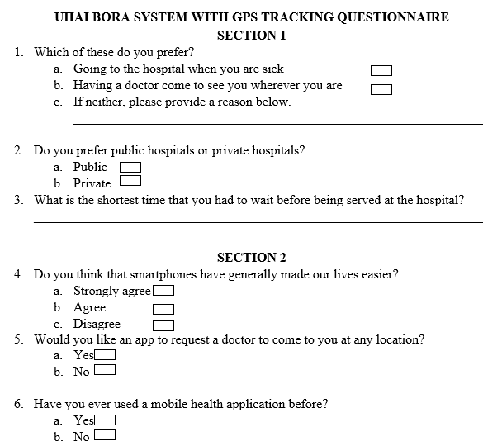

Figure 4 Sample Questionnaire

## 3.4 Data collection

Data collection is the process of gathering and measuring information on variables of interest, in an established systematic fashion that enables one to answer stated research questions, test hypotheses, and evaluate outcomes.

## 3.5 Data Analysis

Content analysis will be used to analyze the data which will be gathered from personal interviews. According to (McCabe, 2014), this is the type of research whereby data gathered is categorized in themes and sub-themes, so as to be able to be comparable. A main advantage of content analysis is that it helps in data collected being reduced and simplified, while at the same time producing results that May then measure using quantitative techniques. Moreover, content analysis gives the ability to researchers to structure the qualitative data collected in a way that satisfies the accomplishment of research objectives. However, human error is highly involved in content analysis, since there is the risk for researchers to misinterpret the data gathered, thereby generating false and unreliable conclusions ( (Bock, June 2012).

## 3.5 Summary

The two major paradigms of research; qualitative and quantitative offer different perspectives and types of information about health and health care. Each type of research need to be evaluated on the merits of its design and intent. Qualitative research focuses on describing expenses with health related phenomena, but does not focus on making predictions or drawing cause and effect conclusions. Quantitative research in contrast seeks to predict an outcome in a population based on numerical data collected from a representative sample of that population. Quantitative research is more widely published and referenced in healthcare literature. However, qualitative research is growing in importance. Also it is becoming more common for studies to combine procedure from both paradigms, producing mixed-methods research.

Various styles of research fall under each paradigm. Each style of research has distinct procedures that need to be followed in order to produce trustworthy or valid results. The three major types of quantitative research are observation, quasi-experimental and experimental. Qualitative research is divided into five types: ethnography, biography, phenomenology, case study and grounded theory.

# CHAPTER FOUR: Analysis and Design

## Analysis

### 4.1.1 Introduction

System analysis is a process of collecting and interpreting facts, identifying the problems, and decomposition of a system into its components.

System analysis is conducted for the purpose of studying a system or its parts in order to identify its objectives. It is a problem solving technique that improves the system and ensures that all the components of the system work efficiently to accomplish their purpose.

Our analysis provide an in depth study of methodologies which were used in system development, data sources, feasibility study, and the system requirements. Our system is a health management system which comprises of a web application and mobile application (mHealth).

MHealth is an abbreviation for mobile health, a term used for the practice of medicine and public health supported by mobile devices. The term is most commonly used in reference to using mobile communication devices, such as mobile phones, tablet computers and PDAs, and wearable devices such as smart watches, for health services, information, and data collection. The mHealth field has emerged as a sub-segment of eHealth, the use of information and communication technology (ICT), such as computers, mobile phones, communications satellite, patient monitors, etc., for health services and information.

mHealth applications include the use of mobile devices in collecting community and clinical health data, delivery of healthcare information to practitioners, researchers, and patients, real-time monitoring of patient vital signs, and direct provision of care (via mobile telemedicine).

### 4.1.2 System Methodologies

The system methodology used is object oriented system analysis and design (OOSAD) which is a structured method for analyzing, designing a system by applying the object-orientated concepts, and which develops a set of graphical system models during the development life cycle of the software.

OOSAD derives some its phases from the SDLC methodology, the distinction of the two methodologies is that OOSAD is object oriented methodology while SDLC procedural (phases without iterations) methodology. Therefore, OOSAD can be defined to be well study improvement of SDLC. The software life cycle is typically divided up into stages going from abstract descriptions of the problem to designs then to code and testing and finally to deployment.

The earliest stages of this process are analysis (requirements) and design. The distinction between analysis and design is often described as “what Vs how”.

The analysis phase identifies the objects, their relationship, and behavior using the conceptual model (an abstract definition for the objects). While in design phase, we describe these objects (by creating class diagram from conceptual diagram usually mapping conceptual model to class diagram), their attributes, behavior, and interactions. Note the activities of OOSAD and the developed models aren’t done once, however they are revisited and refined at every step of development.

### 4.1.3 Data Sources

It is a repository which contains relevant data needed for more investigation like project development. Our data sources are primary data sources, which are the original data source, that is, one in which the data are collected firsthand by the researcher for a specific research purpose or project. Primary data was collected in a number of ways which include;

1. Questionnaires
2. Interviews

#### 4.1.3.1 Questionnaires

Data collected from the questionnaires include Administrative Data, Patient Medical Records, and Comments from Individual Patients

There were few preexisting questionnaires that were suitable for the investigation of mHealth requirements of this project, so we designed a new questionnaire that includes two parts: Part A for users and patients (15 questions), and Part B for health information-related persons (10 questions). Part A is divided into three sections: basic information questions, medical and health-related questions, and smartphone app questions. Part B concerns the current and future development (and current problems) of mHealth, as relayed by health information-related professionals. We distributed the questionnaires to 50 volunteers and, using SPSS13.0 to collect the data and assess its reliability, modified the questionnaires to make it workable for a large-scale investigation. The final reliabilities were 0.802 and 0.848 for Parts A and B, respectively.

##### 4.1.3.1.1 Participants

For questionnaire Part A, we randomly selected patients and related citizens (consisting of family or friends accompanying the patients) in six outpatient departments (medicine, dermatology, gynecology, ophthalmology, otorhinolaryngology, and mental health) of the East African breweries medical clinic which is the largest clinic in the east African breweries limited with an outpatient capacity of over 26,300 per year. Patients with different kinds of disease conditions come from different areas in Nairobi County because they prefer to visit this clinic first. Thus, the opinions of participants from the clinic outpatient areas represent a substantial proportion of the viewpoints of citizens in Kasarani division, Nairobi County. For Part B, we randomly chose engineers, clerks, and managers from three information centers in a hospital (Eabl, Baba ndogo health center), Nairobi county Ministry of Health (GoK), and an information technology (IT) company (Bostech ICT Solution Limited) to complete the questionnaire.

##### 4.1.3.1.2 Data Analysis

We used SPSS13.0 to process and analyze the questionnaire data, which included the following three parts: Define Variables, Data Entry, and Data Statistics.

*Define Variables*

In the variable view, each question item of the questionnaire was treated as a variable; we defined the name, data type, width, label, values, and other variables for each.

*Data Entry*

The types of questions were choice questions or multiple-choice questions; we entered all options selected by our respondents in the questionnaires into SPSS according to the defined variables.

*Data* Statistics

After data entry, we used the frequency, crosstabs, and tables in the descriptions function, defined multiple response sets, and conducted multiple response analyses. Cross tab analysis is a Chi-square test method to measure relevance between every two variables in SPSS13.0. Multiple response analysis is a frequency analyzed when there can be more than one response to a survey question per participant, and allows the set of responses to be combined and collectively analyzed.

##### 4.1.3.1.3 Results

Twenty seven patients and user responded to our questionnaire A, of whom 4 were excluded due to incomplete answers (more than two missing answers). At total of 20 valid respondents were included in our analysis. Many of the answers have pointed out that age and sex heavily affect online information-seeking behavior. We hypothesized that visit type (whether a person is visiting for the first time [first] or second time [subsequent], or is a companion [users] with patients visiting a hospital during the past 2 months) was a key factor for patients acquiring health information. Patients tend to go to large hospitals instead of general practitioners to seek medical treatment once they get sick. In the current health system of Kenya, the more times the patients go to a hospital/clinic, the more they learn about their health conditions. Of the 20 respondents, almost half were women (11/20, 48.7%), and the average age was 31.5 years, with a high rate of young adults (43.9%, 7/20); 42.5% (2/20) were first-time visitors to the clinic, and 35.5% (1/20) were second-time visitors to the clinic.

|  |  |  |
| --- | --- | --- |
| Characteristic | | n (%) |
| Total (N) | | 28 (100.0%) |
| Age (years) | 18-29 | 6 (24.6%) |
| 30-40 | 14 (50.0%) |
| 41-69 | 7 (25.4%) |
| Sex | Male | 7 (38.3%) |
| Female | 11 (61.7%) |
| Visit type | First | 1 (16.5%) |
| Subsequent | 2(18.5%) |
| User | 20 (65.0%) |

Table 1 Participant demographics of the Part A questionnaire.

Nine of 28 respondents to Part B of the questionnaire were excluded due to careless and repeated answers.

|  |  |  |  |  |
| --- | --- | --- | --- | --- |
| Department | Position | | | |
|  | Clerk | Chief Information Officer | Engineer | Researcher |
| Government health information center, n (%) | 0 (0.0%) | 8 (34.8%) | 15(65.2%) | 0 (0.0%) |
| Hospital, n (%) | 8(57.1%) | 1 (7.1%) | 1 (7.1%) | 4 (28.6%) |
| Information technology company, n (%) | 0 (0.0%) | 1 (7.7%) | 12(92.3%) | 0 (0.0%) |

Table 2 Participant characteristics of the Part B questionnaire.

##### 4.1.3.1.4 Evaluation Outcomes

Questionnaire A is divided into three parts: health information-seeking, appointment making and medical treatment, and smartphone usage. Health Information-Seeking

Regardless of age, sex, or visit type, most of the respondents were unaware of their health conditions (62.3%, 17/28) and unclear about former preventive care records (84.6%, 23/28) or hospital visit records (65.4%, 19/28). Most patients (73.7%, 21/28) were willing to check their health, visit, or test records if it was convenient, with most respondents (64.5%, 17/28) obtaining disease information mostly and/or only from their doctors. Patients (user) preferred to get health information from a health expert or hospital visits (65.4%, 19/28) compared to Internet searches (21.1%, 4/28); 55.2% (14/28) indicated that they would likely and/or certainly use the Internet or a mobile app to get some information before seeking a doctor. Additionally, 67.1% (20/28) of respondents answered that they might follow some health suggestions from a prestigious health website; 71.5% (20/28) said they wanted to learn medical-related knowledge if it was convenient. Among all of the above, some significant findings include: women were more likely than men to know partially about their former preventive records (χ2=10.855, P<0.01); subsequent patients knew more about their health status than first-visit patients (χ2=21.075, P<0.01); patients were more aware of their former hospital visit records than non-patients (χ2=9.553, P<0.05); males were more likely than females to choose Internet searches as the way to obtain health information (χ2=10.592, P<0.05); first-visit hospital patients would rather choose Internet information-seeking than others (χ2=15.612, P<0.05); and young adults (18-29 years old) would be more likely than others to use the Internet or a mobile app to obtain some health information before seeking a doctor.

Multiple response analysis showed the most wanted health information included a physical examination, disease awareness, and daily health; computer and smartphone apps were the most favorable ways to search the Internet.

##### 4.1.3.1.5 Appointment Making and Medical Treatment

Multiple response analysis showed that the three most common problems during medical treatment were long waiting times (66.4%, 18/28), difficulty making appointments (46.5%, 11/28), and unclear treatment results (40.3%, 10/28). Table analysis tests showed the most desirable way to make an appointment with a doctor was online (49.6%, 12/28) regardless of age or sex, especially in outpatient departments of internal medicine, otorhinolaryngology, and mental health (χ2= 213.077, P<0.01). However, the results varied by visit type (χ2=25.782, P<0.01), which meant citizens were more likely to choose online appointment-making than others. Respondents showed similar degrees of concern regarding online appointment-making, which included: tedious processes (37.3%, 7/28), registering with the wrong department (33.6%, 5/28), inability to find the most wanted doctor (35.0%, 5/28), and more difficult hospital processes (30.9%, 5/28).

Compared with hospital payment (30.7%, 5/28) and uncertain answers (22.7%, 4/28), most respondents indicated that they wanted to pay the appointment-making fee online (46.7%, 7/28) regardless of age, sex, or visit type, especially in outpatient departments of internal medicine, otorhinolaryngology, and mental health (χ2= 28.843, P<0.05). After online appointment-making, 81.9% (23/28) of the respondents wanted an alert to show the time and process of seeking a doctor in the hospital. If the appointed doctor could not be available on the day (doctors’ schedules are often changed in the hospital), 58.9% (16/28) of respondents chose to make a decision later based on the factual situation, while subsequent visit patients were less likely to continue their hospital visit (χ2=10.911, P<0.05).

In total, 49.1% (9/28) of participants preferred to choose a time to go to the waiting room and wait for the doctor rather than staying in the waiting room after appointment-making, especially in outpatient departments of internal medicine, otorhinolaryngology, and mental health χ2= 27.543, P<0.01), regardless of age or visit type. However, females showed more willingness to wait than males (χ2=9.968, P<0.01). Most respondents only showed partial satisfaction with their medical treatment outcome (54.6%, 10/28). Reasons for dissatisfaction with the doctor-seeking experience included: still unclear about my condition (29.1%, 3/28), have unanswered questions (49.3%, 9/28), and doctors’ poor attitude (21.6%, 3/28).

Twenty-three respondents wrote down other reasons and suggestions about unsatisfactory hospital outpatient experiences, including: five pointed out a lack of clarity of hospital processes and/or ways to choose the correct doctor because of unclear doctor interfaces; three were unclear about the doctors’ prescriptions; three complained about the high medical treatment price, which mainly included medication and physical tests; five respondents did not trust their doctors’ diagnosis; three complained of doctors’ and nurses’ poor service attitudes; five pointed out the prolonged waiting time of outpatients, and waiting for test results after a difficult appointment-making process in the hospital; four respondents were still unclear about all of their conditions or test results; two reported poor navigation and disorder in the outpatient section in the hospital; and four expressed their opinions about the online appointment-making process (Internet problems causing failure, functions that should be customized, mobile payments should also be acceptable, and the process should record the entire view of a patient’s health care).

4.1.3.1.6 Smartphone and App Usage

We defined a smartphone as a phone that has a standalone operating system, running memory, and connection to wireless Internet and mobile communication Internet (so that users can install any third-party software, such as games, navigation, and so on). Data analysis showed that 96.4% (27/28) of our respondents had smartphones, but department difference (χ2=14.18, P<0.05) indicated that elderly patients from the ophthalmology department may not use smartphones. Table test results showed daily time spent on a smartphone significantly declined as the users’ age increased (χ2=20.593, P<0.01), and differences were noted in different departments (χ2=31.613, P<0.01). Among the three age groups (18-29, 30-40, >41), the percentages of daily time spent on a smartphone >3 hours were 45.9% (9/28), 28.2% (4/28), and 22.5% (4/28), respectively. Most respondents (69.8%, 15/28) chose “YES” when asked about receiving pushed messages from health and medical-related apps.

Multiple response analysis results showed several trends: the two most used functions of smartphones were apps (85.5%, 23/28) and phone calls (49.3%, 10/28); the two most used kinds of smartphone-based apps were instant messengers (84.2%, 23/28) and news (59.3%, 13/28); the three most desired kinds of apps were health related (63.9%, 18/28), daily life service related (52.3%, 13/28), and medical treatment related (48.6%, 10/28); respondents comprehensively showed high health-related app expectations regarding health management (47%, 11/28), health learning (59.5%, 18/28), and health record queries (52.1%, 12/28); medical-related app expectations included appointment-making (65.1%, 17/28), treatment results queries (59.2%, 19/28), and patient-provider interactions (53.7%, 17/28). The most accepted kinds of push messages from smartphone apps were test results (58.3%, 17/28) and appointment alerts (51.8%, 13/28).

#### 4.1.3.2 Interview

|  |  |
| --- | --- |
| Area | Issues |
| Policy and regulatory | Privacy and data security  Medical practice across counties and with respect to clinical  practice roles (eg,prescribing regulations)  Bandwidth or spectrum availability |
| Wireless networks | Compatibility across multiple networks  Compatibility across multiple platforms and proprietary systems  Cost to the end user  Coverage in remote areas |
| Health system | Lack of examples of sustainable business models  Lack of reimbursement  Lack of understanding of value mHealth may provide  Clinical roles accountability and integration into clinical practice  Integration into electronic health records and health information systems  Competing health information technology priorities and broader opportunity cost |
| mHealth practice | Lack of knowledge of how to do it well  Wrong focus on the technology or on advantaged populations (those who don’t need it)  Governance in mHealth  ,Publicly available applications not evaluated and without basis in theory or evidence , Stand-alone or soloed initiatives due to existing platforms or proprietary systems |

Initial discussions were held by the salutary healthcare Organisation CEO Dr. Barack Achando, and the three of us (Jonathan Mutune, James Ikubi, and Lenox Onyango). These discussions informed the development of important themes to be covered in the interviews. The themes were the priority and value of mHealth (mobile health), potential benefits to underserved populations, issues and barriers to mHealth implementation, and issues around mHealth research. These initial discussions, along with an environmental scan, also provided a master list of possible interviewees. This was added to by asking each interviewee for recommendations of other potential key informants. The final master list consisted of approximately 16 individuals. It was decided to initially focus on representatives from several areas: relevant Department of Health and Human Services agencies; integrated health systems; people involved in delivering mHealth services; and academics working in mHealth. Potential interviewees were approached by directly, by email and via email introductions from others. A small number did not respond at all (n = 2), but none of those who responded refused an interview. Some potential interviewees who agreed were never able to complete an interview (n = 6), some encounters became informal discussions instead of interviews (n = 5), and more potential interviewees were never contacted due to time constraints and reaching data saturation (n = 3).

Table 3 The interviews were recorded and transcribed, and a general thematic analysis was undertaken

#### 4.1.3.2.1 Analysis and Findings.

A total of 11 key informants participated in semi structured interviews. The interviewees were people interested in mHealth from various University/Interns (n = 1), those from integrated health systems (n = 3), academics working in this area (n = 2), and people working in mHealth companies (n = 1), wireless networks (n = 3), and organizations that sponsor mHealth initiatives or research (n = 1).

4.1.3.2.2 Opportunities to Address the Issues

Some interviewees did discuss their thoughts on how these issues should be addressed, although these discussions were not included in every interview. During the analysis of the discussions, we developed a list of potential opportunities to address the issues in each category.

|  |  |
| --- | --- |
| Area | Opportunities |
| Policy and regulatory | Coordination of wireless industry and health sector |
| Wireless networks | Shared standards for interoperability  Consideration of open architecture or standardized interfaces  Industry coordination and collaboration for mHealth |
| Health system | Use of opportunities of current health reform investment |
| mHealth practice | Collaboration with end users to develop solutions to their problems Foundation of theory and evidence of what works |

*Table 4 Opportunities to address issues in mHealth implementation.*

### 4.1.4 Feasibility Study

A feasibility study is an analysis that takes all of a project's relevant factors into account including economic, technical, operational, and scheduling considerations to ascertain the likelihood of completing the project successfully.

Four aspects of the project were studied.

#### 4.1.4.1 Economic feasibility

Generally, it means whether a business or a project is feasible cost wise and logistically. Economists calculate economic feasibility by analyzing the costs and revenues a business would incur by undertaking a certain project.

The project cost is feasible because all the APIs used are free and the development kit (for the android applications was developed using Android studio and for the web application was developed using NodeJs framework with vuetify for the front-end and NodeJs for backend) and the software to implement the project is an open source. The benefits that come with implementing this project far outweighs any cost that is incurred in terms of the internet fees and money for printing the final documentation.

#### 4.1.4.2 Technical feasibility

Technical feasibility study is the complete study of the project in terms of input, processes, output, fields, programs and procedures. It is a very effective tool for long term planning and trouble shooting. The technical feasibility study should most essentially support the financial information of an organization.

The use of vue JS framework has a great advantage to the development of the applications. This is because Vue JS supports the future of Vue tooling through its vue-cli-3 plugin. With one command you are ready to start building your next great idea. We choose NodeJs development because of its flexibility, simplicity, extensibility and performance. And this is for right reasons. NodeJs is the part of MEAN stack that unlike other stacks is fully JavaScript powered. Vue together with Node.js can be used for building APIs for single-page, multi-page, hybrid mobile and web apps. Nodejs framework has allowed us to use the same language which is JavaScript both on the back-end and front-end. And as such the development process has been much faster and easier as one person will be managing both presentation and data access layer.

Java is used in android development. This is because Java increases security because both the platform and the Java language were developed from the primary day with the issue of security at hand. The platform allows users to obtain codes from the internet and later on run them on Java without infecting the host system with any threats such as virus or malwares. Also you cannot write files from the disk drive on Java, making it extremely protect for use in mobile application development. Java can be kept up limited permission thus will not hurt your computer system.

#### 4.1.4.3 Schedule feasibility

Schedule feasibility is the degree to which a deadline for a strategy, plan, project or process is realistic and achievable.

The system was developed and presented on time.

#### 4.1.4.4 Operation feasibility

Operational feasibility refers to the measure of solving problems with the help of a new proposed system. It helps in taking advantage of the opportunities and fulfills the requirements as identified during the development of the project. It takes care that the management and the users support the project.

The interface of the solution follows all the standards that have been put in place by User Interface experts to ensure it is user friendly. This means that the intended users will have an easy time in learning to use it thus ensuring no resistance is faced. The project is also well documented ensuring that future maintenance especially to do with corrective or an enhancement of its features will be easy for whomever will be working on it.

### 4.1.5 System Requirements

System requirements are the configuration that a system must have in order for a hardware or software application to run smoothly and efficiently.

|  |  |
| --- | --- |
| *Item* | *Requirement* |
| Hardware | Memory of 4 GB RAM or more  Monitor resolution of 1024 x 768 or higher  Intel Pentium 4 or AMD Athlon 2 GHz (or faster)  1 GB (or more) available hard disk space |
| Software | Eclipse version 4.2.2 (Cocoa 32 for Mac OS X)  **BlackBerry Plug-in for Android Development Tool 1.6.1**  Android SDK tools 22.0.5  Android 4.2.2 platform API 17 (BlackBerry 10.2)  Android 2.3.3 (BlackBerry 10.0 and 10.1)  Java Runtime Environment 1.6  Java SE JDK v6.0 |
| Operating system | Windows 7, Windows 8 or Windows 10  Mac OS X Lion(Barolo) 10.7 or Mac OS X Mountain Lion (Zinfandel) 10.8, Mac OS X 10.9 Mavericks (Cabernet), MacOS X 10.10: Yosemite (Syrah), Mac OS X 10.11: El Capitan (Gala),Mac OS 10.12: Sierra (Fuji), Mac OS 10.13: High Sierra (Lobo), Mac OS 10.14: Mojave (Liberty), or Mac OS 10.15: Catalina  Linux Ubuntu 12.04, Linux Mint, Arch Linux, Kubuntu, Mandriva Linux or Sabayon Linux |
| Virtual environment | Limbo PC Emulator QEMU ARM x86 |

Table 5 Android module requirements

Web Application

Below is a list of the minimum Hardware and Software requirements to be used when accessing Salutem web application.

|  |  |
| --- | --- |
| *Item* | *Requirement* |
| Hardware | Memory of 4 GB RAM or more  Monitor resolution of 1024 x 768 or higher  Intel Pentium 4 or AMD Athlon 2 GHz (or faster)  A minimum of 20 GB of available space on the hard disk  Internet Connection Broadband (high-speed) Internet connection with a speed of 4 Mbps or higher  Keyboard and a Microsoft Mouse or some other compatible pointing device |
| Software | **Browsers**:  Chrome* 36+, Edge* 20+, Mozilla Firefox 31+, Internet Explorer 11+ (Windows only), Safari 6+ (MacOS only).  **Editors:**  Sublime text 3, adobe XD, visual studio code, or Notepad ++.  **Programming Languages;**  NodeJs, vuetify.  **Databases and Database management system.**  Real time database- Firebase. |
| Operating system | Windows 7, Windows 8 or Windows 10  Mac OS X Lion(Barolo) 10.7 or Mac OS X Mountain Lion (Zinfandel) 10.8, Mac OS X 10.9 Mavericks (Cabernet), MacOS X 10.10: Yosemite (Syrah), Mac OS X 10.11: El Capitan (Gala),Mac OS 10.12: Sierra (Fuji), Mac OS 10.13: High Sierra (Lobo), Mac OS 10.14: Mojave (Liberty), or Mac OS 10.15: Catalina  Linux Ubuntu 12.04, Linux Mint, Arch Linux, Kubuntu, Mandriva Linux or Sabayon Linux |
| Virtual environment | The Firebase CLI includes a Cloud Functions emulator which can emulate the following function types;  HTTPS functions  Callable functions  Cloud Firestore functions |

Table 6 Web module requirements

#### 4.1.5.1 Functional Requirement

Functional requirement defines a function of a system or its component, where a function is described as a specification of behavior between outputs and inputs. Functional requirements may involve calculations, technical details, data manipulation and processing, and other specific functionality that define what a system is supposed to accomplish.

##### 4.1.5.1.1 Doctors’ Module

|  |  |
| --- | --- |
| *Functionalities* | *Descriptions* |
| Add Patient medical record | At this case, the doctor is responsible of finding patients record from any available sources (Can find from the hand copy record of the old system), create an account related to the patients’ profile, and start keeping patients record in digital form for future use. |
| Confirm Appointment | Doctors’ side is for receiving and viewing bookings and appointments at their end, it will be the responsibility of doctors to confirm the appointment. This will be depending on doctors’ status (Active/inactive), doctors’ mood (in case the doctor is not in the mood of wanting to travel will not confirm the bookings made by patients) and also doctors’ flexibility. |
| View location of patient who booked | After the doctor confirms the appointment, then it will be his/her responsibility to check the location of the patient. The function of doctors viewing the location of patients is a benefit to them because it would help them know the nature of the area the patient lives/living. Because this would help the doctors to plan well for the visit. Some considerations analyzed are once the doctor knows the location of the place can determine the means of transport to come with, type of clothes to wear, for see the weather of the place the day he/she will be coming. |
| View Notification | At the doctors’ end, they will be able to view notifications like clients’ bookings. |
| Check in, check out | Once the doctor responsible has viewed and accepted the booking, he/she will therefore schedule a date (which will happen between him/her and the patient). When the appointment day Is reached the Doctor either visits the patient or the patient visits the doctor(based on their agreement) then the doctor will the one responsible of updating the status of the appointment from active to completed(Check In, Check Out). |
| Scan QR code | Once the day of appointment reaches and the session of treatment begins, Doctors will be scanning the QR code in the Patients records which will calculate time taken for treatment/consultation. This would help Doctors make their bills. |

Table 7 Doctors module functional requirements

##### 4.1.5.1.2 Patients’ Module

|  |  |
| --- | --- |
| *Functionalities* | *Descriptions* |
| Create Account | User/Patients will have to create an account which only authenticate them to all services offered by the organization. |
| Booking for appointments and also booking appointments based on your location(To doctors in your area) | Users/Patients will be making appointments first. The application has the list of locations so it’s the duty of the patient to first know their places and select and doctors living around will be viewing their bookings and the procedure continues. |
| First Aid service and the SOS button request | This functionality helps the patient to use in case of emergency. It’s implemented in such way that when a patient uses it, then the doctor’s side priotises the notification. |
| View Medical Records | When the patient has the fully access to the system then they can be view their status, their treatment history and also the doctors who treats them or who will treat them. |
| View Notification | When a patient makes a booking and the responsible doctor responds to their request, they will get the response as a notification and they can be able to view it. |
| Filter type of doctor(Select doctors) | As mentioned above, patients will be able to view their medical records and therefore there is a functionality which allows patient to select the doctor they want. |

Table 8 User/Patient Module functional requirement

##### 4.1.5.1.3 Admin web Module

|  |  |
| --- | --- |
| *Functionalities* | *Descriptions* |
| Create doctors’ account and manage the account. | The administrator of the account will be responsible for adding new doctors into the salutary organization database. This indeed will be updated on the clients side (Doctors’ list on the client side updates). The admin will also be able to delete the doctor from the organizations’ platform. |
| Check and monitor doctors activities | The administrator is the overall of the whole system and by so doing he/she will be able to monitor all processes and activities happening between the doctors and patients, check which doctors have had lots of visits, ones who have been busy for long and from that history be able to know their salary and commission payment to assign to them.  The admin will be receiving feedbacks from clients and also from the doctors pointing out where there need improvement. |
| Analyse the number of users who have used the system per day. | The admin will be making analysis of all activities which are undergoing in the organization, generate a report which the organization will be using them as a reference when making decision or making improvements in the organization. |
| View Patients and Doctors | As mentioned above (the functionalities of check and monitor activities) the admin will manage everything happening between the doctor and the patient which is in digital form. |
| Broadcast notifications to all users of the system | In case the organization is having a anniversary or any important thing therefore the admin will be responsible for notify all users of the system of any updates. Through either by a text or by email. |

Table 9 Web module functional requirement

#### 4.1.5.2 Non Functional Requirement

Non-functional requirements are attributes that either the system or the environment must have. Some of these are requirements that many stakeholders gravitate to, and some are requirements few if any end users recognize are needed. The following lists non-functional requirements and their descriptions (adapted from McEwen, Scott, Metasys Technologies, IBM DeveloperWorks, and Requirements: An Introduction, 2004):

* ***Usability*** describes the ease with which the system can be learned or used. For example:
* The system is sufficiently intuitive to allow new users to learn basic operations within one day of use.
* The end user is able to access any page with sub-second response time and does not require to move to more than two screens to complete a task.
* ***Reliability*** describes the degree to which the system must work for users. Specifications for reliability typically refer to availability, downtime, time to repair, accuracy, etc. For example:
  + With the exception of a major disaster that disables the entire community, we will have sufficient local and remote redundancy to power down all none critical systems. All critical systems will run on a backup generator or local battery power for at least four hours.
* ***Performance***specifications typically refer to response time, transaction throughput, and capacity. For example:
* While executing a search for a doctor, the system is able to display as more than 5 results per page.
* ***Supportability*** refers to the application’s ability to be easily modified or maintained to accommodate typical usage or change scenarios. For example:
* The system allows users to create new workflows without the need for additional programming. E.g. View Doctors details and highlight them.
* The system allows the operations analyst to modify a clinical decision support rule after obtaining applicable approval. E.g. The Operations Analyst can change data from the admin end.
* ***Interoperability*** refers to the ability of one application to exchange data with another. Interoperability requires the adoption of standards that enable interfaces to be written. Interoperability may also incorporate concepts of connectivity, messaging, and interactive portals. For example:
  + The system must be HL7 compliant and be able to interface with our billing system.
  + A provider portal is available to provide oversight of services between the hospital and the physician office.
* ***Scalability*** generally refers to the ability to increase the number of users or applications associated with the product.
* **System** requirements generally include required operating systems, commercial-grade software development tools (e.g., reusable components), specific hardware or platform requirements, and any environmental requirements. Some would include reliability and performance requirements in system requirements, but these may be issues that end users are particularly concerned about and may best be separated.

### 4.1.6 Conclusions

To many people, the use of mobile phones in health is obvious if their hairdresser is sending them text message reminders, why isn’t their doctor? To date, we have failed to develop mHealth initiatives that are so easy to use and so obviously useful that large numbers of people want to regularly use them over time. As one informant noted, once that is achieved many of the other issues will be resolved.

The overall opportunity of mHealth will come from accessing large, widespread populations directly with individually tailored programs. Even where these programs have only a small effect, with such wide reach there is the opportunity for population-level changes moving the bell-shaped curve of health a small amount with huge public health impact.

## 4.2 Design

### 4.2.1 Introduction

Systems design is the process of defining the architecture, modules, interfaces, and data for a system to satisfy specified requirements.

Mobile and web health applications allow healthcare providers to connect with patients and staff more quickly and dynamically, reaching out to them on the device of their choosing and at their convenience. Apps designed for a smartphone, tablet, or even a smartwatch also allow users to access information when and where they need it, reducing time wasted searching for that data and boosting both engagement and satisfaction rates.

This section covers the architecture, modules, components and data for the system to satisfy the specified requirements.

It is divided into logical designs, physical designs and architectural design.

### 4.2.2 Logical Design

A logical design is a conceptual, abstract design. You do not deal with the physical implementation details yet; you deal only with defining the types of information that you need. The process of logical design involves arranging data into a series of logical relationships called entities and attributes.

Examples of some logical designs used use case, login, activity diagrams, sequence, and class diagram.

#### 4.2.2.1 Use case Diagram

Use case is a description of a system’s behavior or functionality under various conditions as the system responds to requests from users.

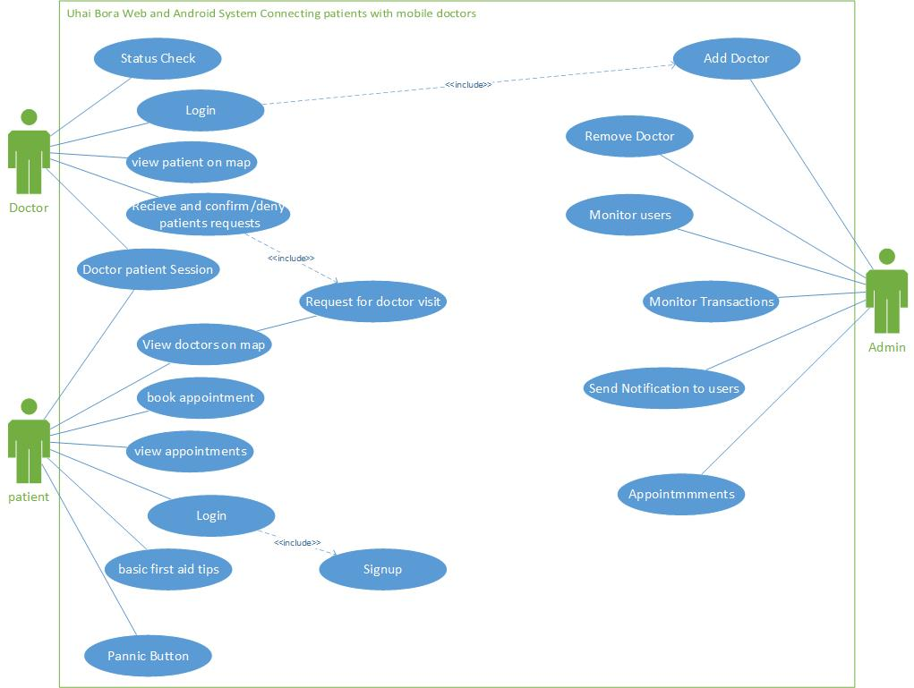

Figure 5 Use case diagram

Use case model/diagram consists of actors and use cases. An actor is an external entity that interacts with the system. In the ***figure 5*** above Doctor, patient, and Admin are actors.

Use case on the other hand is a list of actions or event steps typically defining the interactions between a role and a system to achieve a goal. On the ***figure 5*** above examples of use cases are status check, login etc.

As in the ***figure 5*** above the actor represent a role that a user can play, in this case doctor (actor) interacts with the system by initiating a login (use case).

4.2.2.2 Activity Diagram

Activity diagram is a flowchart to represent the flow from one activity to another activity. The activity can be described as an operation of the system. The control flow is drawn from one operation to another.

The control flow is drawn from one operation to another. This flow can be sequential, branched, or concurrent. Activity diagrams deal with all type of flow control by using different elements such as fork, join, etc

For example, in the ***figure 6*** below is a representation of how activities flow from one state to another. In the ***figure 6*** the user starts by clicking on the activity of viewing doctors on the map. If the operation is successful then user flows to the next activity which is open map and display location of available doctors. At this point all operations are successful and the user can continue with her/his operation in the next activity which is to select a doctor. If the operation at this activity is not successful then the user is taken back to the previous activity which is open map and display location of available doctors. Note that some activities in an activity flow diagram can only be operational if the previous activities are successful. If the initial activity is a fail then the whole flow is a fail meaning the user cannot proceed with any operation. But if all operations at every activity are successful then the user is able to carry on all operations in the activity flow diagram to completion.

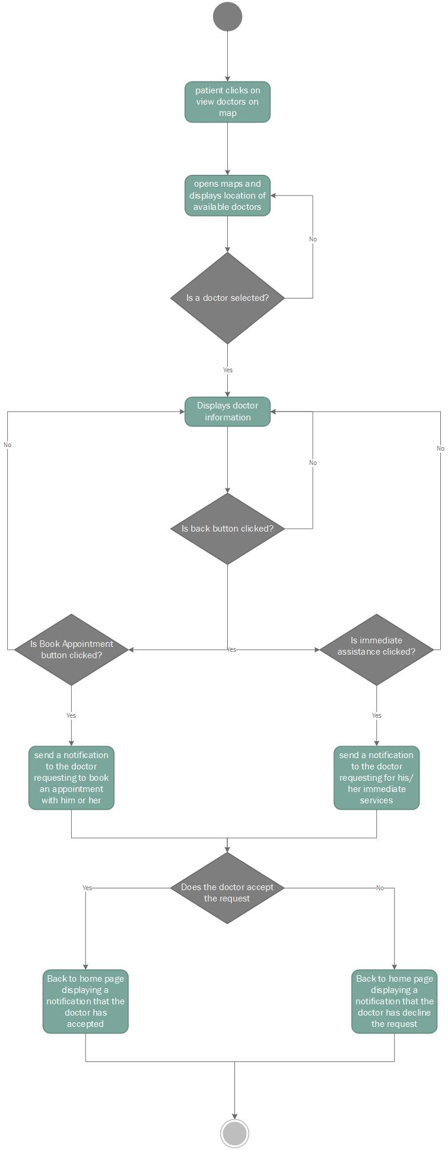

Figure 6 activity diagram

4.2.2.3 Sequence Diagram

A sequence diagram shows object interactions arranged in time sequence. It depicts the objects and classes involved in the scenario and the sequence of messages exchanged between the objects needed to carry out the functionality of the scenario.

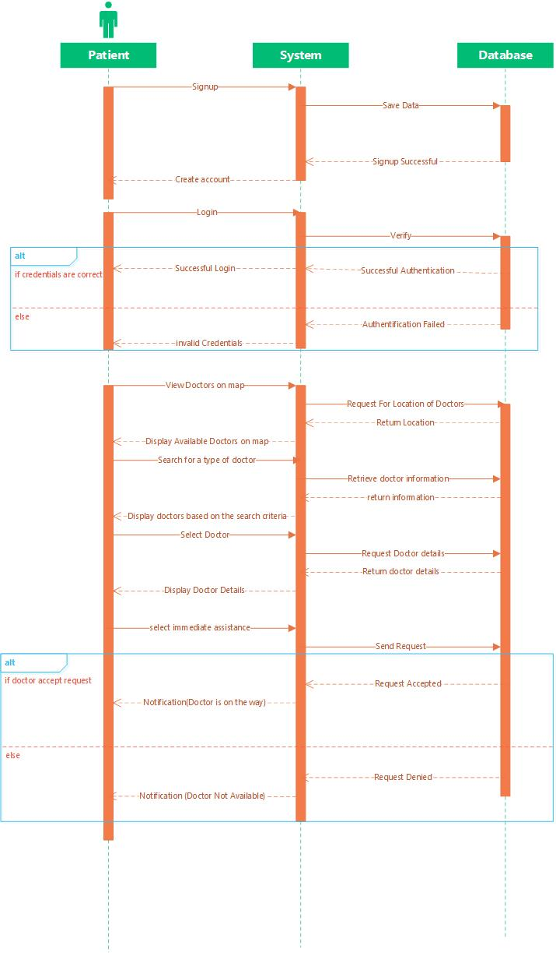

Figure 7 Sequence Diagram

Sequence diagrams describe how and in what order the objects in a system function. In the ***figure 7***is an example of a sequence diagram. A sequence diagram consists of some notation i.e Actor, Message, lifelines etc.

In the example of the ***figure 7***consists of the following actor who is the patient who depict various roles including human users and other external subjects. For example – here the user in the health care system is shown as an actor where it exists outside the system and is not a part of the system. Another notation is the lifelines. Lifeline is a named element which depicts an individual participant in a sequence diagram. So basically each instance in a sequence diagram is represented by a lifeline. Lifeline is displayed in a rectangle called head with its name and type. But if lifeline is modeled in unnamed instance, then the same pattern is followed except now the portion of lifeline’s name is left blank. Example in the ***figure 7*** lifelines are represented with dark red vertical rectangle. Difference between a lifeline and an actor is a lifeline always portrays an object internal to the system whereas actors are used to depict objects external to the system

The other notation of a sequence is the message which is the communication between objects. Example in ***figure 7***is message ***create account*** which is between object Patient and object System. The messages appear in a sequential order on the lifeline between objects.

4.2.2.4 Class Diagram

Class diagram is a type of static structure diagram that describes the structure of a system by showing the system's classes, their attributes, operations (or methods), and the relationships among objects. They are widely used to describe the types of objects in a system and their relationship. They are also composed of three things: a name, attributes and operations.

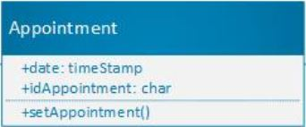

Operations

Attributes

Class Name

Figure 8 Name, attributes and operations of a class diagram

Class Diagrams also display relationship such as inheritance. In the ***figure 8*** below inheritance is shown from the parent class Geolocation to the other node classes (patient, Doctor). Class diagram are used in nearly all object oriented software designs. In our case the system methodology is the object oriented system analysis and design (OOSAD) which is an object oriented software design.

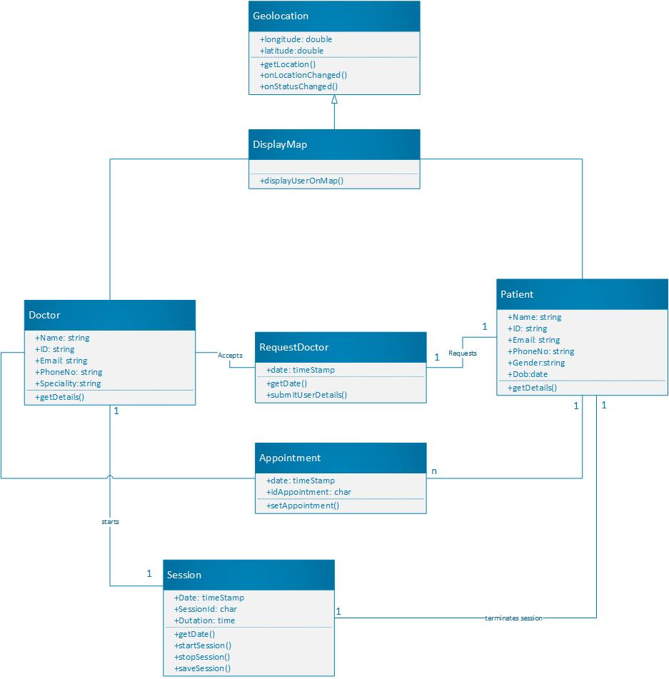

Figure 9 Class diagram

4.2.2.5 Entity-Relationship Diagram

An entity relationship diagram (ERD), also known as an entity relationship model, is a graphical representation of an information system that depicts the relationships among people, objects, places, concepts or events within that system. An ERD is a representational model of data used to represent the entity framework infrastructure. In the ***figure 10***represents how entities (admin, patients, doctors) relate with the other entities. The relationship is the connectivity between the entities in which relationship show the action (sends) of one entity (admin) to the other entity (notices). Entities have attributes. For example entity (patient) has attributes (age, gender, name etc).

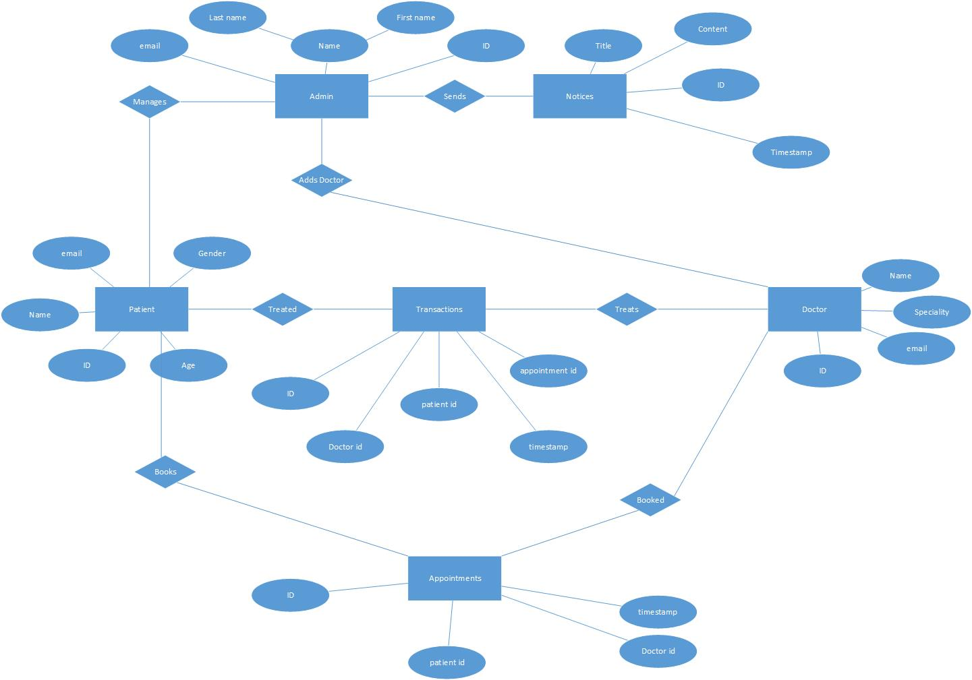

Figure 10 Entity relationship diagram

### 4.2.3 Physical Design

The physical design is a kind of system design. It is a graphical illustration of the system, representing external and internal entities of the system with to and fro data flow. An external entity is an entity exterior to the system and internal entity is an entity inside the system where both can convert the data.

In fact, the physical design is related to the concrete input and output of the system. This deals with how the input data is provided, how the input is processed, and how the output is displayed. In other words, the physical design can be generally classified into the following designs

1. User–Interface designs.
2. Data designs.
3. Process designs. etc

#### 4.2.3.1 User Interface designs

This step concerns about how the user adds information to the system and also how the system gives the information back to the user. For this project user interface is implemented and each interface has different functionality from the other. In this system they include;

##### 4.2.3.1.1 Doctor’s Module

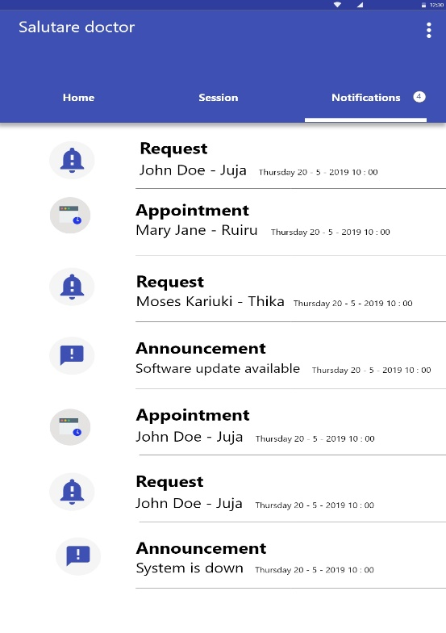

The notification interface has this types of notifications; ***Request, Appointment*** and***Announcement***. ***Request*** means the doctor has to meet with the client the same date the notification the doctor receives. ***Appointment*** on the other hand means the doctor will meet the client on future agreed dates. Finally, ***Announcement*** means message from the client.

Figure 11 The Notification interface

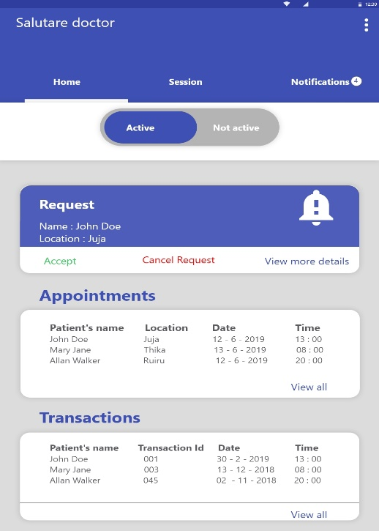

The home page of the doctor’s android application and it consists of main Tabs (***Home***, ***Session and Notifications***) for enabling easy navigation and access of services in the application. The interface has also a switch that shows the status of the doctor, Active button (the doctor is available and can receive patient requests) and Not Active button (the doctor is busy and cannot receive client request).

Figure 12 Doctor Home Page interface

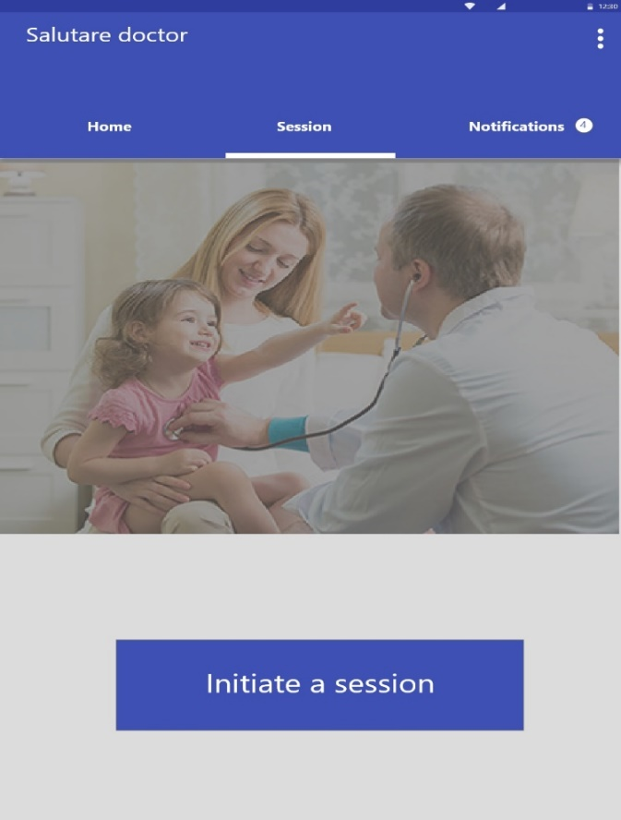

A doctor will be initiating a session by clicking the ***initiate a session*** button when he/she meets the client. Initiate session interface is included because the Organisation wishes to keep track of the time a doctor spends with his/her client. It’s also included to help doctors check time they spend with the patient and from there he/she can estimate charges (fee). Note once a doctor has met his/her client, then his account becomes inactive meaning he/she can longer receive other clients’ request. When he/she terminates the session then his account automatically becomes active meaning he/she can receive client requests (Booking Appointment).

Figure 13 Doctor Session initiation interface

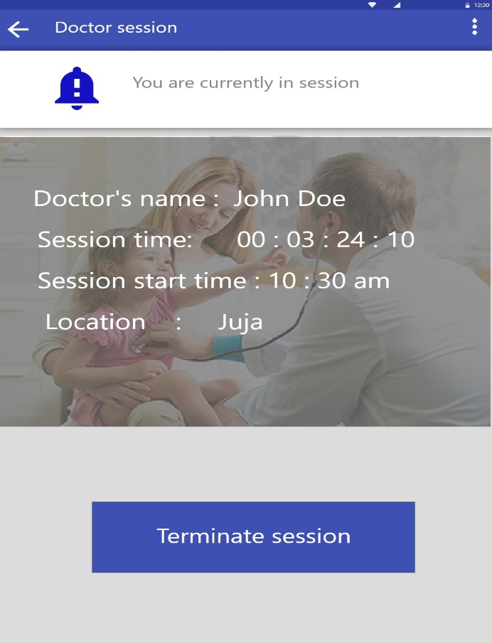

After a doctor have had a successful time with his/her client, the session is recorded. The interface in ***figure 14*** shows the record of session a doctor had with his/her client. The session is recorded for future use e.g. in case the client complains of overcharging then the record can be retrieved as an evidence. The information (***Doctor’s name, Session time, session start time, location***) is displayed when the doctor clicks the ***Terminate session*** button. The data can also be viewed at admin web app.

Figure 14 Doctor Session Termination interface

##### 4.2.3.1.1 Admin web Module

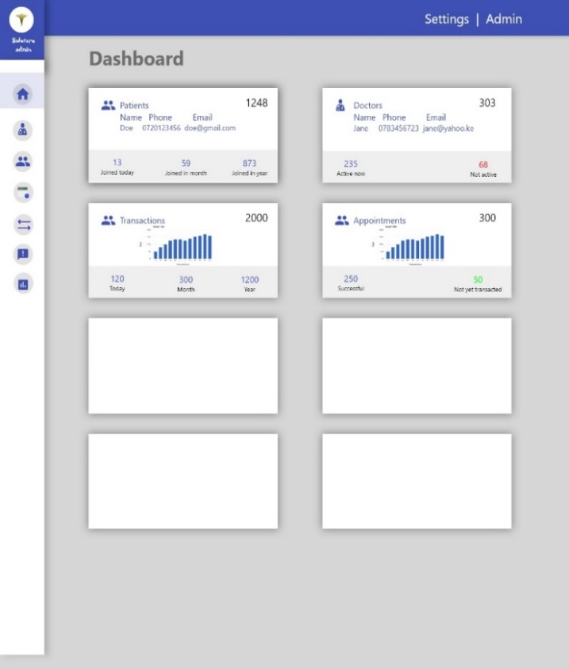

The Dashboard of the Admin Web app. Consists of a navigation bar (Left vertical bar) with tabs which help the admin to easily switch between web pages. The main tabs are the following ***Home tab, View Doctors tab, View Users tab, View Analytics tab, view transactions tab and update software tabs.*** Each tab opens a new page, the new page also consists of sub tabs which perform the required operation. For example in the ***View Doctors page***, there is a number of tabs which are, to **view more** (to view more details about the doctor), ***Delete*** etc, Note the tabs are represented by icons.

Figure 15 The Dashboard interface of the Admin Web Application

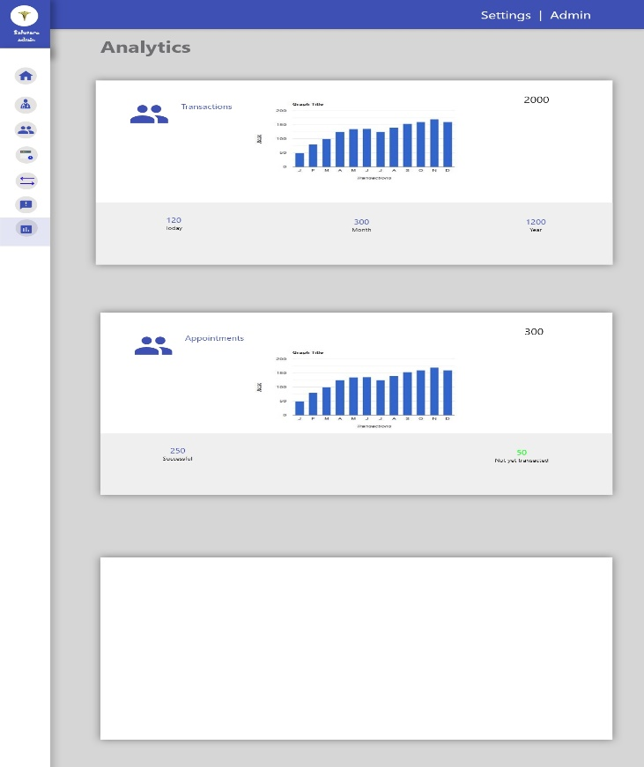

***Figure 16*** shows the analytics of all transactions that will be taking place within a period. For Example the admin will be able to report that in a certain duration the Organisation was able to receive this number of clients. The durations are recorded in the format of day, month and year. The interface have two graphs, the top graph shows all successful transaction have had, the second graph shows the number of appointments clients have booked with the Organisation.

Figure 16 Admin Analysis interface

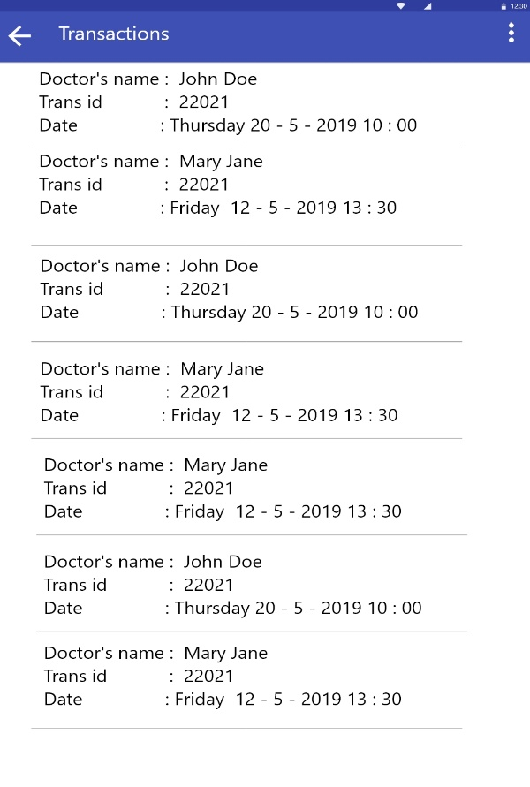

***Figure 17*** shows the interface of the history of all transactions the system has recorded. For example the figure shows details of the doctors who have been booked and have had successful transaction with the client. The Information displayed should been in the format; ***Doctor’s Name***, ***Trans id*** and ***Date*** the transaction successfully transacted. The interface is also on other modules (***Doctor*** and ***Patient Modules***). We have included here to show how the admin can go on process of checking the analytics and comparing them with the transactions.

Figure 17 Transaction history interface

##### 4.2.3.1.1 Patient Module

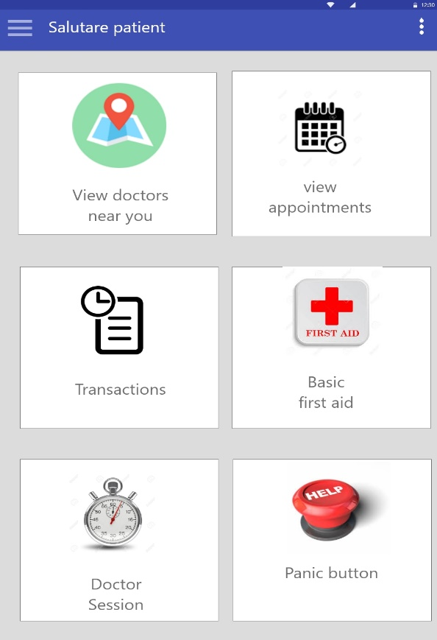

The Patient dashboard. Consists of the following functionalities;

1. ***View doctors near you***, meaning the patient is able to see doctors of the organisation by clicking the button.
2. ***View appointments*** is included to help patient check their appointment (may serve as a reminder).
3. ***Transactions*** help patient check their transaction whenever they happen.
4. ***Basic First aid*** helps patient check first aid instruction. Its an added feature for easy referencing (patient don’t need to switch to other apps).
5. ***Doctor session*** contain the QR code for doctors to scan when starting session with the patient.
6. ***Panic button***is an emergency notification.

Figure 18 Patient module dashboard interface

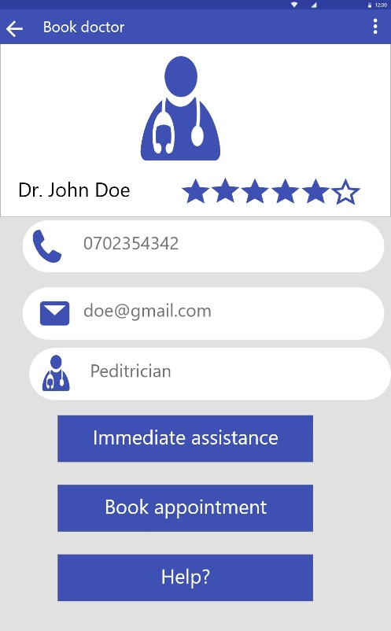

***Figure 19*** shows the booking process interface of the system. For example the figure is showing information about Dr. John Doe who the user has to choose based on the options below which are either book for ***immediate assistance*** or ***book appointment***. The user can also check for the online help/manual by clicking on the ***Help?*** Button.

Figure 19 Patient booking process interface

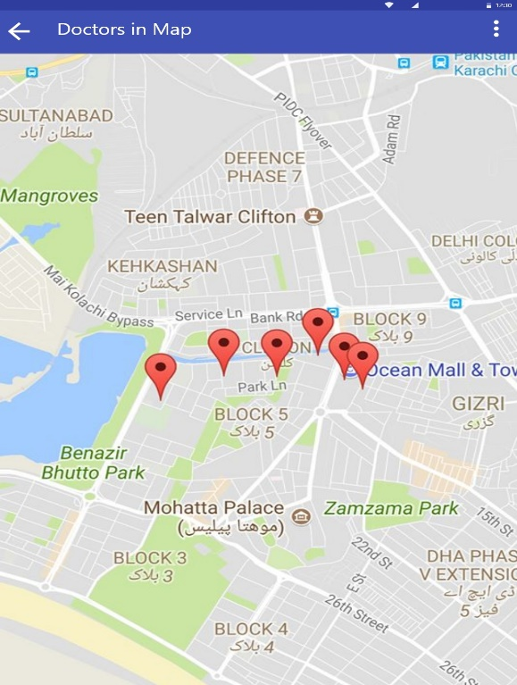

The ***red icons*** shows available doctors in the system. By clicking on any ***red icons*** the user is able to see more details of a doctor. The details are displayed in the following format: ***Doctor’s Nam***e, ***address*** and ***Profession.*** The module help patient check doctor depending on the type of booking they are making, incase it’s for immediate assistance they check doctors who are near them.

Figure 20 checking Doctors in the map Interface

### 4.2.3 Architectural Design

IEEE defines ***architectural design*** as “the process of defining a collection of hardware and***software*** components and their interfaces to establish the framework for the development of a computer system.” The architectural design composes of various taxonomies which include;

***Data centered architectures*, *Data flow architectures, Call and Return architectures, Object Oriented architecture*** and **Layered *architecture.***

Our system is implemented using the data centered architecture. With this architecture data store will reside at the center of this architecture and is accessed frequently by the other components that update, add, delete or modify the data present within the store.

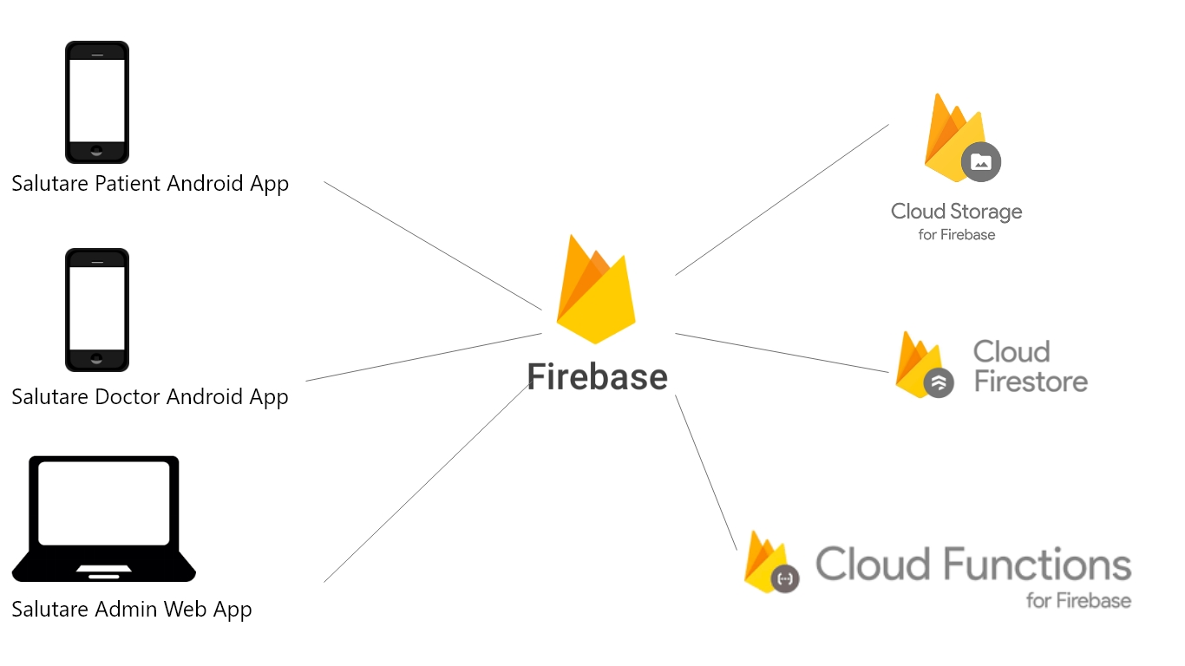

Figure 21 Uhai Bora Salutary Architectural design

The ***figure 21*** illustrates a typical data centered style. The client software access a central repository. The central repository is firebase real-time database. The Firebase Real-time Database is a cloud-hosted NoSQL database that lets you store and sync between your users in real-time. Real-time syncing makes it easy for your users to access their data from any device, be it web or mobile. In our case the system is made up of three applications; two android application (Doctor and Patient Modules) and a web app (Admin Module). Each module can access the same data as the other module. The data appears as JSON files and allows real time changes to occur on the connected client side. When you build cross-platform apps using Android, JavaScript SDKs, your clients end up getting all the data that was updated. The Cloud Firestore data model supports flexible, hierarchical data structures. Stores your data in documents, organized into collections. Cloud Firestore caches data that your app is actively using, so the app can write, read, listen to, and query data even if the device is offline. Firebase Cloud Functions in particular are like Lego blocks that you can connect to any Firebase service. For example, a function can be triggered when an image is uploaded to Firebase Storage to create a thumbnail, or maybe clean some user data when a node is deleted in the Real-time Database. Cloud Functions for Firebase let you automatically run backend code in response to events triggered by Firebase features and HTTPS requests. Your code is stored in Google's cloud and runs in a managed environment. There's no need to manage and scale your own servers. After you write and deploy a function, Google's servers begin to manage the function immediately. You can fire the function directly with an HTTP request, or, in the case of background functions, Google's servers will listen for events and run the function when it is triggered.

As the load increases or decreases, Google responds by rapidly scaling the number of virtual server instances needed to run your function. Each function runs in isolation, in its own environment with its own configuration. In addition to listening for events with a background function, you can call functions directly with an HTTP request or a call from the client.

## 4.4 Summary

Data-centric designer first defines an information model that captures the essential state and events in the system, then creates data input and output specifications, and then develops components that can produce and process that information. Rather than deriving specific data-interface requirements between components, the designer determines how to represent the state of the system and the external or internal events that can affect it. This “data model” captures the essential elements of the physical system as well as the processing logic. The model decouples applications; data can be provided by any (authorized) process and used by any other process. Applications must specify when and how they can supply information, but they do not need to know when or where that data might be used.

The user interface is the means by which the user and a computer system interact, in particular the use of input devices and software. UI is made up of some principles. The principles of user interface design are intended to improve the quality of user interface design. According to Larry Constantine and Lucy Lockwood in their usage-centered design, these principles are: structure principle, the simplicity principle, the visibility principle, the feedback principle, the tolerance principle, the reuse principle.

Analysis is a detailed examination of the elements or structure of something. Analysis is done through some process which involves critical reading of the object to be analyzed. Some tips include: Identify the author's thesis and purpose, analyze the structure of the passage by identifying all main ideas, Consult a dictionary or encyclopedia to understand material that is unfamiliar to you, make an outline of the work or write a description of it and write a summary of the work.

# CHARPTER FIVE: CODING AND IMPLEMENTATION

## 5.1 Introduction

Coding is basically the computer language used to develop apps, websites and software.

Implementation is a realization of a technical specification or algorithm as a program, software component, or other computer system through computer programming and deployment. Many implementations may exist for a given specification or standard.

Salutary Uhai Bora has been coded and implemented in three modules: Two android apps and one web app. For the three modules to work effectively then each module has to run on its own hardware. The three modules access a real-time central database. The modules have been implemented in such way that each can add or delete data in or from the central real time database.

This section elaborates on how the system is set to achieve the set objectives.

## 5.2 System Implementation

Implementation is the carrying out, execution, or practice of a plan, a method, or any design, idea, model, specification, standard or policy for doing something. For an implementation process to be successful, many tasks between different departments need to be accomplished in sequence.

Some of the tasks carried out to ensure that the system was successfully completed are as follows;

### 5.2.1 Admin web module

#### 5.2.1.1 Icons and Information windows

An **icon** is a small picture or image used to represent some aspect of the system. “Using icons on your website reinforces text, giving readers a preview of what is to come before they read it, and act as an easy reminder afterward.” (Klug, 2017). Incorporating icons into a website can make content more easily understandable and memorable. Colorful and modern icons are fun and also when implemented in a website they make it look attractive.

Information (info) windows or Tooltips identify an element when they are activated. They may contain brief helper text about its function. For example, they may contain text information about actionable icons.

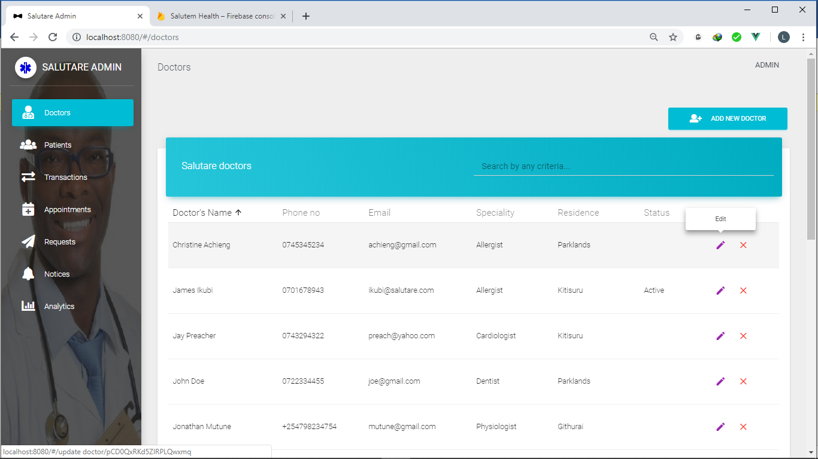

The diagram above contains two icons, the icons represent edit and delete buttons. The icons are reinforced with an info window. As in the diagram, a pen icon has an information window with the text “edit”. The other an X icon represents delete.

#### 5.2.1.2 Tables

A table is a data structure that organizes information into rows and columns. It can be used to both store and display data in a structured format. Databases store data in tables so that information can be quickly accessed from specific rows. Websites use tables to display multiple rows of data on page while Spreadsheets combine both purposes of a table by storing and displaying data in a structured format.

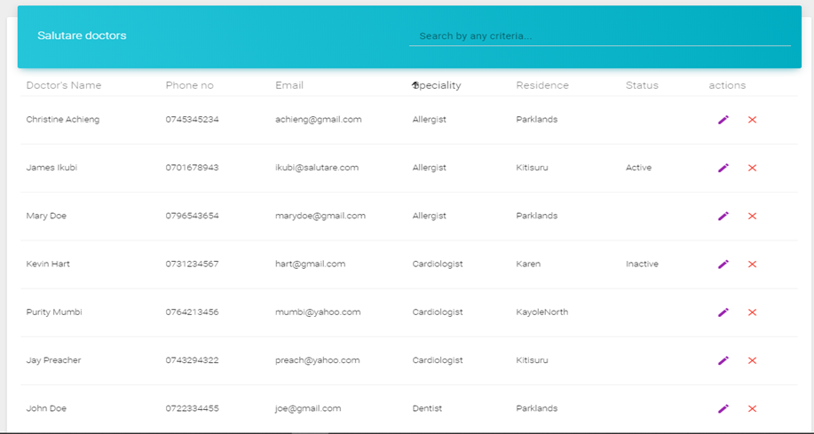

Figure 22 Doctor’s table on admin web module

We have used tables to display large amount of data since they present it in an easy-to-read format. The table also enables us to include action buttons for each row. In the diagram above an edit button and a delete button are included. The buttons enable the administrator to perform various actions on a user, search as delete or update their details.

Dialog boxes are also used for confirmation. A dialog box is a graphical control element in the form of a small window that communicates information to the user and prompts them for a response.

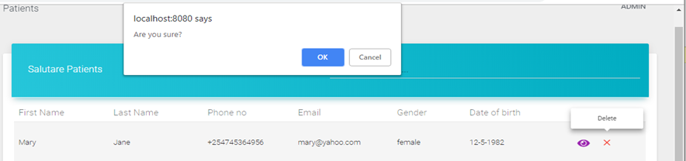

Figure 23 Dialog box on the admin web module.

In the ***figure 23***, a dialog box prompts user to confirm if they want to proceed on deleting. If the user click “***ok***” the item is deleted and if the user presses “***cancel***” the event is aborted.

##### 5.2.1.3.1 Sorting and Searching

The tables also enable ***searching*** and ***sorting****.* ***Searching*** simply means to look for a particular value from a set of values.

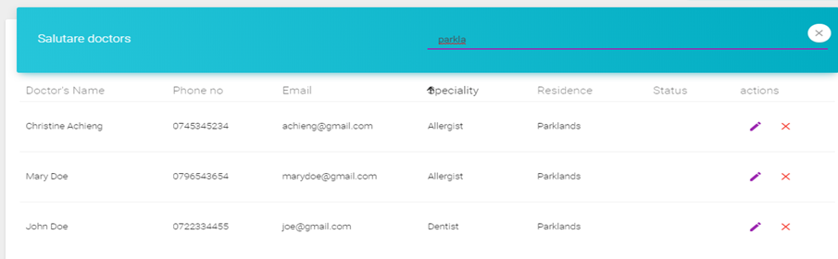

Figure 24 The searching algorithm on the admin web module

The ***figure 24*** shows a table that allow searching by any criteria. Example doctors with Parklands as their residence are displayed.

***Sorting*** simply means rearranging a set of values in ascending or descending order.

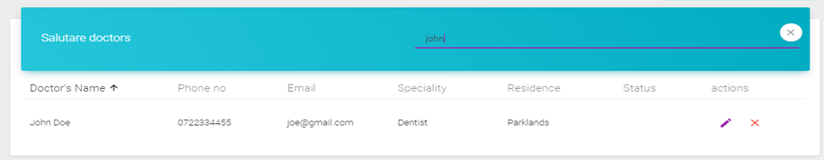

Figure 25 the sorting algorithm on the admin web module

The ***figure 25*** shows the doctor sorted with the name John. The table can be sorted using any of the table headers. This is done by clicking on the header i.e. doctor’s name, phone no email etc. When clicked, sorting is toggled in ascending or descending order. The ***Figure 26*** shows the table which is sorted in ascending order of specialty, i.e. Allergist first the Cardiologist.

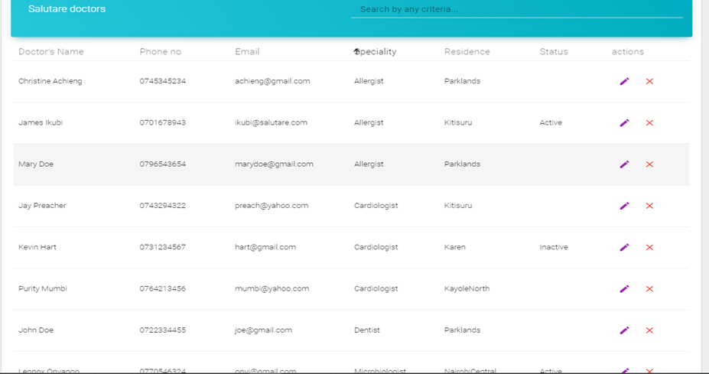

Figure 26 sorting by the specialty of allergist, cardiologist, Dentist

**Sample Table HTML code**

This is code that shows the HTML for displaying a table. On the diagram below is a table showing doctors Data as fetched from database. It also contains the buttons to edit or delete an item from database.

<md-table

v-model="doctors"

:table-header-color="tableHeaderColor"

md-sort="docName"

md-sort-order="asc"

>

<md-table-empty-state

md-label="No doctors found "

:md-description="`Kindly wait or try a different search term if searching.`"

></md-table-empty-state>

<md-table-row slot="md-table-row" slot-scope="{ item }">

<md-table-cell

md-label="Doctor's Name"

md-sort-by="docName"

>{{ item.docName }}</md-table-cell>

<md-table-cell md-label="Phone no" md-sort-by="phone">{{ item.phone }}</md-table-cell>

<md-table-cell md-label="Email" md-sort-by="email">{{ item.email }}</md-table-cell>

<md-table-cell md-label="Speciality" md-sort-by="speciality">{{ item.speciality }}</md-table-cell>

<md-table-cell md-label="Residence" md-sort-by="residence">{{ item.residence }}</md-table-cell>

<md-table-cell md-label="Status" md-sort-by="status">{{ item.activityStatus }}</md-table-cell>

<md-table-cell md-label="actions">

<md-button

class="md-just-icon md-simple md-primary"

tag="router-link"

v-bind:to="{ name: 'UpdateDoctor', params: { doctor_id: item.id }}"

>

<md-icon>edit</md-icon>

<md-tooltip md-direction="top">Edit</md-tooltip>

</md-button>

<md-button

class="md-just-icon md-simple md-danger"

tag="router-link"

@click="deleteDoctor(item)"

>

<md-icon>close</md-icon>

<md-tooltip md-direction="top">Delete</md-tooltip>

</md-button>

</md-table-cell>

</md-table-row>

</md-table>

**Fetch data from doctor**

Node Js code to fetch data from a database. In the diagram below, we fetch each doctor document which contains fields such as first-name from a collection called “*doctors”*. A collection is like a table in SQL.

async fetchDoctorsData() {

db.collection("doctors")

.orderBy("firstName")

.get()

.then(querySnapshot => {

this.loading = true;

querySnapshot.forEach(doc => {

var docName = doc.data().firstName + " " + doc.data().lastName;

var docCordinates = doc.data().latestLocation;

var activity = doc.data().latestActivity;

var activityStatus = "";

var activityColor = "";

if (activity === 0) {

activityStatus = "Inactive";

activityColor = "#EE4F4C";

} else if (activity === 1) {

activityStatus = "Active";

activityColor = "#64BA68";

}

const docData = {

id: doc.id,

docName: docName,

phone: doc.data().phone,

email: doc.data().email,

activityStatus: activityStatus,

activityColor: activityColor,

residence: doc.data().residence,

speciality: doc.data().speciality,

docCordinates: docCordinates

};

this.doctors_array.push(docData);

//draw doctor's marker on map

this.generateMarker(docData);

});

});

}, //end get doctors

***Search from Table***

Node Js code to search from an array of objects. It helps to search from a table with different column names.

const searchByCriteria = (items, term) => {

if (term) {

return items.filter(

item =>

toLower(item.docName).includes(toLower(term)) ||

toLower(item.email).includes(toLower(term)) ||

toLower(item.speciality).includes(toLower(term)) ||

toLower(item.phone).includes(toLower(term)) ||

toLower(item.activityStatus).includes(toLower(term)) ||

toLower(item.residence).includes(toLower(term))

);

}

return items;

};

#### 5.2.1.4 Forms

A web form, also called an HTML form, is an online page that allows for user input. It is an interactive page that mimics a paper document or form, where users fill out particular fields. Typically, a web form contains a combination of form elements such as a input field, checkbox, submit button, text box and select.

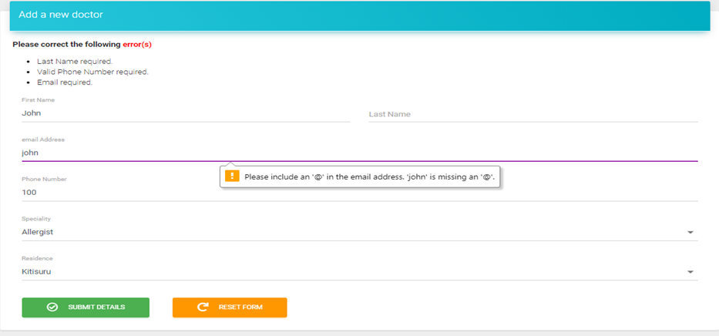

Figure 27 Example of a web form

In our forms we have input field for data entry and select to choose from a list of options. For example when selecting a specialty you can choose between Dentist, Cardiologist, Allergist, and Microbiologist just to mention a few.

We also have the reset button to enable user to clear the form. It wipes values from all fields by "resetting" the form to its default appearance.

Validation has also being implemented in the forms. Form validation helps us to ensure that users fill out forms in the correct format, making sure that submitted data will work successfully with our applications. Client-side validation is validation that occurs in the browser before the data has been submitted to the server. It’s user friendly because it gives an instant response.

In the ***figure 27***, errors of unfilled input fields are displayed as well as invalid phone number and email.

***Sample from HTML***

<form @submit.prevent="saveDoctor" class="col s12">

<p v-if="errors.length">

<b>Please correct the following <strong style="color:red">error(s)</strong></b>

<ul>

<li :key="index" v-for="(error,index) in errors" >{{ error }}</li>

</ul>

</p>

<div class="md-layout">

<div class="md-layout-item md-small-size-100 md-size-50">

<md-field>

<label>First Name</label>

<md-input v-model="firstName" type="text"></md-input>

</md-field>

</div>

<div class="md-layout-item md-small-size-100 md-size-50">

<md-field>

<label>Last Name</label>

<md-input v-model="lastName" type="text"></md-input>

</md-field>

</div>

***Save Details***

Node Js code to save details to the firebase database. This is in a collection called doctors by creating a document with all the details. This is after validation function is called.

saveDoctor: function () {

this.checkForm(); //first validate the form

db.collection("doctors")

.add({

firstName: this.firstName,

lastName: this.lastName,

residence: this.residence,

speciality: this.speciality,

phone: this.phone,

email: this.email,

doctorID:this.authID,

latestLocation: "",

latestActivity: "",

})

***Validate Details***

Check if all the data is filled in the inputs of the form and perform the appropriate validation, such as unfilled fills or wrong phone number format.

checkForm: function (e) {

if (this.firstName && this.lastName && this.phone && this.email && this.residence && this.speciality && this.authID) {

return true;

}

this.errors = [];

if (!this.firstName) {

this.errors.push('First Name required.');

}

if (!this.lastName) {

this.errors.push('Last Name required.');

}

if (!this.phone) {

this.errors.push('Phone Number required.');

} else if (!this.validPhone(this.phone)) {

this.errors.push('Valid Phone Number required.');

}

if (!this.email) {

this.errors.push('Email required.');

}

if (!this.residence) {

this.errors.push('Residence required.');

}

if (!this.speciality) {

this.errors.push('Speciality required.');

}

if (!this.authID) {

this.errors.push('Authentication ID required.');

}

e.preventDefault();

}, //end check form

***Validate Phone Number***

Validate with Kenyan standard of either 0 then 9 digits or +254 the 9 digits.

validPhone: function (phone) {

var re = /^(\+254|0)[1-9]\d{8}$/;

return re.test(phone);

},//end validate phone

#### 5.2.1.5 Maps

A map is a diagrammatic representation of an area of land or sea showing physical features, cities and roads.

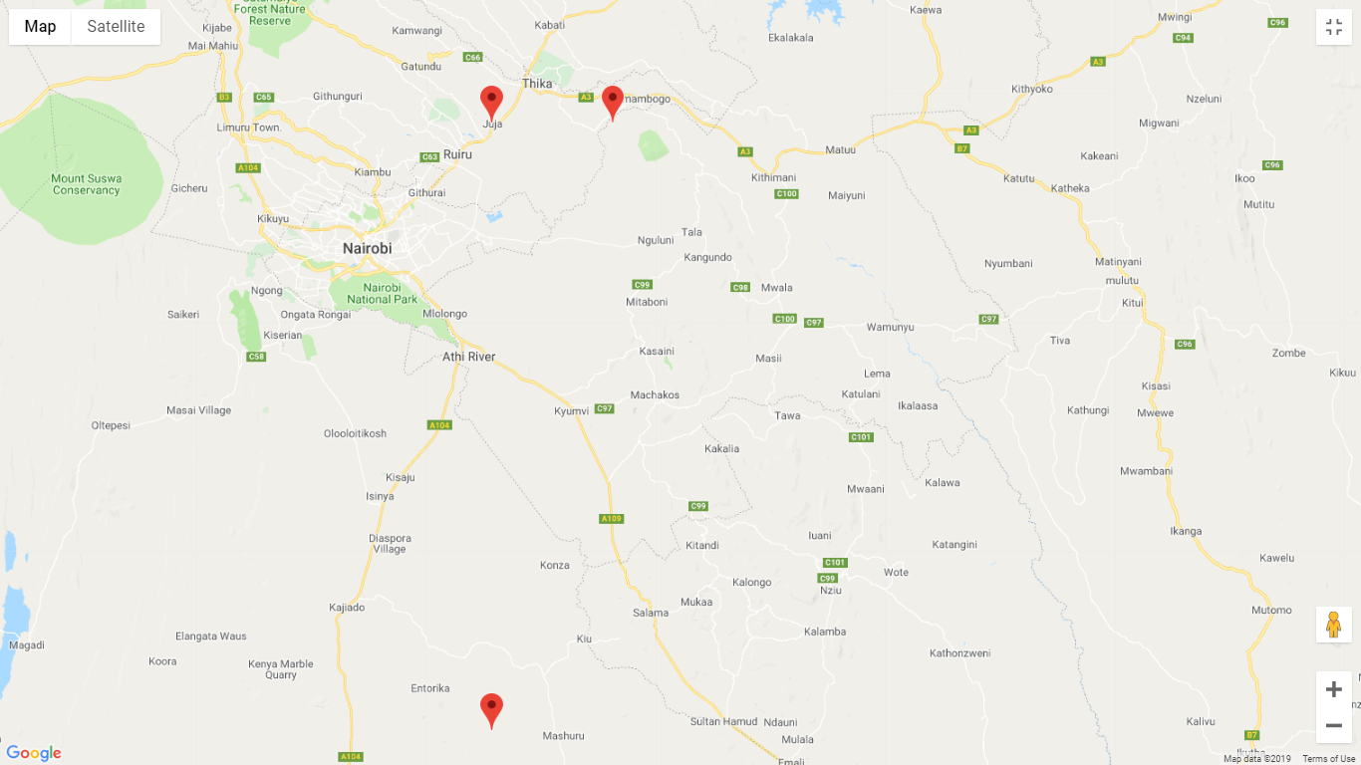

Figure 28 Salutary Map showing available doctors in the Organisation

A map is important because it is used to predict and figure out where things are located. A map is also necessary in order to establish a path, either for traveling somewhere (geographically) or for following something through a region. This is why we implemented maps in our administrator management system. The map enables us to see where our doctors and patients are located at the current time.

The map contains markers to represent the position of the doctor or patient. The marker is displayed as a red icon with a black dot. The marker when clicked, displays an information window that contains more details about the user.

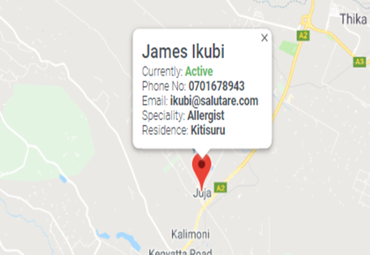 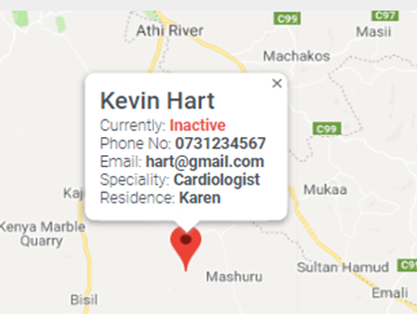

Figure 29 Details of doctors In the Organisation on the map

In the ***figure 29***, the info windows contain details of doctors. This include the name, status, phone number, email, specialty and the residence. The status in one of the pictures is indicated as “currently: active”. This is because it’s the current status of the doctor, meaning he or she is available and can receive patient’s requests. A green color is used to display an active status and red for inactive status.

***Generate Marker***

Generate a marker object with coordinates longitude and latitude, and populate an information window to display doctor details, such as phone number.

async generateMarker(docData) {

var latitude = docData.docCordinates._lat;

var longitude = docData.docCordinates._long;

var markerInfoWindow = "";

markerInfoWindow += " <md-card >";

markerInfoWindow += " <md-card-header>";

markerInfoWindow += " <md-card-header-text>";

markerInfoWindow +=

' <div class="md-title">' + docData.docName + "</div>";

markerInfoWindow +=

' <div class="md-subhead">Currently: <strong style="color:' +

docData.activityColor +

'">' +

docData.activityStatus +

"</strong></div>";

markerInfoWindow +=

' <div class="md-subhead">Phone No: <strong>' +

docData.phone +

"</strong></div>"

***Draw Map with markers***

Draw a map displaying all the markers generated

<gmap-map :center="center" :zoom="12" style="width:100%; height: 400px;">

<gmap-info-window

:options="infoOptions"

:position="infoWindowPos"

:opened="infoWinOpen"

@closeclick="infoWinOpen=false"

></gmap-info-window>

<gmap-marker

:key="index"

v-for="(m, index) in markers"

:position="m.position"

@click="toggleInfoWindow(m,i); center=m.position" >

</gmap-marker>

</gmap-map>

#### 5.2.1.6 Menus

A menu is a set of options presented to the user of a computer application to help the user find information or execute a program function. It may also consist of a collection or list of links.

Side bar static navigation is a type of modern navigation menu for websites. “This is one of the leading navigation menus where there are static scenes, virtual talks and interactive videos which are all spiced with the pragmatic features which are powered by these non-standard menus that catch eyes.” (Staff, 2019), he also goes on to say “Thus, using this many links can be seen in a bird’s view giving visual weight to numerous links at a time and which can be easily accessible. Thus, the users feel comfier with this menu as all the links are available at your fingertips.”

Side bar static navigation is applied in the development of the Salutare administrator dashboard. The menu is fixed to the left hand side of the display. The menu contains a list of links that redirect user to the pages represented, i.e. doctors page, patient’s page, analytics page etc. The text is reinforced using icons.

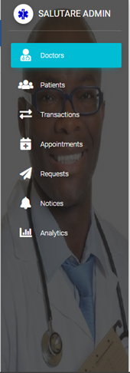

Figure 30 The Salutary menu window

#### 5.2.1.7 Graphics

A graph or chart is a diagrammatical illustration of a set of data. A line chart or line plot or line graph is a type of chart which displays information as a series of data points called 'markers' connected by straight line segments. A line chart is often used to visualize a trend in data over intervals of time – a time series – thus the line is often drawn chronologically.

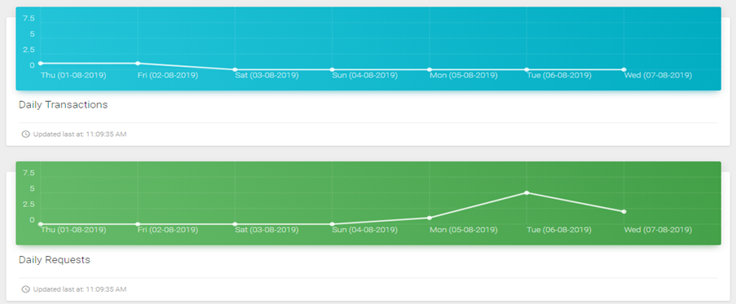

Figure 31 line chart of Salutare

Line charts are implemented in the system to help with data analysis. Graphs are used to show transactions, requests and appointments that doctors and patients have been making over a period of time.

The ***figure 31*** shows graphs of transactions and requests that have occurred in the past week. For example if today is Wednesday (07-08-2019), it displays the graph as from Thursday (01-08-2019).

***Populate Graph Data***

Declare variables to draw a graph, then assign values such as the graph color, graph X and Y values to the variables.

transactionsLoaderColor:"#15BBCF",

transactionsLoading:true,

showTransactionsLoader: true,

transactionsGraphComponentKey: 0,

transactions_array: [],

dailyTransactionsChart: {

data: {

labels: [],

series: []

},

options: {

lineSmooth: this.$Chartist.Interpolation.cardinal({

tension: 0

}),

low: 0,

high: 10, // the Y axis

chartPadding: {

top: 0,

right: 0,

bottom: 0,

left: 0

}

}

}, //End daily transactions chart Data

***HTML code for the graph***

Draw graph HTML, depending on the data assigned.

<div class="md-layout-item md-large-size-100 md-xsmall-size-100 md-size-100">

<chart-card

:chart-data="dailyTransactionsChart.data"

:chart-options="dailyTransactionsChart.options"

:chart-type="'Line'"

:key="transactionsGraphComponentKey"

data-background-color="blue"

>

<template slot="content">

<h4 class="title">Daily Transactions</h4>

</template>

<template slot="footer">

<div class="stats">

<md-icon>access_time</md-icon>Updated last at:

<span id="app">{{ last_refresh_time }}</span>

</div>

</template>

</chart-card>

</div>

</div> <!-- End transactions graph document -->

***Get number of events on a certain date***

To draw a graph, for each day, we need to get the number of events on that day. As in the diagram below we get the count on a date, and use the data to draw the graph accordingly.

async getCollectionCount(collectionName, dateToCount) {

var counter = 0;

await db

.collection(collectionName)

.where("date", "==", dateToCount)

.get()

.then(querySnapshot => {

querySnapshot.forEach(doc => {

/**

* Increment the count

*/

counter++;

});

}); //end appointment collection

return counter;

}, // end getCollectionCount on particular date

***Final Admin Module***

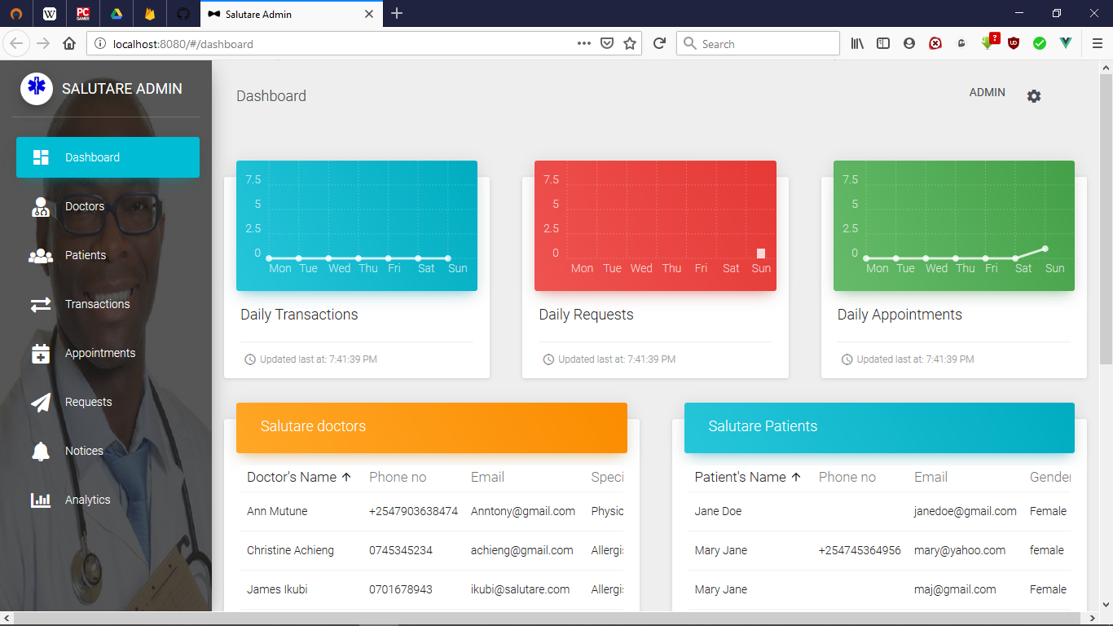

Figure 32 Admin Module dashboard

***Doctors Table***

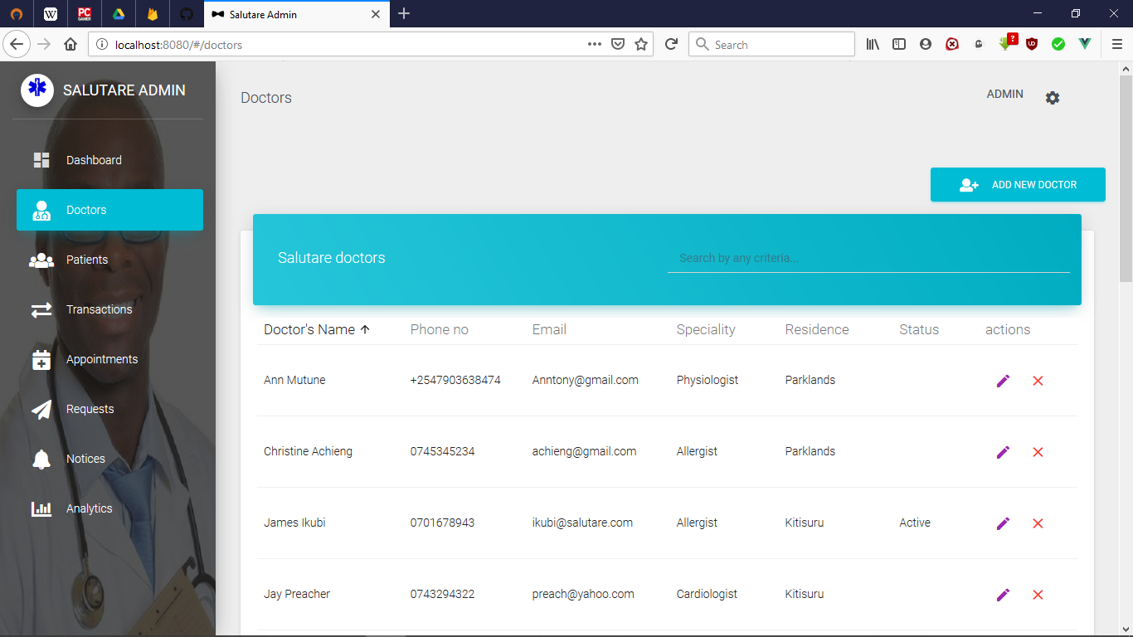

Figure 33 Doctors table interface

***Doctors Maps***

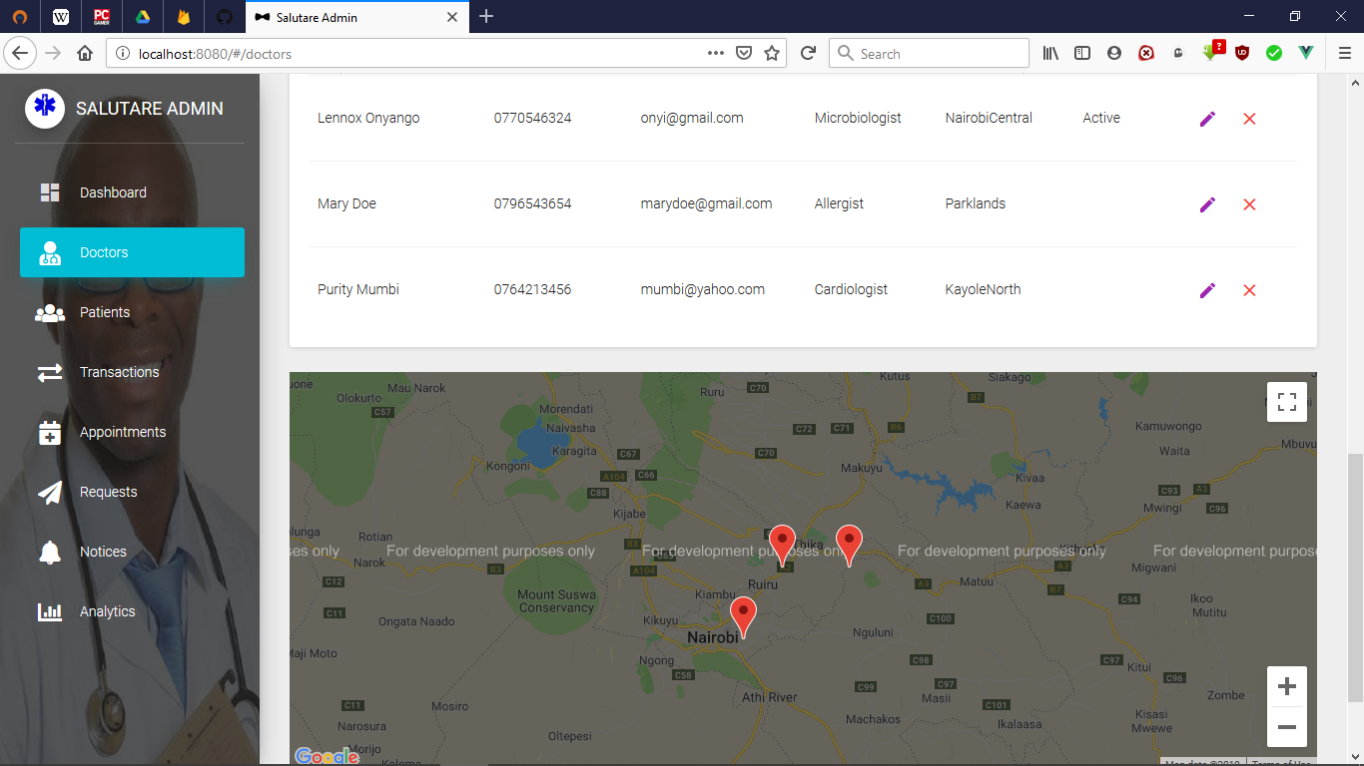

Figure 34 Doctors Map interface

***Fill doctors form***

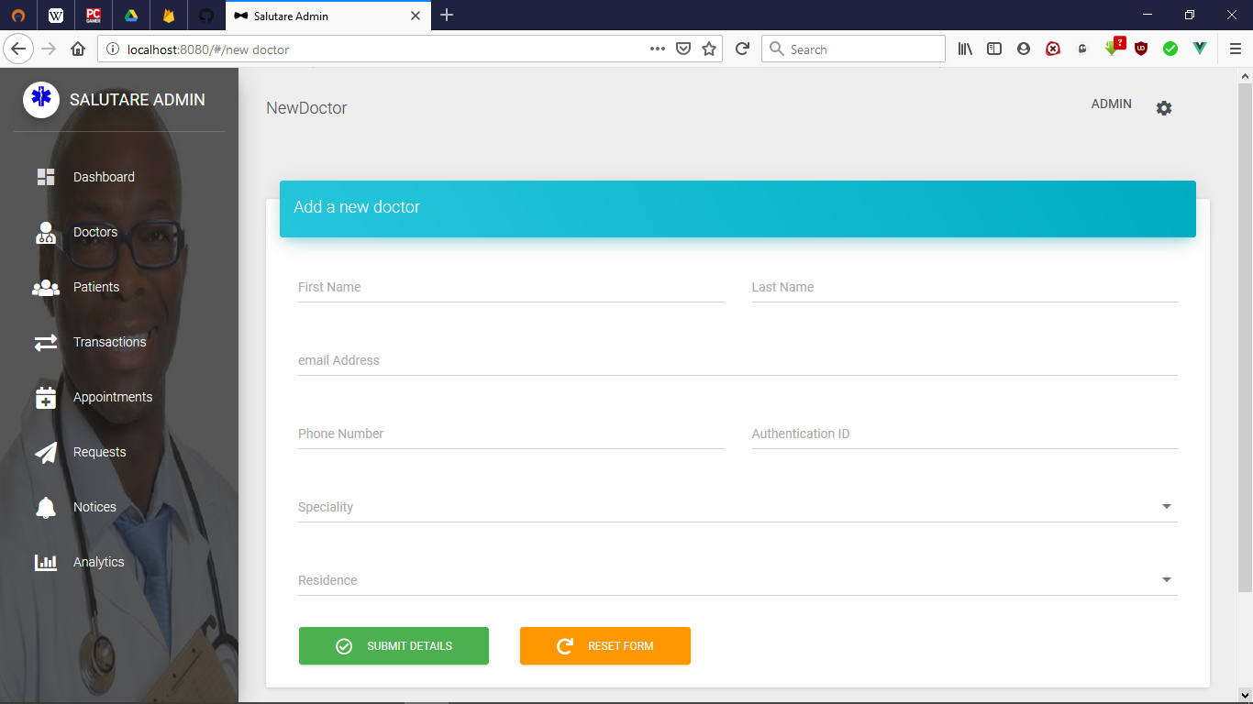

Figure 35 Doctors Form

***Analytics page with graphs***

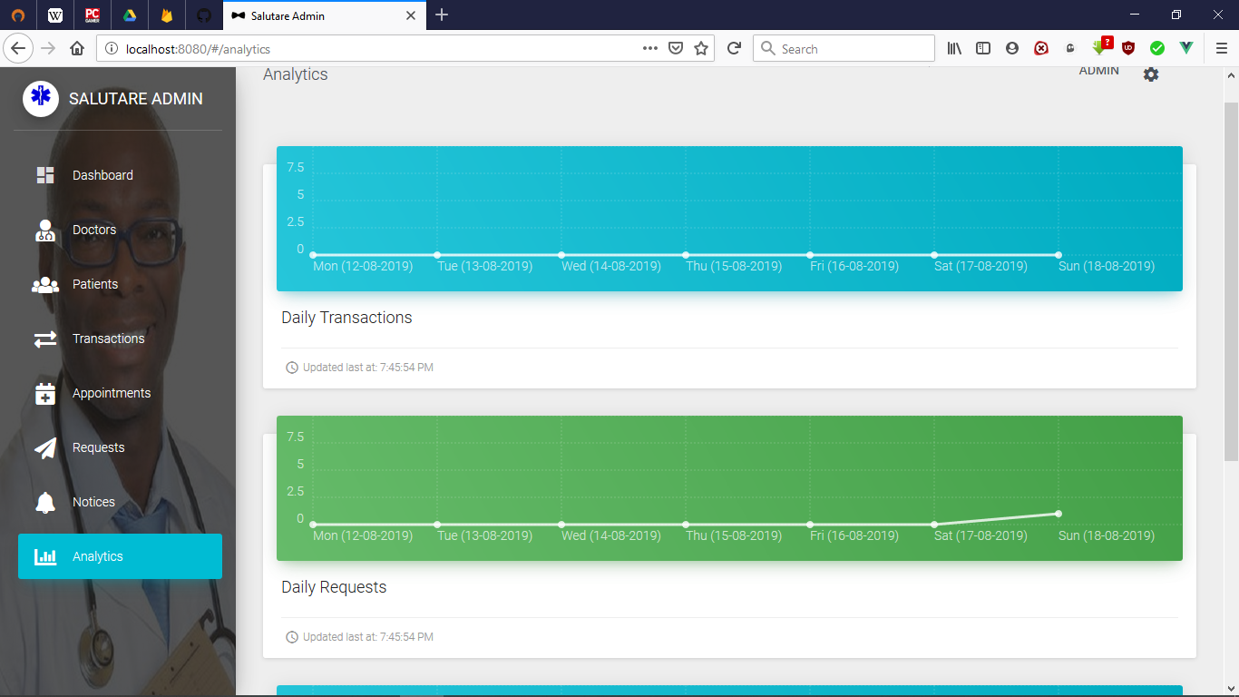

Figure 36 Analytics page with graphics

### 5.2.2 Android doctors’ module

#### 5.2.2.1 Menus

##### 5.2.2.1.1 Option Menu

The option menu is the primary Collection of menu items for an activity. It is normally where actions that have impact on the application are placed such as search, settings etc. Below is a screenshot that shows an option menu implement in this project.

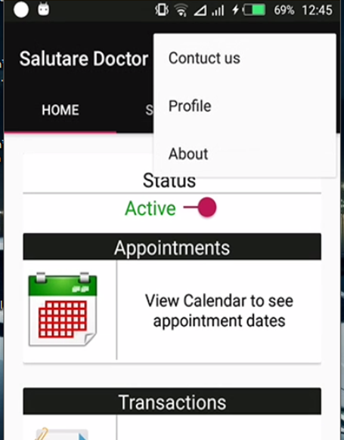

Figure 37 Option menu on doctors ‘module

#### 5.2.2.2 Switch

A Switch is a two-state toggle switch widget that can select between two options. It is used to display checked and unchecked state of a button providing slider control to user. Switch is a subclass of Compound Button. It is basically an off/on or 1/0 button which indicate the current state of Switch. ***Figure 38*** shows a switch when off indicates that the doctor is not active that is he/she is not ready to receive any patient request. When the doctor presses the switch button his or her status changes from not active to active which means he or she can start receiving requests from patients. At this stage he/she can update his/her location so that the patient can see on the map.

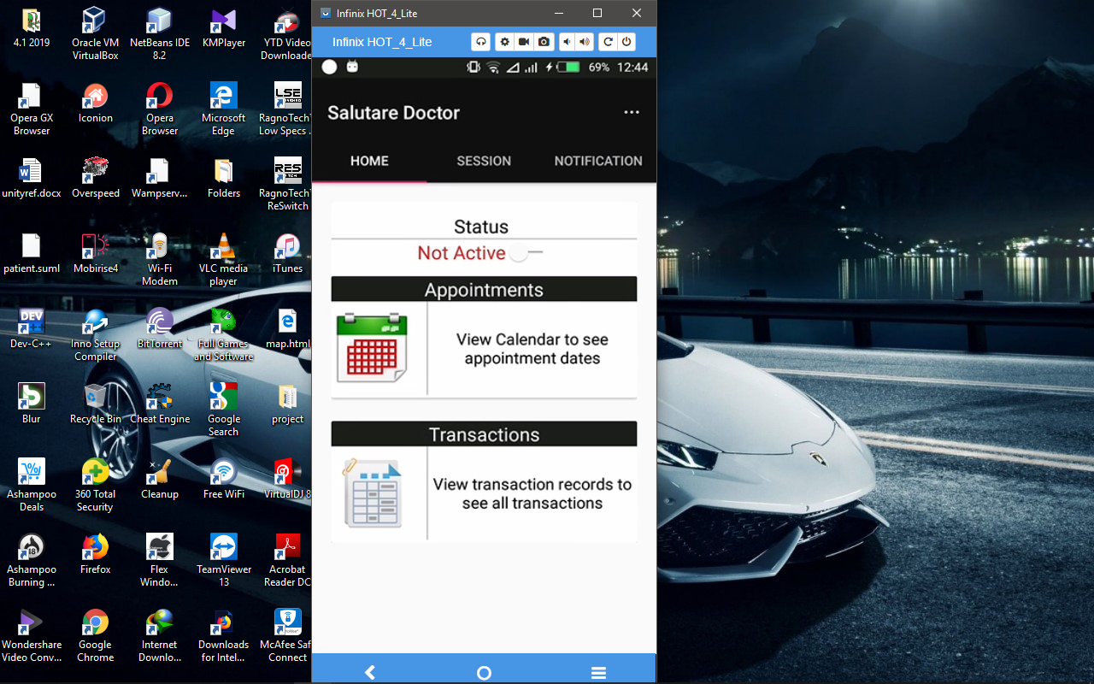

Figure 38 switch button for showing status of a doctor

#### 5.2.2.3 Button

A button is a type of android widget that performs a specified action when it is clicked. A standard android button is represented by the android class android.widget.Button.

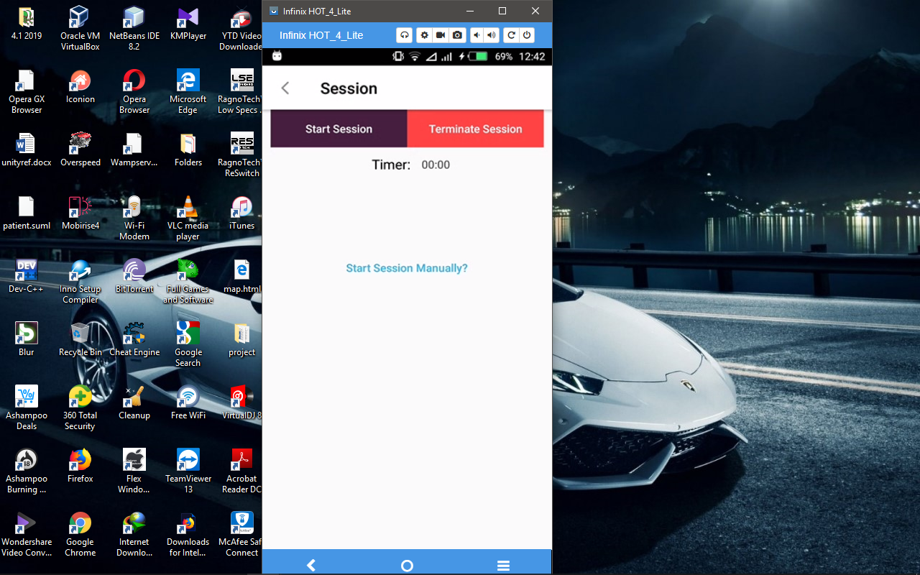

Figure 39 Start and terminate buttons which are used to monitor the session which a doctor and patient spend

#### 5.2.2.4 Text view

A text View is a type of android widget that displays texts in different fonts, sizes and color. The patient android application has been implemented with several text views to display data such as the name of the doctor, specialty, etc. The ***figure 40*** shows how text views have been used to display different types of information for a particular doctor.

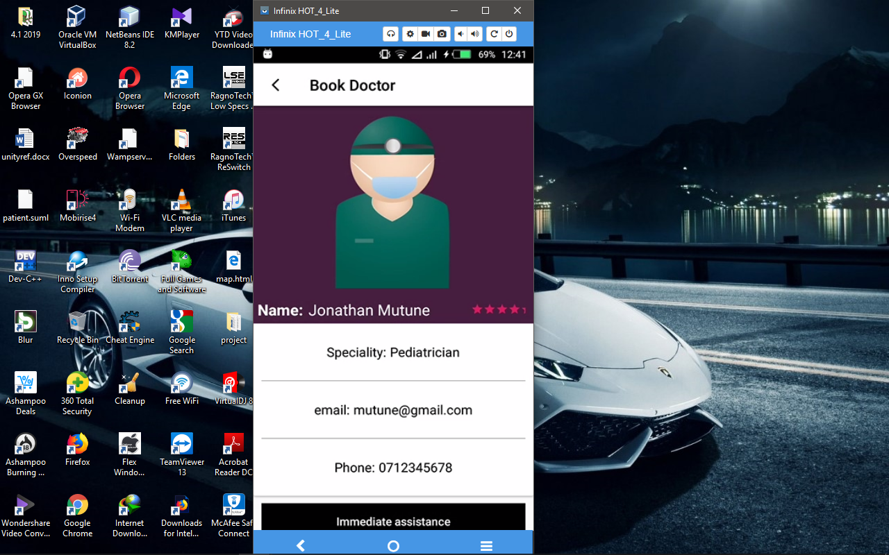

Figure 40 Text view of a doctor in salutary system

#### 5.2.2.5 Maps

A map is a diagrammatic representation of an area of land or sea showing physical features, cities, roads, etc. The doctor module has a map to enable the doctor to find location of patients who have booked them and also finding the best route in order to arrive to the patient. Below is a screenshot that show a doctor finding a route to a patient.

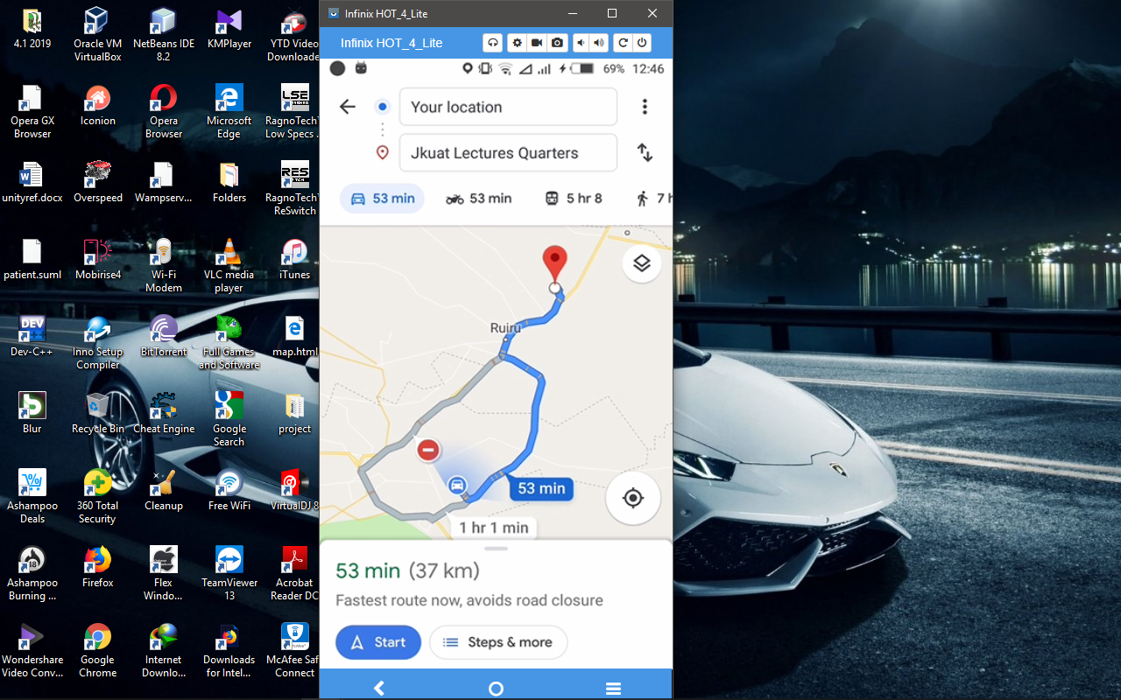

Figure 41 Map functionality on doctors’ module

#### 5.2.2.6 Toast Message

A toast is a notification message that pops up for a specific duration. It is normally triggered by an event. That is if something has gone wrong or right.

Java code snippet for displaying Toast Message in the ***Figure 42***.

Toast.makeText(getApplicationContext(),

"Accepted",

Toast.LENGTH_SHORT).show();

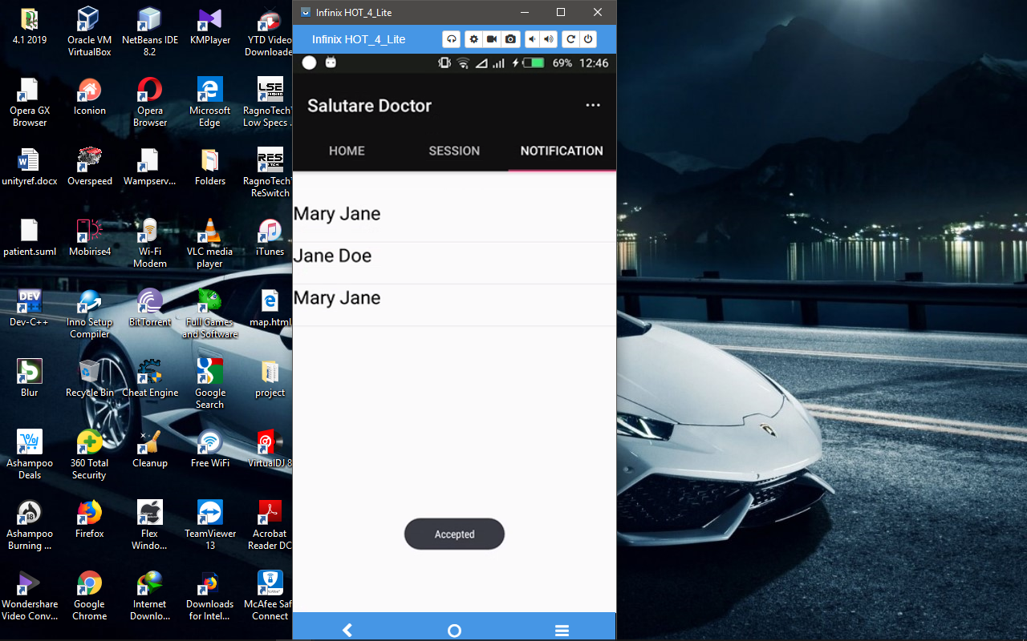

Figure 42 Example of toast message in the salutary

#### 5.2.2.7 Android Tabbed Layout

Tabbed layout allows a user to navigate to different activity fragments easily by simply just swiping left or right. The doctor application has tabbed layout that contains three fragments that is the home, session and notification fragments. ***Figure 43*** shows the three fragments.

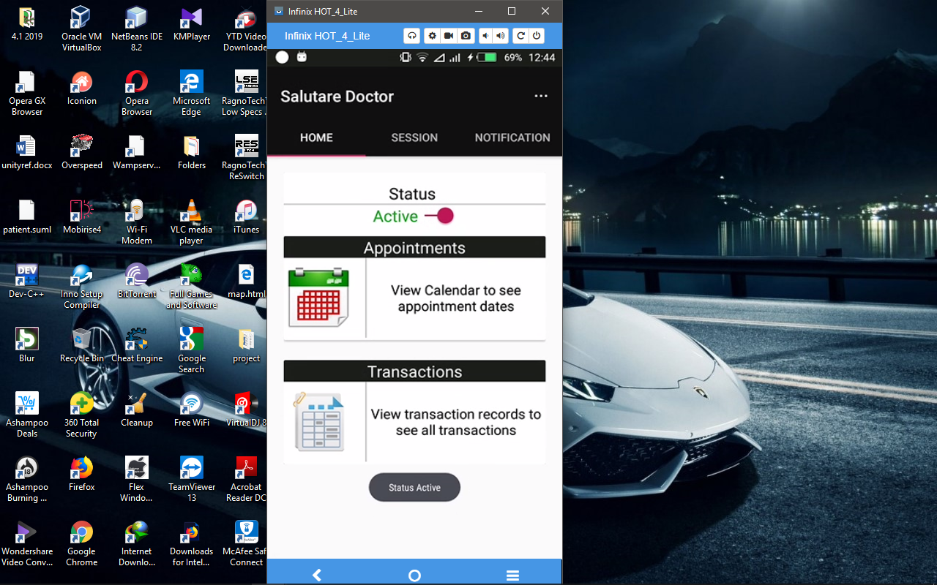

Figure 43 android tabbed layout

### 5.2.3 Patient android module

#### 5.2.3.1 Navigation Drawer

The navigation drawer is a UI panel that shows your app's main navigation menu. The drawer appears when the user touches the drawer icon in the app bar or when the user swipes a finger from the left edge of the screen. The drawer icon is displayed on all top-level destinations that use a Drawer Layout.

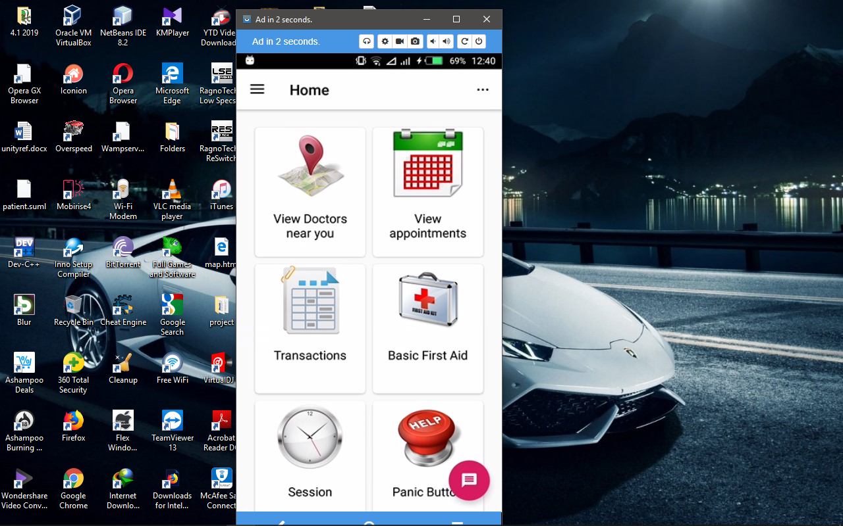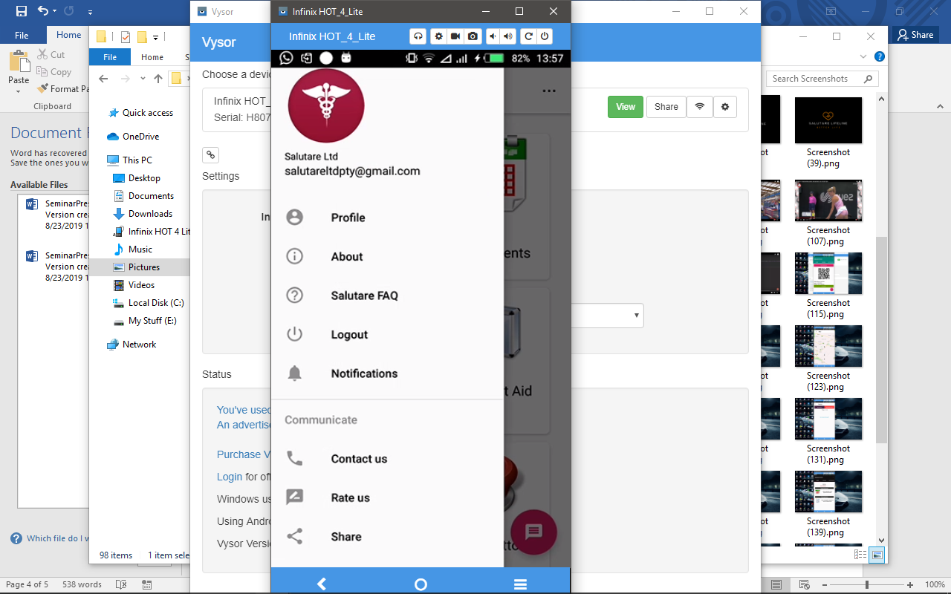

Figure 44 the patient module navigation drawer

#### 5.2.3.2 Android containers: List view

This is a view group that displays a list of scrollable items. The list items are automatically inserted to the list using an Adapter that pulls content from a source such as an array or database query and converts each item result into a view that's placed into the list. Below is a screenshot that displays a single entry of the name of the doctor that the patient has sent request to and the status of the request in a custom List View. On click, the application will direct the user to another activity that displays more information about the request.

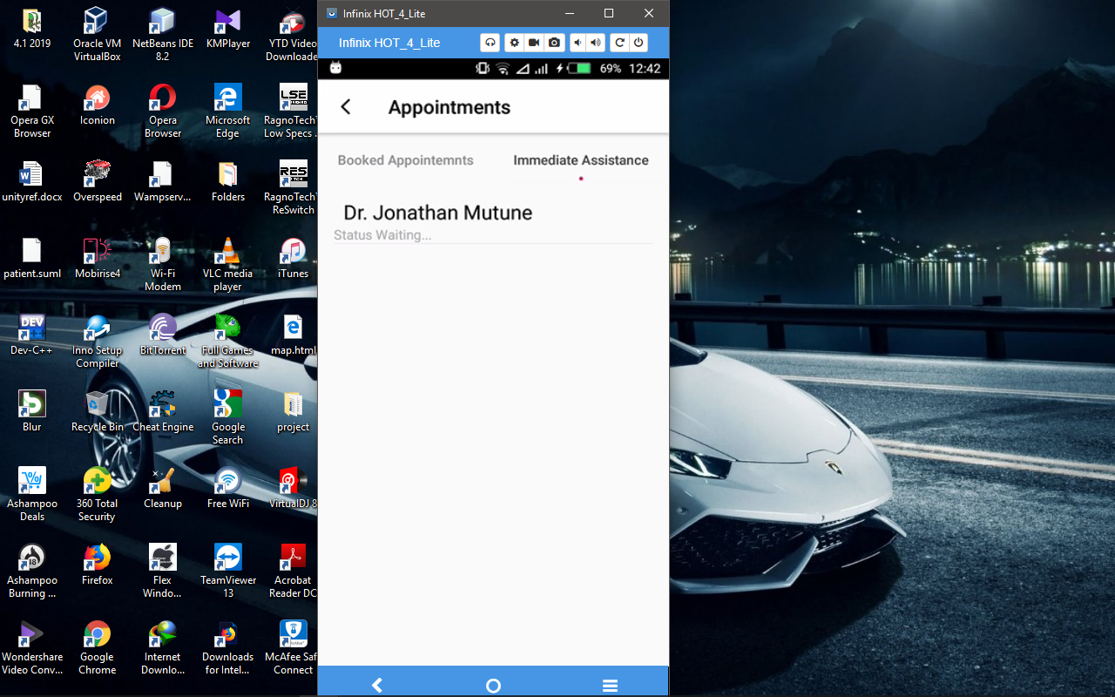

Figure 45 List view

5.2.3.3 Maps

The patient android app contains a map powered by google API, which enables patients to easily locate doctors in the nearby areas. The map requires internet in order to display locations of different doctors and also display the patient’s Location. Ideally the map triangulates and zooms in to the location of the patient so that the patient can know his/her location and be able to locate doctors near him or her. The diagram below shows a map in the patient application displaying the current location of the device and available doctors.

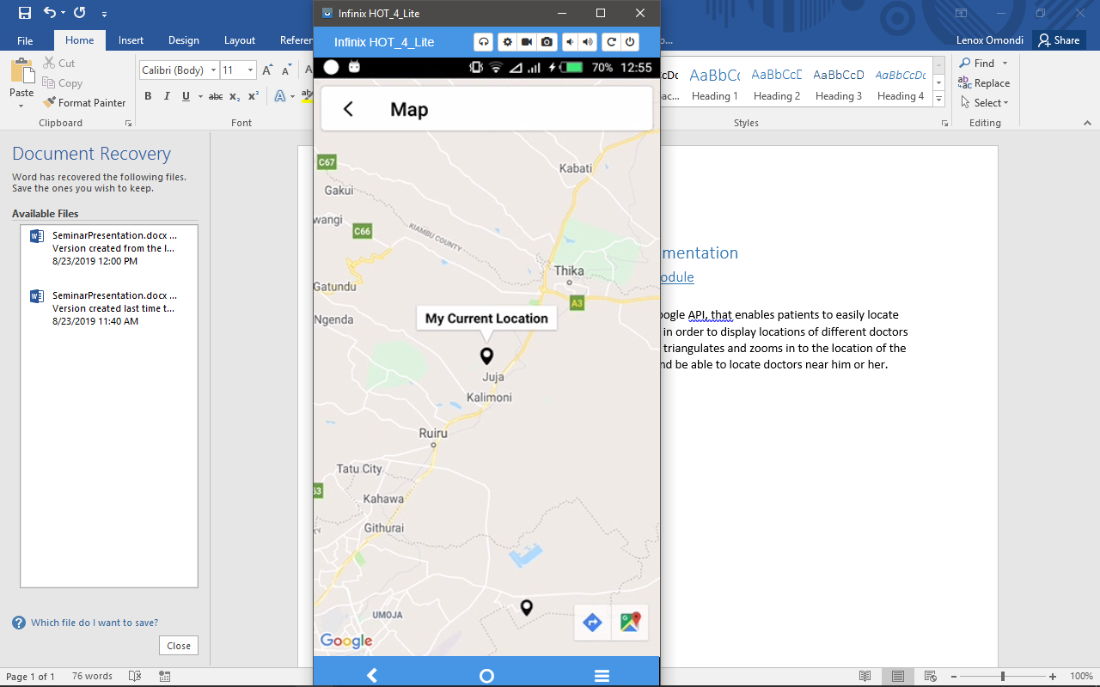

Figure 46 map module showing patient the location of a doctor

5.2.3.4 Buttons

A button is a type of android widget that performs a specified action when it is clicked. A standard android button is represented by the android class android.widget.Button.

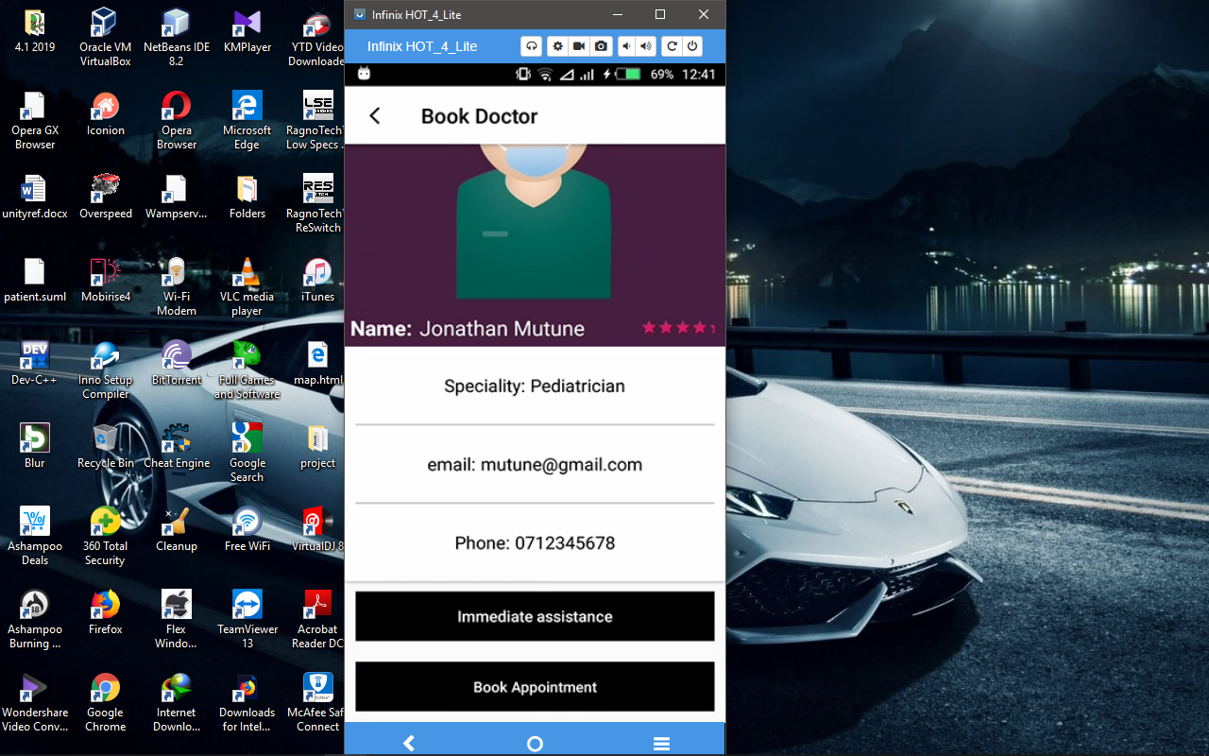

Figure 47 Patient buttons for booking a doctors, also for monitoring session

##### 5.2.3.5.1 Radio Buttons

A radio button is a type of android widget that allows users to select only one option from a variety or a set of options in a particular group. The patient application utilizes the use of radio buttons in the create account section where a patient can be able to select their gender.

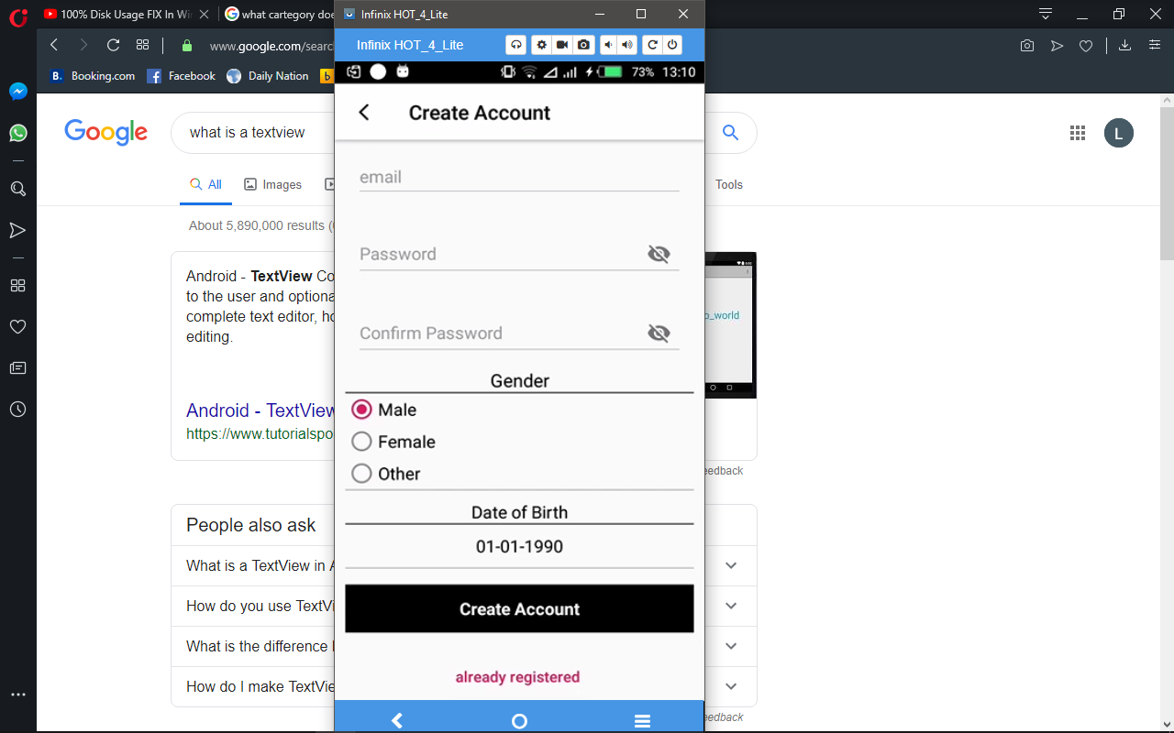

Figure 48 radio buttons used for selecting the gender of a user

5.2.3.6 Rating Bar

A Ratting bar is an extension of seek bar and a Progress bar that allows users to rate a feature of the application of the entire application by sliding through the star icons (normally five in number), which would act as a user’s content about a certain feature or the entire application.

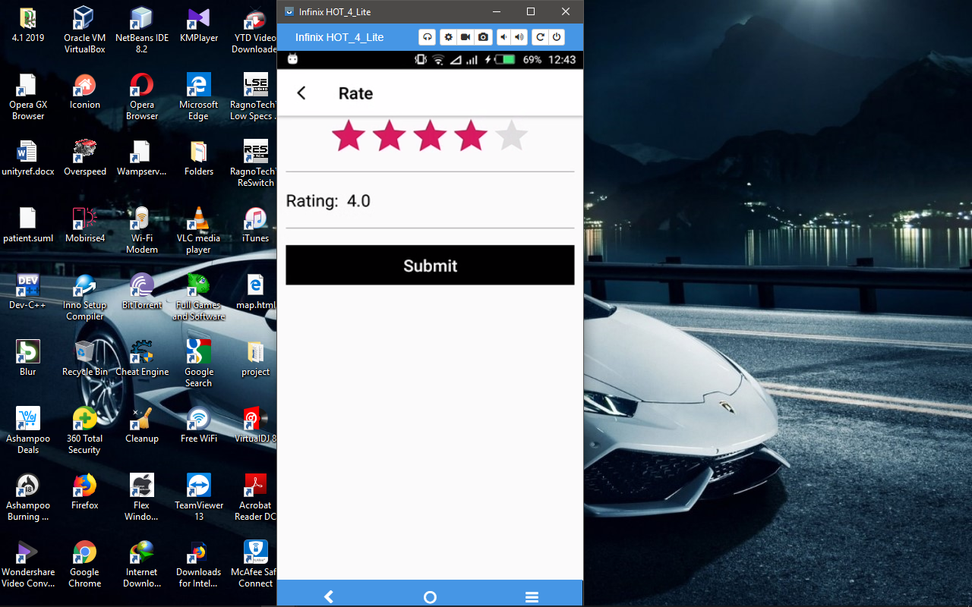

Figure 49 Rating Bar

5.2.3.6 Calendar view

Calendar view allows a user to select the date consisting of the day, month and year. In the patient app there are two instances of calendar view that is in the book doctor section for selecting the appointment date and in the create account section for selecting the date of birth.

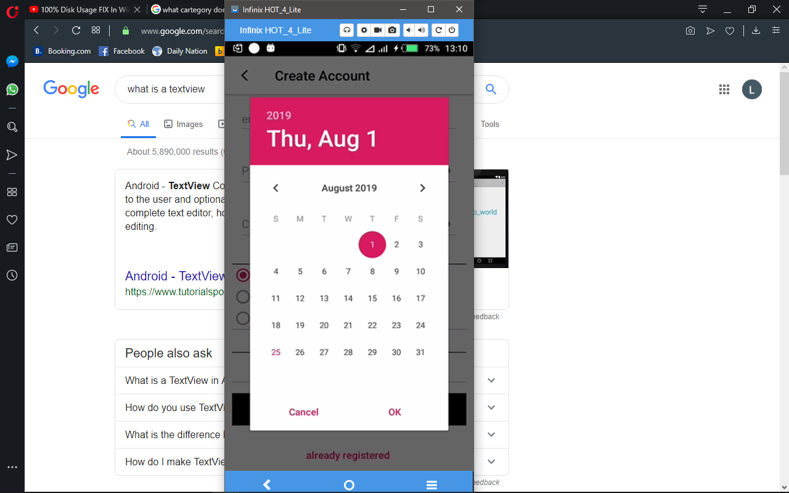

Figure 50 Calendar view

#### 5.2.3.7 Image view

Displays image resources, for example Bitmap or draw able resources. Image View is also commonly used to apply tints to an image and handle image scaling.



Figure 51 Image View

The following XML snippet is a common example of using an Image View to display an image resource:

<ImageView

android:layout_width="wrap_content"

android:layout_height="wrap_content"

android:src="@drawable/ic_doctor.png"

/>

##### 5.2.3.7.1 Circle Image View

Circle image view Displays images but usually have a circular outline. As this is just a custom Image View and not a custom Drawable or a combination of both, it can be used with all kinds of drawables.

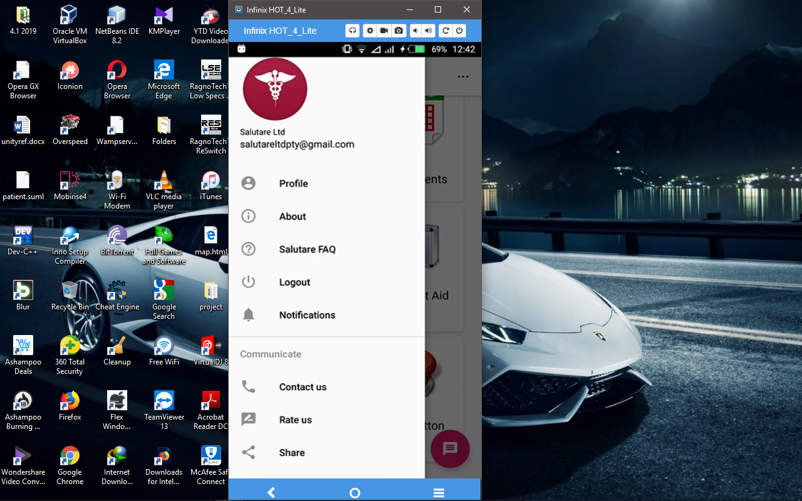

Figure 52 Circle image view

Xml snippet

<de.hdodenhof.circleimageview.CircleImageView

xmlns:app="http://schemas.android.com/apk/res-auto"

android:id="@+id/profile_image"

android:layout_width="96dp"

android:layout_height="96dp"

android:src="@drawable/profile"

app:civ_border_width="2dp"

app:civ_border_color="#FF000000"/>

#### 5.2.3.8 Progress dialog

Android Progress Dialog is a UI which shows the progress of a task like you want user to wait until the previous lined up task is completed and for that purpose you can use progress dialog. Below is a diagram that shows a progress dialog after a user has pressed the login Button and the application is verifying the user’s credentials.

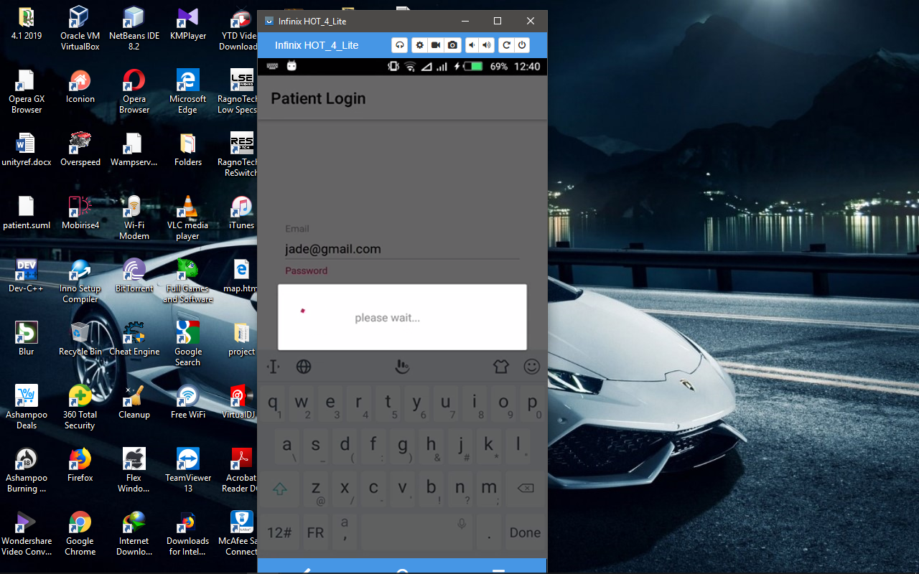

Figure 53 Progress Dialog

#### 5.2.3.9 Alert dialog

Alert Dialog can be used to display the dialog message with positive and negative buttons. It can be used to interrupt and ask the user about his/her choice to continue or discontinue. Android Alert Dialog is composed of three regions: title, content area and action buttons. Like in the screenshot below the title is Doctor, content area displays doctor’s first name and the specialty of the doctor and the action buttons which are cancel and view more whereby if a user clicks on cancel the dialog is dismissed and if the user clicks on view more it takes the user to a new activity that displays more information about that particular doctor.

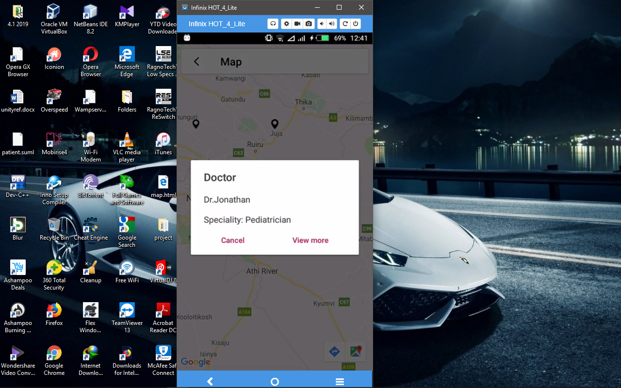

Figure 54 An alert dialog

#### 5.2.3.10 TextInputEditText

TextInputLayout provides an implementation for [Material text fields](https://material.io/go/design-text-fields). Used in conjunction with a [TextInputEditText](https://developer.android.com/reference/com/google/android/material/textfield/TextInputEditText), TextInputLayout makes it easy to include Material **text fields**in layouts.

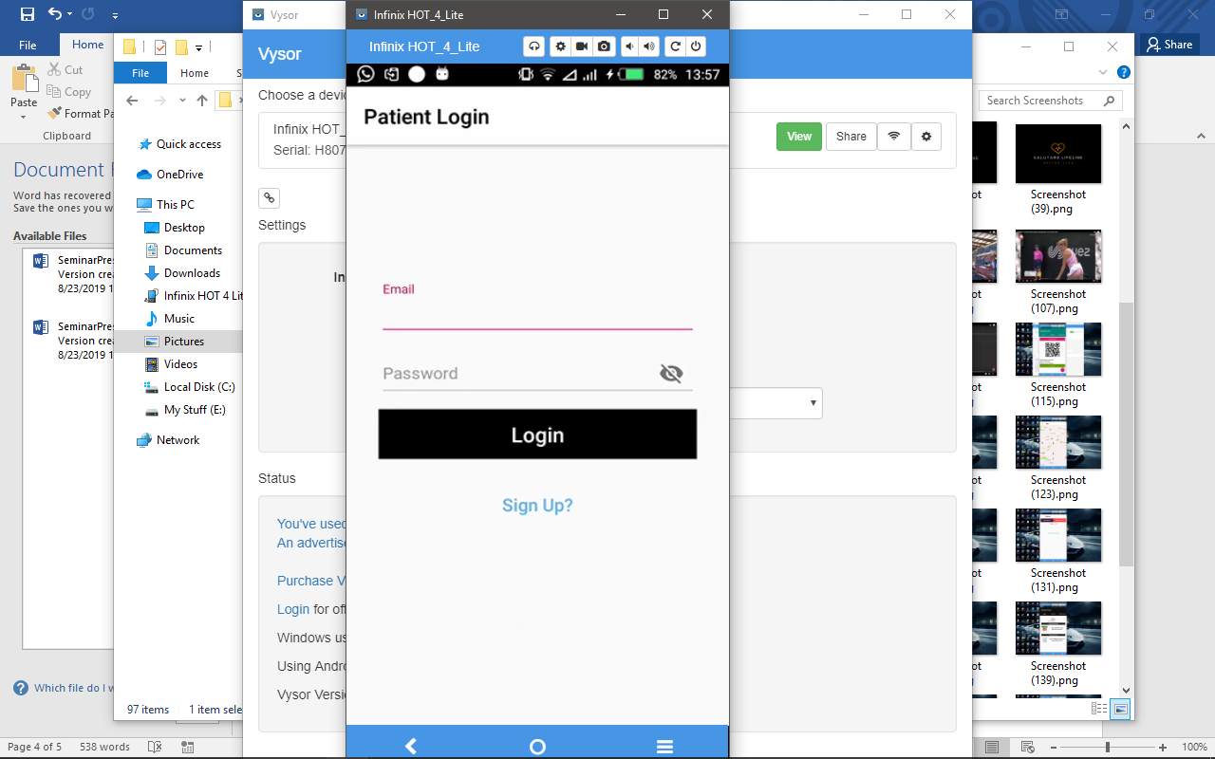

Xml code snippet for TextInputEditText.

<com.google.android.material.textfield.TextInputLayout

android:layout_width="match_parent"

android:layout_height="wrap_content">

<com.google.android.material.textfield.TextInputEditText

Android:layout_width="match_parent"

Android:layout_height="wrap content"

/>

</com.google.android.material.textfield.TextInputLayout>

#### 5.2.3.11 Forms

Below is a diagram that shows a login form and a create account form that is supposed to be filled in by the user.

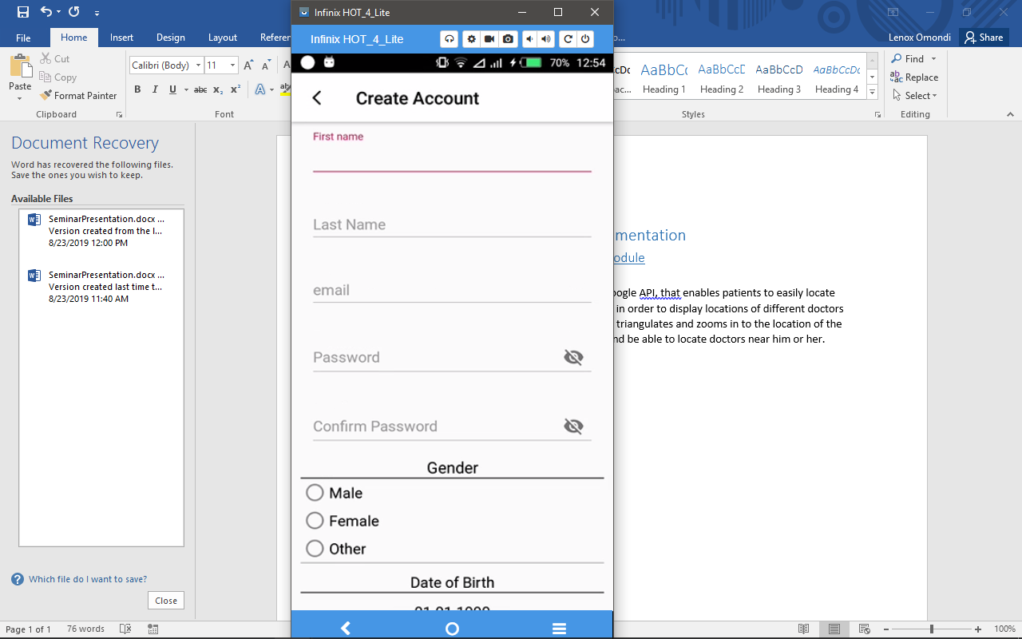

Figure 55 Users filling form

# CHAPTER SIX: TESTING

## 6.0 Introduction

Testing is required for an effective performance of software application or product. It's important to ensure that the application should not result into any failures because it can be very expensive in the future or in the later stages of the development.

Software testing is performed to detect and help correct bugs (errors) in computer software. Testing involves ensuring not only that the software is error-free but that it provides the required functionality to the user.

This chapter elaborates on the tests carried out to measure the system’s achievement of the objectives.

## 6.1 Objectives of testing

1. To demonstrate the working functionality of the system.

2. To assess the usability of the system.

3. To assess the system’s accuracy i.e. if information is uploaded by one module then the other module can retrieve the same data.

4. To check systems security of information, I.e. to check how secure the system can store users data without other thwart hackers checking compromising it.

## 6.3 Testing scope

The following is subjected into the following:

### 6.3.1 Functional Testing

Functional testing is a way of checking software to ensure that it has all the required functionality that's specified within its functional requirements.

The system main functionality of the system is for patient to check doctors on a map, and book the doctors, the nearby doctors to accept patient’s requests, and visit them at their place of residence, and the admin to monitor all the operations of the system.

The system achieved all of the functions provided in the functional requirements.

***The Patient module for checking doctors on the map and booking them.***

 

Figure 56 Checking and booking doctor module functionality

***The doctor module for viewing and accepting patient’s requests checking them on the map***



Figure 57 doctors accepts patient request and views the location on a map

#### 6.3.1.1 Performance testing

This test is used determine how a system performs in terms of responsiveness and stability under a particular workload.

The speed of uploading and downloading of data to and from the real time database is pretty much fast. I.e. when a doctor presses the switch button to activate or deactivate his/her status then the other users on the other modules gets the updates immediately.

#### 6.3.1.2 User interface testing

This entails testing the system User Interface to ensure it meets its specifications.

The user interface has been with the latest features e.g. consists of circle image view, navigation drawers, option menus, forms, tables, text views etc

Android modules navigation drawers



Figure 58 Navigation Drawer for the android modules

***The admin module navigation drawer***

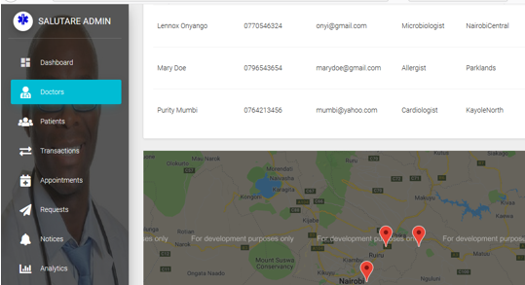

Figure 59 Admin module navigation drawer

The user interface is friendly

#### 6.3.1.3 Security testing

Security testing intends to uncover vulnerabilities of the system and determine that its data and resources are protected from possible intruders. Data in this system is stored in a real time firebase database and each module can access same data by either uploading or downloading. Security of data is automatically enabled by the functions of the real-time database. This functions are the cloud Firestore, cloud firebase and cloud functions.

Cloud Functions for Firebase let you automatically run backend code in response to events triggered by Firebase features and HTTPS requests. Your code is stored in Google's cloud and runs in a managed environment. There's no need to manage and scale your own servers.

Firebase provides a real-time database and backend as a service. The service provides application developers an API that allows application data to be synchronized across clients and stored on Firebase's cloud.

#### 6.3.1.4 Portability testing

Portability testing is the process of determining the degree of ease or difficulty to which a software component or application can be effectively and efficiently transferred from one hardware, software or other operational or usage environment to another.

The Android modules were tested in different android versions and they showed a pass result E.g. Android 4.4 (KitKat), android 6.0 (Marshmallow). The admin web module was tested in different operating system environments and different web browsers. E.g. the system was developed and run on windows operating environment, we tested it using Linux operating system and the result was a pass.

#### 6.3.1.5 Test cases

A **test case** is a specification of the inputs, execution conditions, testing procedure, and expected results that define a single test to be executed to achieve a particular [software testing](https://en.wikipedia.org/wiki/Software_testing) objective, such as to exercise a particular program path or to verify compliance with a specific requirement.

Test cases underlie testing that is methodical rather than haphazard. A battery of test cases can be built to produce the desired coverage of the software being tested. Formally defined test cases allow the same tests to be run repeatedly against successive versions of the software, allowing for effective and consistent [regression testing](https://en.wikipedia.org/wiki/Regression_testing).

Below are some of our test cases.

|  |  |  |  |  |  |  |
| --- | --- | --- | --- | --- | --- | --- |
| **TEST CASE ID** | **TEST SCENARIO** | **TEST STEPS** | **TEST DATA** | **EXPECTED RESULTS** | **ACTUAL RESULTS** | **PASS/FAIL** |
| T01 | Check user login with valid data | 1.Enter email  2.Enter password  3.Click login | Email= john@gmail.com  Password = 123456 | One should login into application | As expected | Pass |
| T02 | Check user login with invalid data | 1.Enter Email  2.Enter password  3.Click login | Username= john@gmail.com  Password = 00000 | One should not login into application | As expected | Pass |
| T03 | Fill right phone number on form | 1.Enter Phone no  2. Click submit | Phone =0721345678  Or  +254789123456 | One should submit form | As expected | Pass |
| T04 | Fill wrong phone number on phone | 1.Enter Phone no  2. Click submit | Phone =07213456  Or  “text” Or “2348” | One should not submit form | As expected | Pass |

6.3.2 Unit testing

Unit testing is a level of software testing where individual units/ components of a software are tested. The purpose is to validate that each unit of the software performs as designed. A unit is the smallest testable part of any software. It usually has one or a few inputs and usually a single output.

The system was developed in three modules namely: Doctors module, patient module and admin module. Each module was tested thorough and all the tests were a pass.

***The patient module testing of viewing doctors in a the system***



Figure 60 Patient checking doctors in the system unit test

***The Doctor module was tested the functionality of doctors checking the distance to the patient place of residence***



Figure 61 Doctors checking the route to patient’s place of residence

***The admin module test for checking the analytics***



Figure 62 Monitoring Daily transaction module testing

### 6.3.3 Integration Testing

Integration testing is a level of software testing where individual units are combined and tested as a group. The purpose of this level of testing is to expose faults in the interaction between integrated units. We first integrated the two android module units, i.e. We uploaded patient information to the database using the patient module unit and we checked if we could find the same using the doctors’ module unit and the results were a pass. We went ahead and used the admin module unit we were able to access the same data.



Mary

Jane

Maryj@gmail.com

Figure 63 Data uploaded to the database on patient module unit



Figure 64 Data retrieved from the database using doctor’s module unit

### 6.3.4 System Testing

System testing is a level of software testing where a complete and integrated software is tested. The purpose of this test is to evaluate the system's compliance with the specified requirements

We checked the analytics of the whole system and we were able to see all transaction updates that happened when we’re doing the integration testing.



Figure 65 Analytics functionality showing all transaction happened in a particular scope

# CHAPTER SEVEN: CHALLENGE, RECOMMENDATION AND CONCLUSION

## 7.1 introduction

Health care is moving into the home increasingly often and involving a mixture of people, a variety of tasks, and a broad diversity of devices and technologies; it is also occurring in a range of residential environments. The factors driving this migration include the rising costs of providing health care; the growing numbers of older adults; the increasing prevalence of chronic disease; improved survival rates of various diseases, injuries, and other conditions(Technology been introduced to almost all disciplines). The health care that results varies considerably in its safety, effectiveness, and efficiency, as well as its quality and cost.

## 7.2 Challenges

Software engineering employs a well-defined and systematic approach to develop software. Changes in software development are unavoidable. In today's world, changes occur rapidly and accommodating these changes to develop complete software is one of the major challenges faced by the software engineers. Some of the challenges we faced are health care technologies, including medical devices and health information technologies involved in health care.

## 7.3 Recommendation

Health care technologies include medical devices that are used in the home as well as information technologies related to home-based health care. The four recommendations in this area concern: Regulating technologies for health care consumers, developing guidance on the structure and usability of health information technologies, developing guidance and standards for medical device labeling and improving adverse event reporting systems for medical devices. The adoption of these recommendations would improve the usability and effectiveness of technology systems and devices, support users in understanding and learning to use them, and improve feedback to government and industry that could be used to further improve technology for home care.

Ensuring the safety of emerging technologies will help curb challenges users face. The government should collaborate to regulate, certify, and monitor health care applications and systems that integrate medical devices and health information technologies. As part of the certification process, the agencies should require evidence that manufacturers have followed existing accessibility and usability guidelines and have applied user-centered design and validation methods during development of the product.

## 7.4 conclusion

The field of mHealth is at an inflection point. With dozens of projects implemented and proven benefits, all trends indicate that investment will continue and mHealth projects will serve an ever wider range of constituents in the years ahead. At the same time, technological innovations will bring enhanced benefits, particularly in the areas of data collection, patient monitoring, and remote diagnostic and treatment support, where application development is already proceeding at breakneck speed.

Health needs in the developing world are rapidly evolving to include chronic diseases, in addition to the communicable diseases most often associated with developing countries. MHealth is well-positioned to address these challenges using currently available technology. For example, SMS alerts can be equally useful in raising public health awareness of HIV/AIDS and in ensuring patient adherence to treatments for chronic diseases such as diabetes. Emerging technologies, such as wide-area wireless systems, will also be an asset in tackling today’s health challenges and those of tomorrow.

**Gnatt chart**

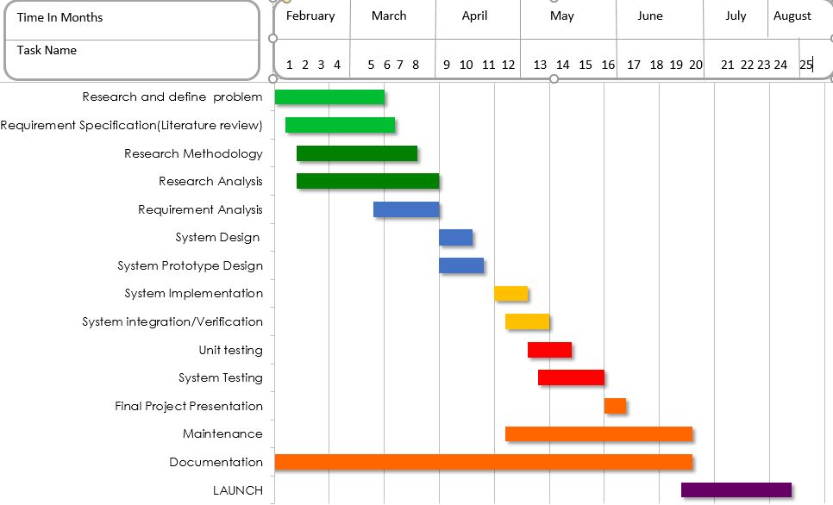

Table 10 Gnatt chart

## BUDGET

|  |  |
| --- | --- |
| **Requirements** | **Cost (KShs)** |
| **Research Internet** | **4,000.00** |
| **Flash Drive/External Drive** | **1000.00** |
| **Printing** | **1200.00** |
| **Electricity** | **500.00** |
| **Transport** | **700.00** |
| **Total Cost** | **7400.00** |

Table 11 Budget

# References

Akiki, P. A. (2014). Adaptive Model-Driven User Interface Development Systems. *UI*, 47.

al., H.-T. e. (June 2013). A Survey on Smartphone-Based Systems for Opportunistic User Context Recognition. *A Survey on Smartphone-Based Systems for Opportunistic User Context Recognition*, 1,345 .

Anderson, G. J. (July 2011). User Perception of Touch Screen Latency. *User Perception of Touch Screen Latency*, 148.

Armitage, J. (December 2015). A UK perspective on smartphone use amongst doctors within the surgical profession. 107-112.

Becker, D. (June 2015). Best Practices of Library Mobile Website Design: A Literature Review. *Best Practices of Library Mobile Website Design: A Literature Review*, 164.

Bock, K. &. (June 2012). *Data Collections and Analysis .* New York.

Cockburn, A. (December 2008). A Review of Overview+Detail, Zooming, and Focus+Context Interfaces. *A Review of Overview+Detail, Zooming, and Focus+Context Interfaces*, 83.

Esplin, C. (2016, October 24). *What is firebase?* Retrieved from how to firebase: https://howtofirebase.com/what-is-firebase-fcb8614ba442

GeekyAnts. (2017, December 28). *Introduction to firebase*. Retrieved from hackernoon: https://hackernoon.com/introduction-to-firebase-218a23186cd7

Homan, J. (2014, April 5). *relational vs non-relational databases*. Retrieved from plural sight: https://www.pluralsight.com/blog/software-development/relational-non-relational-databases

Kenyanya., J. (2015, March 8). *Issues affecting healthcare in Kenya and Sub-Saharan Africa. Retrieved from:.* Retrieved from https://www.linkedin.com/pulse/issues-affecting-healthcare-kenya-sub-saharan-africa-james-kenyanya

Kim, J. (2015). *Design for Experience.* Switzerland: Springer International Publishing.

Koskinen, E. (January 2008). Feel-good touch: finding the most pleasant tactile feedback for a mobile touch screen button. *Feel-good touch: finding the most pleasant tactile feedback for a mobile touch screen button.*, 4654.

McCabe, M. &. (2014). *Types of Research.* Chicago.

Merab, E. (2018, July 24). *Even after two visits to the hospital with excruciating headache doctors told her that all she needed was a good sleep.* Retrieved from https://www.nation.co.ke/newsplex/medicalnegligence/2718262-4673818-t7jjajz/index.html

Moriso, C. a. (August 2013). Mobile devices as infotainment user interfaces in the car: contextual study and design implications. *Mobile devices as infotainment user interfaces in the car: contextual study and design implications*, 70.

Moulder, J. (April 2005). Mobile phone, mobile phone base stations and cancer: A review. 289.

Pal, K. (2016, June 7). *Why the World Is Moving Toward NoSQL Databases*. Retrieved from Techopedia: http://www.techopedia.com/Websites database - security/Why the World Is Moving Toward NoSQL Databases.html

Park, G. (August 2011). Tactile effect design and evaluation for virtual buttons on a mobile device touchscreen. *Tactile effect design and evaluation for virtual buttons on a mobile device touchscreen*, 67.

Punchoojit, L. (2016). HCI. *Usability*, 89.

Quinn, P. (May 2012). Improving scrolling devices with document length dependent gain. *Improving scrolling devices with document length dependent gain*, 7.

Rodrigues, P. a. (Novermber 2013). Survey and Analysis of Current Mobile Learning Applications and Technologies. *Survey and Analysis of Current Mobile Learning Applications and Technologies*, 4410.

Ross, S. (November 2018). *How GPS has affected our lives .* New york.

Ross, S. (November 2018). *How GPS has revolutioned our lives.* New York.

Rouse, M. (August 2015). *Databases and DBMS.* Milano.

Silver, L. (2019). Smartphone Ownership Is Growing Rapidly Around the World, but Not Always Equally. *Smartphone Ownership Is Growing Rapidly Around the World, but Not Always Equally*, 10-20.

Stephandis, C. (2014). *in The Encyclopedia of Human-Computer Interaction, Interaction Design Foundation, 2nd edition,*. Retrieved from Design for all: https://www.interaction-design.org/literature/book/the-encyclopedia-of-human-computer-interaction-2nd-ed/design-4-all. View at Google Scholar

Stergen, M. T. (2019, February 20). *top-phone-tracker-apps/*. Retrieved from Mobile tracking: http://thetruthspy.com/top-phone-tracker-apps/

Stergiannis, P. (Nov 2018). *Emergency Department.* Agioi Anargyroi.

Taylor, K. (2019). Smartphone Ownership Is Growing Rapidly Around the World, but Not Always Equally. *Smartphone Ownership Is Growing Rapidly Around the World, but Not Always Equally*, 10-20.

Unonymous. (2017, June 29). *What are the challenges facing the health sector in Kenya? Retrieved from:.* Retrieved from https://www.kenyaplex.com/questions/3397-what-are-the-challenges-facing-the-health-sector-in-kenya.aspx

widen, R. (April,2018). *Apps Solutions.* London.

Zhou, J. (May 2013). Older Adults’ use of Smart Phones: An Investigation of the Factors Influencing the Acceptance of New Functions. *Older Adults’ use of Smart Phones: An Investigation of the Factors Influencing the Acceptance of New Functions*, 447.

Akiki, P. A. (2014). Adaptive Model-Driven User Interface Development Systems. *UI*, 47.

al., H.-T. e. (June 2013). A Survey on Smartphone-Based Systems for Opportunistic User Context Recognition. *A Survey on Smartphone-Based Systems for Opportunistic User Context Recognition*, 1,345 .

Anderson, G. J. (July 2011). User Perception of Touch Screen Latency. *User Perception of Touch Screen Latency*, 148.

Armitage, J. (December 2015). A UK perspective on smartphone use amongst doctors within the surgical profession. 107-112.

Becker, D. (June 2015). Best Practices of Library Mobile Website Design: A Literature Review. *Best Practices of Library Mobile Website Design: A Literature Review*, 164.

Bock, K. &. (June 2012). *Data Collections and Analysis .* New York.

Cockburn, A. (December 2008). A Review of Overview+Detail, Zooming, and Focus+Context Interfaces. *A Review of Overview+Detail, Zooming, and Focus+Context Interfaces*, 83.

Esplin, C. (2016, October 24). *What is firebase?* Retrieved from how to firebase: https://howtofirebase.com/what-is-firebase-fcb8614ba442

GeekyAnts. (2017, December 28). *Introduction to firebase*. Retrieved from hackernoon: https://hackernoon.com/introduction-to-firebase-218a23186cd7

Homan, J. (2014, April 5). *relational vs non-relational databases*. Retrieved from plural sight: https://www.pluralsight.com/blog/software-development/relational-non-relational-databases

Kenyanya., J. (2015, March 8). *Issues affecting healthcare in Kenya and Sub-Saharan Africa. Retrieved from:.* Retrieved from https://www.linkedin.com/pulse/issues-affecting-healthcare-kenya-sub-saharan-africa-james-kenyanya

Kim, J. (2015). *Design for Experience.* Switzerland: Springer International Publishing.

Koskinen, E. (January 2008). Feel-good touch: finding the most pleasant tactile feedback for a mobile touch screen button. *Feel-good touch: finding the most pleasant tactile feedback for a mobile touch screen button.*, 4654.

McCabe, M. &. (2014). *Types of Research.* Chicago.

Merab, E. (2018, July 24). *Even after two visits to the hospital with excruciating headache doctors told her that all she needed was a good sleep.* Retrieved from https://www.nation.co.ke/newsplex/medicalnegligence/2718262-4673818-t7jjajz/index.html

Moriso, C. a. (August 2013). Mobile devices as infotainment user interfaces in the car: contextual study and design implications. *Mobile devices as infotainment user interfaces in the car: contextual study and design implications*, 70.

Moulder, J. (April 2005). Mobile phone, mobile phone base stations and cancer: A review. 289.

Pal, K. (2016, June 7). *Why the World Is Moving Toward NoSQL Databases*. Retrieved from Techopedia: http://www.techopedia.com/Websites database - security/Why the World Is Moving Toward NoSQL Databases.html

Park, G. (August 2011). Tactile effect design and evaluation for virtual buttons on a mobile device touchscreen. *Tactile effect design and evaluation for virtual buttons on a mobile device touchscreen*, 67.

Punchoojit, L. (2016). HCI. *Usability*, 89.

Quinn, P. (May 2012). Improving scrolling devices with document length dependent gain. *Improving scrolling devices with document length dependent gain*, 7.

Rodrigues, P. a. (Novermber 2013). Survey and Analysis of Current Mobile Learning Applications and Technologies. *Survey and Analysis of Current Mobile Learning Applications and Technologies*, 4410.

Ross, S. (November 2018). *How GPS has affected our lives .* New york.

Ross, S. (November 2018). *How GPS has revolutioned our lives.* New York.

Rouse, M. (August 2015). *Databases and DBMS.* Milano.

Silver, L. (2019). Smartphone Ownership Is Growing Rapidly Around the World, but Not Always Equally. *Smartphone Ownership Is Growing Rapidly Around the World, but Not Always Equally*, 10-20.

Stephandis, C. (2014). *in The Encyclopedia of Human-Computer Interaction, Interaction Design Foundation, 2nd edition,*. Retrieved from Design for all: https://www.interaction-design.org/literature/book/the-encyclopedia-of-human-computer-interaction-2nd-ed/design-4-all. View at Google Scholar

Stergen, M. T. (2019, February 20). *top-phone-tracker-apps/*. Retrieved from Mobile tracking: http://thetruthspy.com/top-phone-tracker-apps/

Stergiannis, P. (Nov 2018). *Emergency Department.* Agioi Anargyroi.

Taylor, K. (2019). Smartphone Ownership Is Growing Rapidly Around the World, but Not Always Equally. *Smartphone Ownership Is Growing Rapidly Around the World, but Not Always Equally*, 10-20.

Unonymous. (2017, June 29). *What are the challenges facing the health sector in Kenya? Retrieved from:.* Retrieved from https://www.kenyaplex.com/questions/3397-what-are-the-challenges-facing-the-health-sector-in-kenya.aspx

widen, R. (April,2018). *Apps Solutions.* London.

Zhou, J. (May 2013). Older Adults’ use of Smart Phones: An Investigation of the Factors Influencing the Acceptance of New Functions. *Older Adults’ use of Smart Phones: An Investigation of the Factors Influencing the Acceptance of New Functions*, 447.